**Unit 1: Introduction of Automation System**

**Introduction to Industrial Automation:**

**Automation** or automatic control, is the use of various [control systems](http://en.wikipedia.org/wiki/Control_system) for operating equipment such as machinery, processes in factories, boilers and heat-treating ovens, switching in telephone networks, steering and stabilization of ships, aircraft and other applications with minimal or reduced human intervention. Some processes have been completely automated.

The biggest benefit of automation is that it saves labor, however, it is also used to save energy and materials and to improve quality, accuracy and precision.

According to a Manufacturing Engineer automation may be as follows

“Automation is a technology concerned with the application of Mechanical, Electrical, Electronic and Computer based systems to operate and control production.”

* Automation means use of Available technologies to reduce the need of Human work.
* Automation is a step beyond mechanization. Mechanization provides human operators machinery to assist themselves with the muscular requirements of work……While Automation greatly decreases the need for human sensory and mental requirements as well.

**The term *automation*, inspired by the earlier word**[***automatic***](http://en.wiktionary.org/wiki/automatic)**(coming from** [***automaton***](http://en.wikipedia.org/wiki/Automaton)**), was not widely used before 1947, when General Motors established the automation department. It was during this time that industry was rapidly adopting**[**feedback controllers**](http://en.wikipedia.org/wiki/PID_controller)**, which were introduced in the 1930s.**

**Industrial Automation**

Industrial automation deals primarily with the automation of manufacturing, quality control and material handling processes. General purpose controllers for industrial processes include [Programmable logic controllers](http://en.wikipedia.org/wiki/Programmable_logic_controller) and computers. One trend is increased use of [Machine vision](http://en.wikipedia.org/wiki/Machine_vision) to provide automatic inspection and robot guidance functions, another is a continuing increase in the use of [robots](http://en.wikipedia.org/wiki/Robot).

**Industrial automation** is the use of control devices such as PC/PLCs/PACs etc. to control industrial processes and machinery by removing as much labor intervention as possible, and replacing dangerous assembly operations with automated ones. Industrial automation is closely linked to [control engineering](https://www.electrical4u.com/control-engineering-historical-review-and-types-of-control-engineering/).

**Advantages and disadvantages**

Manufacturers face many challenges in today’s globally competitive business landscape. Some of these challenges include harsh manufacturing environments (in a world which is increasingly focused on safety – and rightly so), increasingly complex supply chains, meeting the latest energy efficient standards, and competing with companies with very small marginal costs.

Many of these reasons drive manufacturers towards industrial automation. The advantages to Industrial Automation include:

* Increased labor productivity
* Improved product quality
* Reduced labor or production cost
* Reduced routine manual tasks
* Improved safety
* Assisted remove monitoring

### Increased Labor Productivity

Automation increases the production rate by producing greater output for a given labor input. It is not possible for human workers to work for long hours without losing accuracy. On the other hand, without compromising on accuracy, automated control systems able to work for long hours. Hence increased productivity and efficiency per hour of labor input.

### Improved Product Quality

One of the chief benefits of the automation is that the reduction of fraction defect rate. With the manual operation of manufacturing process, there may be a compromise on quality specifications of the product. But the automation system performs operations with greater conformity and uniformity to the quality specifications. By using the automation systems, industrial processes are controlled and monitored at all stages in order to produce a qualitative end product.

### Reduced Labor or Production Cost

The automated systems help the industries to save a great deal in the long term by substituting automated machinery in place of human labor so that unit production cost is reduced. Automation equipment running smoothly or uniformly 24 × 7 not only increases the productivity, but also consequently results in an excellent return on investment by saving salaries, workforce costs, pensions and costs with employees. The automated system also reduces the labor shortage by substituting automated operations in place of labor.

### Reduced Routine Manual Tasks

In many industrial applications, process variables like temperature, liquid level, pressure, etc. are to be periodically monitored as a routine task to maintain their set levels. Thus an automation system creates the automatic working condition by employing closed-loop control systems.

### Improved Safety

By implementing an automated system, work is made safer by transferring the worker from an active participation location in the process to the supervising role. The automated machines are able to work in hazardous environments and other extreme environments. Also, these systems make use of industrial robots in place of human workers, especially in life-threatening conditions (chemical and high-temperature conditions). Thus, an **industrial automation** system prevents the accidents and injuries to the workers.

### Assist Remote Monitoring

Most of the industrial operations have to be controlled remotely for convenient and long-distance monitor and control of process variables. For such cases, automated systems provide a communication link between the process area and supervising (monitor and control) area, thereby allowing operators to control and monitor the industrial processes from a remote location. The best example of this remote control is the automated [electric power](https://www.electrical4u.com/electric-power-single-and-three-phase/) grid control.

**The following methods are often employed to improve productivity, quality, or robustness.**

* Install automation in operations to reduce cycle time.
* Install automation where a high degree of accuracy is required.
* Replacing human operators in tasks that involve hard physical or monotonous work.
* Replacing humans in tasks done in dangerous environments (i.e., fire, space, volcanoes, nuclear facilities, underwater, etc.)
* Performing tasks that are beyond human capabilities of size, weight, speed, endurance, etc.
* Economic improvement: Automation may improve in economy of enterprises, society or most of humanity. For example, when an enterprise invests in automation, technology recovers its investment; or when a state or country increases its income due to automation like [Germany](http://en.wikipedia.org/wiki/Germany) or [Japan](http://en.wikipedia.org/wiki/Japan) in the 20th Century.
* Reduces operation time and work handling time significantly.
* Frees up workers to take on other roles.
* Provides higher level jobs in the development, deployment, maintenance and running of the automated processes.

**The main disadvantages of automation are:**

* Causing [unemployment](http://en.wikipedia.org/wiki/Unemployment) and [poverty](http://en.wikipedia.org/wiki/Poverty) by replacing human labour.
* Security Threats/Vulnerability: An automated system may have a limited level of intelligence, and is therefore more susceptible to committing errors outside of its immediate scope of knowledge (e.g., it is typically unable to apply the rules of simple logic to general propositions).
* Unpredictable/excessive development costs: The [research and development](http://en.wikipedia.org/wiki/Research_and_development) cost of automating a process may exceed the cost saved by the automation itself.
* High initial cost: The automation of a new [product](http://en.wikipedia.org/wiki/Product_(business)) or [plant](http://en.wikipedia.org/wiki/Plant) typically requires a very large initial investment in comparison with the unit cost of the product, although the cost of automation may be spread among many products and over time.

In manufacturing, the purpose of automation has shifted to issues broader than productivity, cost, and time.

**Automation tools**

Engineers can now have [numerical control](http://en.wikipedia.org/wiki/Numerical_control) over automated devices. The result has been a rapidly expanding range of applications and human activities. [Computer-aided technologies](http://en.wikipedia.org/wiki/Computer-aided_technologies) (or CAx) now serve the basis for mathematical and organizational tools used to create complex systems. Notable examples of CAx include [Computer-aided design](http://en.wikipedia.org/wiki/Computer-aided_design) (CAD software) and [Computer-aided manufacturing](http://en.wikipedia.org/wiki/Computer-aided_manufacturing) (CAM software). The improved design, analysis, and manufacture of products enabled by CAx has been beneficial for industry.

[Information technology](http://en.wikipedia.org/wiki/Information_technology), together with [industrial](http://en.wikipedia.org/wiki/Industry) [machinery](http://en.wikipedia.org/wiki/Machinery) and [processes](http://en.wikipedia.org/wiki/Industrial_process), can assist in the design, implementation, and monitoring of control systems. One example of an [industrial control system](http://en.wikipedia.org/wiki/Industrial_control_systems) is a [programmable logic controller](http://en.wikipedia.org/wiki/Programmable_logic_controller) (PLC). PLCs are specialized hardened computers which are frequently used to synchronize the flow of inputs from (physical) [sensors](http://en.wikipedia.org/wiki/Sensor) and events with the flow of outputs to actuators and events.

[Human-machine interfaces](http://en.wikipedia.org/wiki/Human-computer_interaction) (HMI) or [computer human interfaces](http://en.wikipedia.org/wiki/Human%E2%80%93computer_interaction) (CHI), formerly known as man-machine interfaces, are usually employed to communicate with PLCs and other computers. Service personnel who monitor and control through HMIs can be called by different names. In industrial process and manufacturing environments, they are called operators or something similar. In boiler houses and central utilities departments they are called stationary engineers.

Different types of automation tools exist:

* ANN - [Artificial neural network](http://en.wikipedia.org/wiki/Artificial_neural_network)
* DCS - [Distributed Control System](http://en.wikipedia.org/wiki/Distributed_Control_System)
* HMI - [Human Machine Interface](http://en.wikipedia.org/wiki/Human_Machine_Interface)
* SCADA - [Supervisory Control and Data Acquisition](http://en.wikipedia.org/wiki/Supervisory_Control_and_Data_Acquisition)
* PLC - [Programmable Logic Controller](http://en.wikipedia.org/wiki/Programmable_logic_controller)
* [Instrumentation](http://en.wikipedia.org/wiki/Instrumentation)
* [Motion control](http://en.wikipedia.org/wiki/Motion_control)
* [Robotics](http://en.wikipedia.org/wiki/Robotics)

### Limitations to automation

* Current technology is unable to automate all the desired tasks.
* Many operations using automation have large amounts of invested capital and produce high volumes of product, making malfunctions extremely costly and potentially hazardous. Therefore, some personnel are needed to ensure that the entire system functions properly and that safety and product quality are maintained.
* As a process becomes increasingly automated, there is less and less labor to be saved or quality improvement to be gained. This is an example of both [diminishing returns](http://en.wikipedia.org/wiki/Diminishing_returns) and the [logistic function](http://en.wikipedia.org/wiki/Logistic_function).
* As more and more processes become automated, there are fewer remaining non-automated processes. This is an example of exhaustion of opportunities. New technological paradigms may however set new limits that surpass the previous limits.

**Recent and emerging applications**

* Automated retail
  + - Food and drink
    - Stores
* Automated mining
* Automated video surveillance
* Automated highway systems
* Automated waste management
* Home automation
* Industrial automation
* Agriculture
* Agent-assisted Automation

**Reasons for Automating**

* To increase labor productivity
* To reduce labor cost
* To mitigate the effects of labor shortages
* To reduce or remove routine manual and clerical tasks
* To improve worker safety
* To improve product quality
* To reduce manufacturing lead time
* To accomplish what cannot be done manually
* To avoid the high cost of not automating

**Automation Facilities includes**

* Automatic machine tools to process parts,
* Automatic ASSEMBLY machines,
* Industrial Robots
* Automatic material handling and storage systems,
* Automatic inspection system for quality control,
* Feedback control and computer process control
* Computer system for Planning, Data acquisition and decision making to support manufacturing activities

**Automation Principle**

* Understand the existing process
* Input/output analysis
* Value chain analysis
* Charting techniques and mathematical modeling
* Simplify the process
* Reduce unnecessary steps and moves
* Automate the process
* Ten strategies for automation and production systems
* Automation migration strategy

**Automation Strategies**

* Specialization of operations
* Combined operations
* Simultaneous operations
* Integration of operations
* Increased flexibility
* Improved material handling and storage
* On-line inspection
* Process control and optimization
* Plant operations control
* Computer-integrated manufacturing

**Components of Industrial Automation**

* 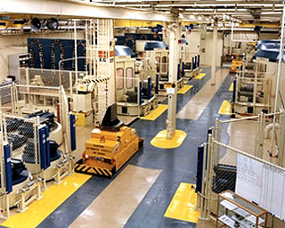Storage Systems
* Handling Systems
* Assembly Lines
  + Assembly Cells
  + Machines
    - Actuators
    - Sensors
* Production Lines
  + - Production Cells
    - Machines
      * Actuators
      * Sensors

**Classification of Automation**

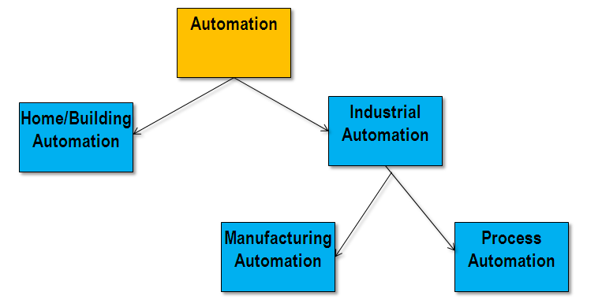

**Home Automation**

Home automation is the residential extension of [building automation](http://en.wikipedia.org/wiki/Building_automation). It is automation of the home, housework or household activity. Home [automation](http://en.wikipedia.org/wiki/Automation) may include centralized control of lighting, [HVAC](http://en.wikipedia.org/wiki/HVAC) (heating, ventilation and air conditioning), appliances, security locks of gates and doors and other systems, to provide improved convenience, comfort, energy efficiency and security. [Home automation for the elderly and disabled](http://en.wikipedia.org/wiki/Home_automation_for_the_elderly_and_disabled) can provide increased quality of life for persons who might otherwise require caregivers or institutional care.

A home automation system integrates electrical devices in a house with each other. The techniques employed in home automation include those in building automation as well as the control of domestic activities, such as [home entertainment systems](http://en.wikipedia.org/wiki/Home_cinema), [house plant](http://en.wikipedia.org/wiki/Houseplant) and yard watering, [pet feeding](http://en.wikipedia.org/wiki/Raw_feeding), changing the ambiance "scenes" for different events (such as dinners or parties), and the use of [domestic robots](http://en.wikipedia.org/wiki/Domestic_robot). Devices may be connected through a [home network](http://en.wikipedia.org/wiki/Home_network) to allow control by a [personal computer](http://en.wikipedia.org/wiki/Personal_computer), and may allow remote access from the [internet](http://en.wikipedia.org/wiki/Internet). Through the integration of [information technologies](http://en.wikipedia.org/wiki/Information_technology) with the home environment, systems and appliances are able to communicate in an integrated manner which results in convenience, energy efficiency, and safety benefits.

**Benefits:**

* Home automation refers to the use of computer and [information technology](http://en.wikipedia.org/wiki/Information_technology) to control home appliances and features (such as windows or lighting). Systems can range from simple remote control of lighting through to complex computer/micro-controller based networks with varying degrees of intelligence and automation. Home automation is adopted for reasons of ease, security and energy efficiency.[[4]](http://en.wikipedia.org/wiki/Home_automation#cite_note-Harper17-4)[[5]](http://en.wikipedia.org/wiki/Home_automation#cite_note-Gerhart1-5)
* In modern construction in industrialized nations, most homes have been wired for electrical power, telephones, TV outlets (cable or antenna), and a [doorbell](http://en.wikipedia.org/wiki/Doorbell). Many household tasks were automated by the development of specialized automated appliances. For instance, automatic [washing machines](http://en.wikipedia.org/wiki/Washing_machine) were developed to reduce the manual labor of cleaning clothes, and [water heaters](http://en.wikipedia.org/wiki/Water_heater) reduced the labor necessary for [bathing](http://en.wikipedia.org/wiki/Bathing).
* The use of gaseous or [liquid fuels](http://en.wikipedia.org/wiki/Liquid_fuels), and later the use of electricity enabled increased automation in heating, reducing the labor necessary to manually refuel [heaters](http://en.wikipedia.org/wiki/Stove) and [stoves](http://en.wikipedia.org/wiki/Kitchen_stove). Development of [thermostats](http://en.wikipedia.org/wiki/Thermostat) allowed more automated control of heating, and later cooling.
* As the number of controllable devices in the home rises, interconnection and communication becomes a useful and desirable feature. For example, a furnace can send an alert message when it needs cleaning or a refrigerator when it needs service. If no one is supposed to be home and the alarm system is set, the home automation system could call the owner, or the neighbors, or an [emergency number](http://en.wikipedia.org/wiki/Emergency_number) if an intruder is detected.
* Automation may be as straightforward as turning on the lights when a person enters the room. In advanced installations, rooms can sense not only the presence of a person inside but know who that person is and perhaps set appropriate lighting, temperature, music levels or television channels, taking into account the day of the week, the time of day, and other factors.
* Other automated tasks may include reduced setting of the heating or air conditioning when the house is unoccupied, and restoring the normal setting when an occupant is about to return. More sophisticated systems can maintain an [inventory](http://en.wikipedia.org/wiki/Inventory) of products, recording their usage through bar codes, or an [RFID](http://en.wikipedia.org/wiki/RFID) tag, and prepare a [shopping list](http://en.wikipedia.org/wiki/Shopping_list) or even automatically order replacements.
* Home automation can also provide a remote interface to home appliances or the automation system itself, to provide control and monitoring on a [Smartphone](http://en.wikipedia.org/wiki/Smartphone) or [web browser](http://en.wikipedia.org/wiki/Web_browser).

Example:

Remote monitoring in home automation could be triggered when a [smoke detector](http://en.wikipedia.org/wiki/Smoke_detector) detects a fire or smoke condition, causing all lights in the house to blink to alert any occupants of the house to the possible emergency. If the house is equipped with a [home theater](http://en.wikipedia.org/wiki/Home_cinema), a home automation system can shut down all audio and video components to avoid distractions, or make an audible announcement. The system could also call the home owner on their mobile phone to alert them, or call the fire department or [alarm monitoring](http://en.wikipedia.org/wiki/Alarm_monitoring) company.

**Tasks:**

### 

### HVAC

[Heating, ventilation and air conditioning (HVAC)](http://en.wikipedia.org/wiki/HVAC) systems can include temperature and [humidity](http://en.wikipedia.org/wiki/Humidity) control, including fresh air heating and natural cooling. An Internet-controlled [thermostat](http://en.wikipedia.org/wiki/Thermostat) allows the homeowner to control the building's heating and air conditioning systems remotely. The system may automatically open and close windows to cool the house.

### Lighting

[Lighting control systems](http://en.wikipedia.org/wiki/Lighting_control_system) can be used to control household electric lights. Lights can be controlled on a time cycle, or arranged to automatically go out when a room is unoccupied. Electronically controlled lamps can be controlled for brightness or color to provide different light levels for different tasks. Lighting can be controlled remotely by a wireless control or over the Internet. Natural lighting ([day lighting](http://en.wikipedia.org/wiki/Daylighting)) can be used to automatically control window shades and draperies to make best use of natural light.

### Audio-visual

This category includes audio and video switching and distribution. Multiple audio or video sources can be selected and distributed to one or more rooms and can be linked with lighting and blinds to provide mood settings.

### Shading

Automatic control of blinds and curtains can be used for:

* [Presence simulation](http://en.wikipedia.org/w/index.php?title=Presence_simulation&action=edit&redlink=1)
* [Privacy](http://en.wikipedia.org/wiki/Privacy)
* [Temperature control](http://en.wikipedia.org/wiki/Temperature_control)
* [Brightness control](http://en.wikipedia.org/w/index.php?title=Brightness_control&action=edit&redlink=1)
* [Glare control](http://en.wikipedia.org/w/index.php?title=Glare_control&action=edit&redlink=1)
* [Security](http://en.wikipedia.org/wiki/Security) (in case of shutters)

### Security

A household [security systems](http://en.wikipedia.org/wiki/Security_systems) integrated with a home automation system can provide additional services such as remote surveillance of security cameras over the Internet, or central locking of all perimeter doors and windows.

With home automation, the user can select and watch [cameras](http://en.wikipedia.org/wiki/Cameras) live from an Internet source to their home or business. Security systems can include motion sensors that will detect any kind of unauthorized movement and notify the user through the security system or via cell phone.

The automation system can simulate the appearance of an occupied home by automatically adjusting lighting or window coverings. Detection systems such as fire alarm, gas leak, carbon monoxide, or water leaks can be integrated. Personal [medical alarm](http://en.wikipedia.org/wiki/Medical_alarm) systems allow an injured home occupant to summon help.

### Intercoms

An [intercom](http://en.wikipedia.org/wiki/Intercom) system allows communication via a [microphone](http://en.wikipedia.org/wiki/Microphone) and [loud speaker](http://en.wikipedia.org/wiki/Loud_speaker) between multiple rooms. Integration of the [intercom](http://en.wikipedia.org/wiki/Intercom) to the [telephone](http://en.wikipedia.org/wiki/Telephone), or of the video door entry system to the television set, allowing the residents to view the door camera automatically.

### Industrial Automation

### Industry Need

* High Volume, Low Cost (Production)
* High Precision
* Flexibility
* Less Manual Process
* Less Production/Storage Space
* Reduce Breakdown/ High Efficiency

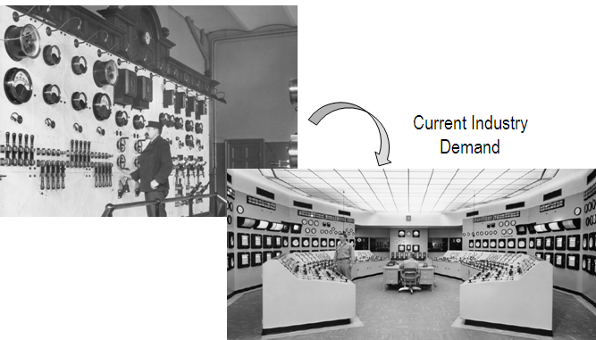

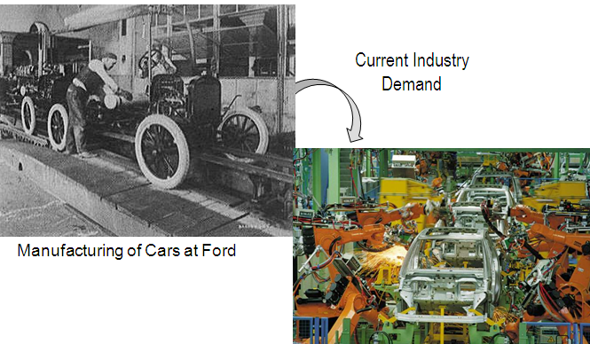

### Market Requirement

* Fast Delivery
* High Variety
* Rapid Product Launch
* High Quality
* Cut throat Competition
* Innovative Products

### Levels of Automation

1. Device level – actuators, sensors, and other hardware components to form individual control loops for the next level
2. Machine level – CNC machine tools and similar production equipment, industrial robots, material handling equipment
3. Cell or system level – manufacturing cell or system
4. Plant level – factory or production systems level
5. Enterprise level – corporate information

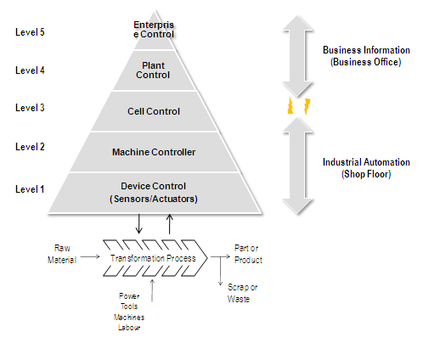

### Three Automation Types

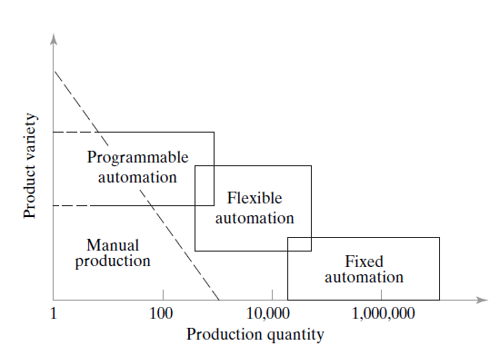

**Fixed Automation**

Sequence of processing (or assembly) operations is fixed by the equipment configuration

Typical features:

* Suited to high production quantities
* High initial investment for custom-engineered equipment
* High production rates
* Relatively inflexible in accommodating product variety

**Programmable Automation**

Capability to change the sequence of operations through reprogramming to accommodate different product configurations

Typical features:

* High investment in programmable equipment
* Lower production rates than fixed automation
* Flexibility to deal with variations and changes in product configuration
* Most suitable for batch production
* Physical setup and part program must be changed between jobs (batches)

**Flexible Automation**

System is capable of changing over from one job to the next with little lost time between jobs

Typical features:

* High investment for custom-engineered system
* Continuous production of variable mixes of products
* Medium production rates
* Flexibility to deal with soft product variety

**Basic Elements of Automated System**

* + Business functions - sales and marketing, order entry, cost accounting, customer billing
  + Product design - research and development, design engineering, prototype shop
  + Manufacturing planning - process planning, production planning, MRP, capacity planning
  + Manufacturing control- shop floor control, inventory control, quality control

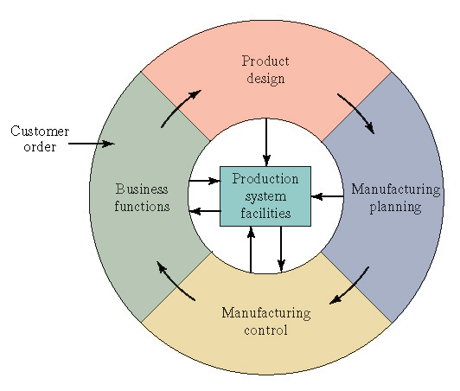

**Output**

**Input**

**Control/Process**

**Basic Elements of Automation**

* Sensors……………Flexible Input
* PLC/ DCS.……...…Flexible Controller
* Actuators…………..Flexible Output
  + Pneumatic System
  + Hydraulic System
  + Electrical System
  + Mechatronic System: Industrial Robot
* Communication Protocol

**Industrial automation** (IA) is an integrated, flexible and low-cost system platform that consists of various equipment and elements which perform a wide variety of functions like sensing, control, supervision and monitoring related to industrial processes. The figure below shows the structure of industrial automation which describes the various functional elements of IA.

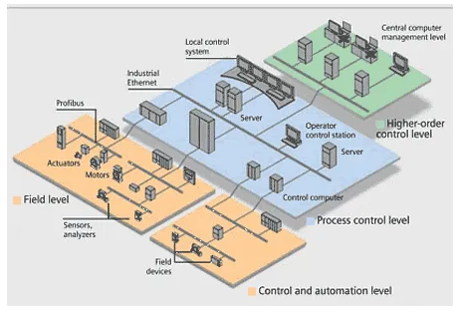

**Sensing and Actuating Elements**

The [sensors](https://www.electrical4u.com/sensor-types-of-sensor/) or sensing elements convert the physical process variables such as flow, pressure, temperature, etc. into electrical or pneumatic form. Various sensors include thermocouples, [Resistor Temperature Detectors](https://www.electrical4u.com/resistance-temperature-detector-or-rtd-construction-and-working-principle/) (RTDs), [strain gauges](https://www.electrical4u.com/strain-gauge/), etc. The signals from these sensors are used for processing, analyzing, and decisions in order to produce the control output. The various control techniques are implemented to produce the required output by comparing the current sensed process variable with set values. Finally, the controllers produce the computed outputs and are applied as electrical or pneumatic signal inputs to the actuating elements. Actuators convert the electrical or pneumatic signals to the physical process variables. Some of the actuators include control valves, relays, motors, etc.

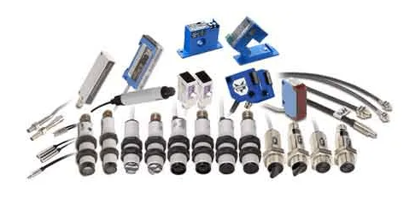

A special category of the instruments is smart instruments which are integrated systems of sensing or actuating elements with the capability of communicating with field buses. These smart devices consist of a signal conditioning circuit internally and facilitate connecting directly to the communication link in the industrial [bus system](https://www.electrical4u.com/electrical-bus-system-and-electrical-substation-layout/).

**Control System Elements**

These are the microprocessor-based electronic controllers or simply industrial computers that accept the signals from various [sensors](https://www.electrical4u.com/sensor-types-of-sensor/) as well as command signals from supervisory systems or from human operators. These controllers can be continuous control systems or sequential/logic control depends on the structure of control nature. The controller processes the sensing values and supervisory values and depends on the control structure, it produce the control output to various actuating devices.

A modern type of control device used in automation systems is the Programmable Logic Controller (PLC). PLCs come with dedicated software so that these are capable of being programmed to perform corresponding control operations. PLCs have rugged CPU, digital I/O, analog I/O and communication modules such that they can operate at industry environment conditions to control the various process parameters.

Human Machine Interface or operator interface is a graphical interface for the operators which displays the process information such as process variable status, logging results to the database, generating alarm signals, etc. SCADA is one of the graphical user interfaces which remotely controls the industrial operations. Also, Distributed control systems (DCS) provide their own HMI for the graphical display of various industrial parameters.

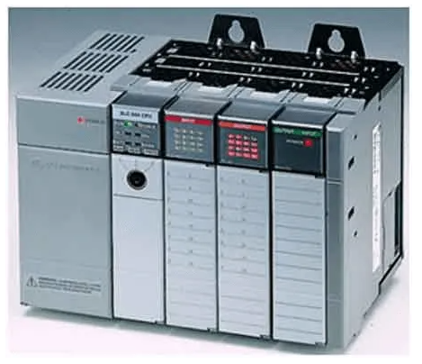

**Supervisory Control Elements**

Supervisory control performs higher level control over the automatic controllers which further controls the smaller subsystems. The major elements of this level are process station PCs, and Human Machine Interfaces. These process station PCs are responsible for functions like set point computations, performance monitoring, diagnostics, startup, shutdown, and other emergency operations.

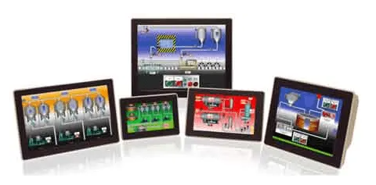

Human Machine Interface or operator interface is a graphical interface for the operators which displays the process information such as process variable status, logging results to the database, generating alarm signals, etc. SCADA is one of the graphical user interfaces which remotely controls the industrial operations. Also, Distributed control systems (DCS) provide their own HMI for the graphical display of various industrial parameters.

**Industrial Automation**

**Manufacturing Automation:**

* Automated machine tools
* Transfer lines
* Automated assembly systems
* Industrial robots
* Automated material handling and storage systems
* Automatic inspection systems for quality control

**Process Automation:**

* Flow Control
* Temperature Control
* Pressure Control etc.

**Types of Industrial Automation**

Industrial automation is the use of computer and machinery aided systems to operate the various industrial operations in a well-controlled manner. Depends on the operations involved, the industrial automation systems are majorly classified into two types, namely process plant automation and manufacturing automation.

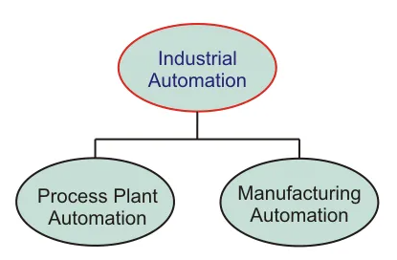

**Process Plant Automation**

In process industries, the product results from many chemical processes based on some raw materials. Some of the industries are pharmaceuticals, petrochemical, cement industry, paper industry, etc. Thus, the overall process plant is automated to produce the high quality, more productive, high reliable control of the physical process variables.

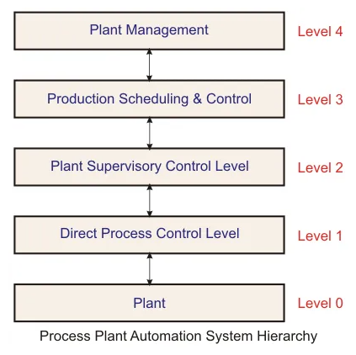

The above figure shows the process automation system hierarchy. It consists of various layers representing widespread components in a process plant.

Level 0 or Plant: This level consists of machines which are closest to processes. In this, [sensors](https://www.electrical4u.com/sensor-types-of-sensor/) and actuators are used to translate the signals from the machines and physical variables for the purpose of analysis and to produce the control signals.

Direct Process Control: In this level, automatic controllers and monitoring systems acquire the process information from sensors and correspondingly drives the actuator systems. Some of the tasks of this level are-

* Data acquisition
* Plant monitoring
* Dara checking
* Open and closed loop control
* Reporting

Plant Supervisory Control: This level commands the automatic controllers by setting the targets or set points. It looks after the control equipment for optimal process control. Some of the tasks of this level are:

* Plant monitoring performance
* Optimal process control
* Plant coordination
* Failure detection, etc.

Production Scheduling and Control: This level solves the decision-making problems like resource allocation, production target, maintenance management, and so on. Tasks of this level include:

* Production dispatch
* Inventory control
* Production supervision, production reporting, etc.

Plant Management: This is the higher level of the process plant automation. It deals more with commercial activities than technical activities. Tasks of this level include-

* Market and Customer analysis
* Orders and sale statistics
* Production planning
* Capacity and order balance, etc.

**Manufacturing Automation System**

The manufacturing industries make the product out of materials using machines/robotics. Some of these manufacturing industries include textile and clothing, glass and ceramic, food and beverages, paper making, etc. New trends in manufacturing systems have been using automation systems at every stage such as material handling, machining, assembling, inspection, and packaging. With the computer-aided control and industrial robotic systems, manufacturing automation becomes very flexible and efficient.

The figure below shows the manufacturing automation system hierarchy in which all functional levels are automated by using different automation tools.

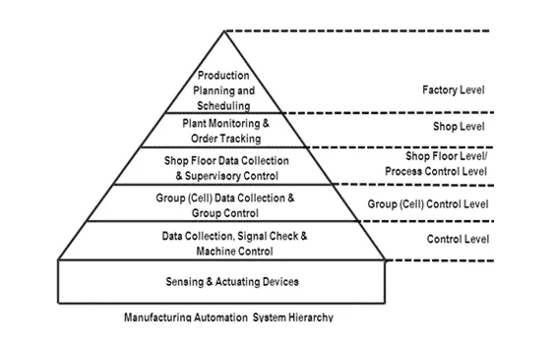

Below is an explanation of each level in the manufacturing automation system hierarchy:

Machinery Level: In this level various sensing and actuating devices controls the manufacturing process. It is an instrumentation level of machine control. Tasks of this level include data collection, signal check, and machine control.

Cell or Group Level: This is another automation level at which operation of a group of machines within manufacturing cells are co-ordinated. Various automated controllers like PLCs are employed for such control of machines.

Shop Floor Level: It is a supervisory automated level where supervision and coordination of several manufacturing cells are carried out.

Plant Level: This automation level performs the activities of production monitoring, control, and scheduling, etc. HMIs employed at this level facilitate to control all the manufacturing process variables remotely.

Enterprise Level: This level does all the management related activities such as production planning and scheduling, etc.

**Introduction to PLC**

**PLC Background**

A programmable logic controller is unit of hardware used to control and automate industrial processes. **P**rogrammable **L**ogic **C**ontrollers (PLCs) are often defined as miniature industrial computers that contain hardware and software that is used to perform control functions. The first PLC was developed to help General Motors eliminate traditional relay-based machine control systems. In large applications where thousands of relays exist, wiring and troubleshooting could be quite complicated.

In 1968 Bedford Associates, a company in Bedford, MA, developed a device called a Modular Digital Controller for General Motors. The MODICON, as it was known, was an electronic device, not a mechanical one, it was perfect for GM's requirements, as well as for many other manufacturers and users of control equipment. With less wiring, simpler troubleshooting, and easy programming, PLC technology caught on quickly. 

A PLC has three main aspects: the inputs and outputs and the control program. The inputs are connected to sensors that inform the PLC about the environment. The program uses a set of logical instructions that drives the outputs based on the inputs. The outputs are connected to the devices that need to be controlled. In figure, the PLC has eight inputs and four outputs.

There are two basic types of Programmable Logic Controllers: a single box type and a modular or rack type. The box type is smaller and used for simpler control situations. It is supplied as an integral compact package, compete with power supply, processor, memory and input output units. Some of the most basic of theses only have 4 outputs. They typically can have from 4 to 40 inputs and outputs. Box types PLCs have limited expansion capabilities.

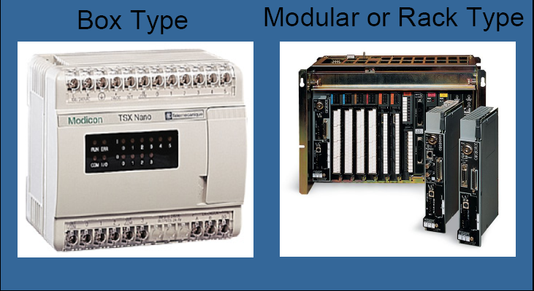

The modular type consists of a central rack that house various handpicked modules that are appropriate for each control situation. A large variety of modules exist that satisfy many needs such as power supplies, processors, analog input and outputs, digital input and outputs, and communications. I/O modules can always be added after the unit it installed to suit new needs. Power supplies can be upgrade to meet new power requirements. Also, the I/O modules can be much more specialized than that of the box type PLCs. For example, there are modules that serve as PID control or TTL logic inputs. Modular PLCs are used for larger and more complex operations. Typically, they have from 20 to 100 inputs and outputs and up.

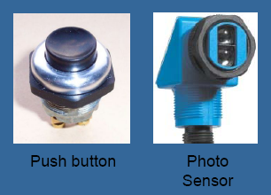 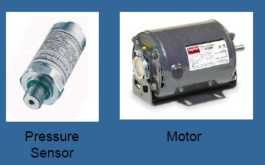

Control processes need devices to monitor events or measure needed values. These devices are generically called inputs to the PLC. For example, input devices can be proximity switches, photoelectric sensors, temperature sensors, push buttons, or pressure sensors. An input is anything that can sense the status of the environment and then convert that information in to a signal. Often the signal can simply be a voltage that is either on or off. Outputs are anything that would need to be controlled based on the inputs like motors, indicator lights, and fans, warning sirens or heating elements.

**Relay Control Example**

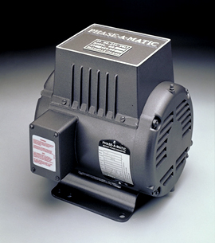

Often industrial equipment will use three phase power for various reasons such as cost, size and durability. Suppose some industrial woodworking equipment is installed at a residential home. In order to use the equipment, the normal two phase power into the house needs to be converted into three phase power via a converter. Some of the equipment is located in the garage and some in the basement. Therefore, the three phase power needs to be available at both locations. Consequently, the converter needs to have start and stop controls at both locations.

The converter has three contacts. Two are connected to the 220 VAC source. The other is connected to a starting capacitor and a push button. When the power is switched on nothing immediately happens. The 3-phase converter has a motor that needs to be started via a starting capacitor. After the motor has started only the 220 VAC source is required for continued operation. When 3-phase power is no longer needed, the process is stopped by disconnecting power.

However, this is only the basic concept of operation. The process should simply have one button for start and one button for stop at each location. This means that a timed relay will take the place of the momentary push button, and a relay latching system is need instead of a the power switch. In this way, the system can operate using push buttons.





A relay is a device that responds to a voltage change by activating a switch. When the input is energized with a voltage a current will flow thought the coil and cause it to become magnetized. Magnetic force will pull the contact close and thus close the circuit. When the input voltage taken away the magnet will de-activate and the contact will open again. A relay and a contactor basically serve the same function. The name contactor is simply used for high current.



Below is a picture of the main control box for the converter with the components labeled. This is how the control mechanism is put together without a PLC. The power switch and momentary push button have been replaced with start and stop buttons. The operational logic is performed by the start relay and a time delay relay.



Below is a block diagram that shows the manner in which each device is connected to each other. The wiring should look a little complex and confusing. The blocks in yellow represent ‘Relay logic’. The light blue blocks are output devices. The wiring would be much simpler with a PLC. The 2-pole contactor controls the power supply to the converter. The 1-pole contactor controls the starting capacitor. The Remote lamp is a indicator light at the remote location. When lit it indicate that the converter is operating



Below is a schematic of how devices would be connected if a PLC was used for control. Note how simple the wiring becomes. When using a PLC, physical wiring poses much less difficulty. Consequently, this helps avoid problems and speeds installation. The inputs are on the left and the outputs are on the right. Notice how the PLC took the place of two relays, the start relay and the timed relay. By replacing these two components the PLC has already almost paid for itself. Furthermore, by using a PLC additional timers, relays and other devices can be added for logical control at no cost.

One aspect that is not shown here is the program that the PLC must run to control the process correctly. At each point, an input and output are connected to the PLC there is an address. This address is used in the software to keep track of the different devices.



**PLC Process Example**



Suppose there is a process where there is a pressure build up. A solenoid is powered to keep a valve shut. Every time a pressure sensor is tripped, a solenoid is de-activated for 10 seconds. That in turn allows the valve to open and the pressure to be released. After 10 seconds, power is restored to the solenoid and the valve is closed. (A solenoid is another type of relay.) Also suppose that the process needs to count how many times the solenoid is de-activated. Without a PLC the process would follow the diagram above. The pressure sensor would feed information in a timer and a counter (two separate unites of hardware). But what if the process included 10 sensors and 10 solenoids? We’d need 10 timers and 10 counters. That’s a large amount of hardware that takes up room on the factory floor. Moreover, if a manual release button and other safety sensors were also needed, the situation can become complex and involve a large amount of hardware. If any one unit failed the whole system would have to be shut down, the fault found and then fixed. Before PLCs, however, this is how it was done.

Instead of a large amount of devices and the resulting complicated wiring, one piece of hardware, a PLC can take the place of all 20 timers and counters. It can simulate all the necessary logic within its programming. And if the PLC breaks, it is easily replaced.



PLCs replace all the wiring and individual pieces of hardware like counters, timers and relays. Before PLCs were used the wiring, configuring and troubleshooting all these components would often get very complicated. With a PLC, all wiring is done in software where it is drawn clearly and much easier to understand. This adds an additional benefit were if a change was needed to be made, no disconnecting of hardware would be required. No one would have to disconnect wires and move around hardware. That can be very time consuming and tedious. Only the PLC’s program would need to be updated and then loaded into the PLC’s memory.

**Typical PLC Applications**

PLCs are implemented in a variety of control operations from large to small. Carwashes are a popular use for PLCs because it involves intricate use of sensors and motors, but also has the need for relatively complex logic. Carwashes have several wash types that use or doesn’t use certain features. Each car wash can be a very unique and involved process, but it is greatly simplified when done in the PLC’s software as opposed to a hardware implementation.

PLCs are used for sorting packages on a conveyor by operating a diverter. One conveyor can move many types of packages. A sensor can detect a package type and a series of diverters can sort them at the end of the belt. In this way, one conveyor can be used instead of many. But the PLC is flexible, it can be reprogrammed if and when the sorting task changes or if enhanced operation is needed.

PLCs are used to operate greenhouse irrigations systems. It can be used to control how often and the amount of water distributed to certain areas. It can control a large amount of valves to certain areas and is flexible as the greenhouse’s needs change.

Lumber mills use PLCs to control the main saw and loading of wood while various sensors ensure safe operation so that people and equipment are not harmed. A lumber mill saw is very expensive and many precautions must be taken to ensure that nothing goes wrong when moving lumber through the mill.

PLCs can withstand the hash condition desert conditions while controlling an oil recovery process. Temperatures can get higher than 120 degrees Fahrenheit in the desert, yet a PLC can read sensors and control the motors necessary for oil extraction. These tiny computers are meant to be rugged.

**Basic PLC Structure**

A PLC has four major internal components. The CPU contains the microprocessor, registers, control clock and various other processing units. The memory contains user’s program, program data storage and PLC’s operating system. Some memory is ROM (read only memory) wish gives permanent storage for the operations system and fixed data for the CPU. Other memory is RAM (random access memory) which stores data for the user’s program and values of timers, counters and other internal devices. Often some of the PLC’s RAM has battery backups so that if the PLC’s power is unexpectedly turned off it can resume normal operation when the power is restored by referring to the battery backed bits. The input and outputs provides the interface between the system and the outside world. The PLC’s program is stored on EEPROM (electrically erasable programmable read-only memory) that is a permanent part of the PLC. As memory costs drop new types of memory such as flash are being used.

Inputs to, and outputs from, a PLC is necessary to monitor and control a process. Both inputs and outputs can be categorized into two basic types: logical or continuous. Consider the example of a light bulb. If it can only be turned on or off, it is logical control. If the light can be dimmed to different levels, it is continuous. Continuous values seem more intuitive, but logical values are preferred because they allow more certainty, and simplify control. As a result most controls applications (and PLCs) use logical inputs and outputs for most applications.

Here are some typical input voltage values for PLCs:

* 12-24 Vdc
* 100-120 Vac
* 10-60 Vdc
* 12-24 Vac/dc
* 5 Vdc (TTL)
* 200-240 Vac
* 48 Vdc
* 24 Vac

There are many trade-offs when deciding which type of input cards to use.

* DC voltages are usually lower and therefore safer (i.e., 12-24V).
* DC inputs are very fast, AC inputs require a longer on-time. For example, a 60Hz wave may require up to 1/60sec for reasonable recognition.
* DC voltages can be connected to larger variety of electrical systems.
* AC signals are more immune to noise than DC, so they are suited to long distances, and noisy (magnetic) environments.
* AC power is easier and less expensive to supply to equipment.
* AC signals are very common in many existing automation devices.

Outputs are often specified as being of relay type, transistor type or triac type. With relay type, the signal from the PLC output is used to operate a relay and so is able to switch currents of the order of a few amperes in an external circuit. Relay outputs are suitable for AC and DC switching. They can withstand high surge currents and voltage transients. The transistor type of output uses a transistor to switch current through the external circuit. This gives a considerable faster switching action. Triac outputs can be used to control external loads which are connected to the AC power supply. It is strictly for AC. operation.

Typical output voltages are listed below, and roughly ordered by popularity:

* 120 Vac
* 24 Vdc
* 12-48 Vac
* 12-48 Vdc
* 5Vdc (TTL)
* 230 Vac

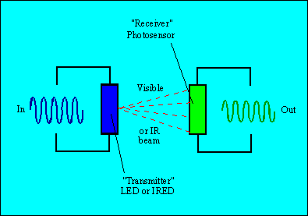The PLCs CPU is protected by Optoisolators. That is it is electrically isolated from its inputs and outputs. The Optoisolators uses a LED and photo sensor to convey voltage information. When a digital pulse passes through the LED, a pulse of infrared radiation is produced. This pulse is detected by the phototransistor and gives rise to a voltage in that circuit. The gap between the LED and the phototransistor give electrical isolation. This way if there is a large voltage spike, the PLC will not be damaged.

The terms sourcing and sinking are used to describe the way in which DC devices are connected to a PLC. An input or output said to be sourcing when it uses a PLC as its power source. PLCs often provide power for the output devices connected to it. An input or output said to be sinking when it provides its own power for operation. Often sensors are used as sinking inputs. When discussing sourcing and sinking we are usually referring to the output of the sensor that is acting like a switch. In fact, the output of the sensor is normally a transistor that will act like a switch (with some voltage loss). A PNP transistor is used for the sourcing output, and an NPN transistor is used for the sinking input. When discussing these sensors the term sourcing is often interchanged with PNP, and sinking with NPN.

Some PLC haves communications inputs and outputs. This can be serial or parallel cables or even the ability to communicate on an Ethernet. Is useful in large controls situations where many PLCs in remote locations are controlled by one master PLC.

**Basic PLC Operation**

A PLC works by continuously running a program that checks the inputs and then updates the outputs. The process of the PLC running thought its program is called scanning. Scanning speed depends on the program size and execution time. The total time for a PLC to check the inputs, run the program and update the outputs is called the cycle time. Typical cycle times are 10 ms to 100 ms. Every cycle the inputs are check and saved to memory. Then the program is run using the status of the saved inputs. After the program is done the outputs are updated and the cycle starts again.

**Introduction to SCADA Systems**

Supervisory control and data acquisition (SCADA) is a system of software and hardware elements that allows industrial organizations to:

* Control industrial processes locally or at remote locations
* Monitor, gather, and process real-time data
* Directly interact with devices such as sensors, valves, pumps, motors, and more through human-machine interface (HMI) software
* Record events into a log file

SCADA systems are crucial for industrial organizations since they help to maintain efficiency, process data for smarter decisions, and communicate system issues to help mitigate downtime.

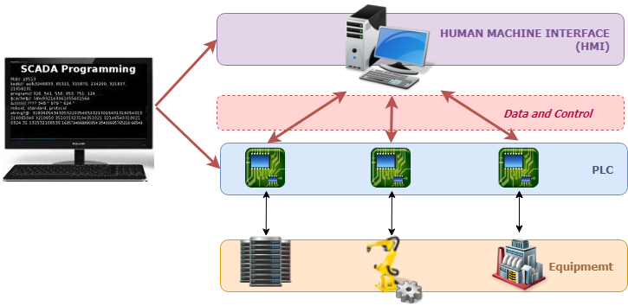

The basic SCADA architecture begins with programmable logic controllers (PLCs) or remote terminal units (RTUs). PLCs and RTUs are microcomputers that communicate with an array of objects such as factory machines, HMIs, sensors, and end devices, and then route the information from those objects to computers with SCADA software. The SCADA software processes, distributes, and displays the data, helping operators and other employees analyze the data and make important decisions.

For example, the SCADA system quickly notifies an operator that a batch of product is showing a high incidence of errors. The operator pauses the operation and views the SCADA system data via an HMI to determine the cause of the issue. The operator reviews the data and discovers that Machine 4 was malfunctioning. The SCADA system’s ability to notify the operator of an issue helps him to resolve it and prevent further loss of product.

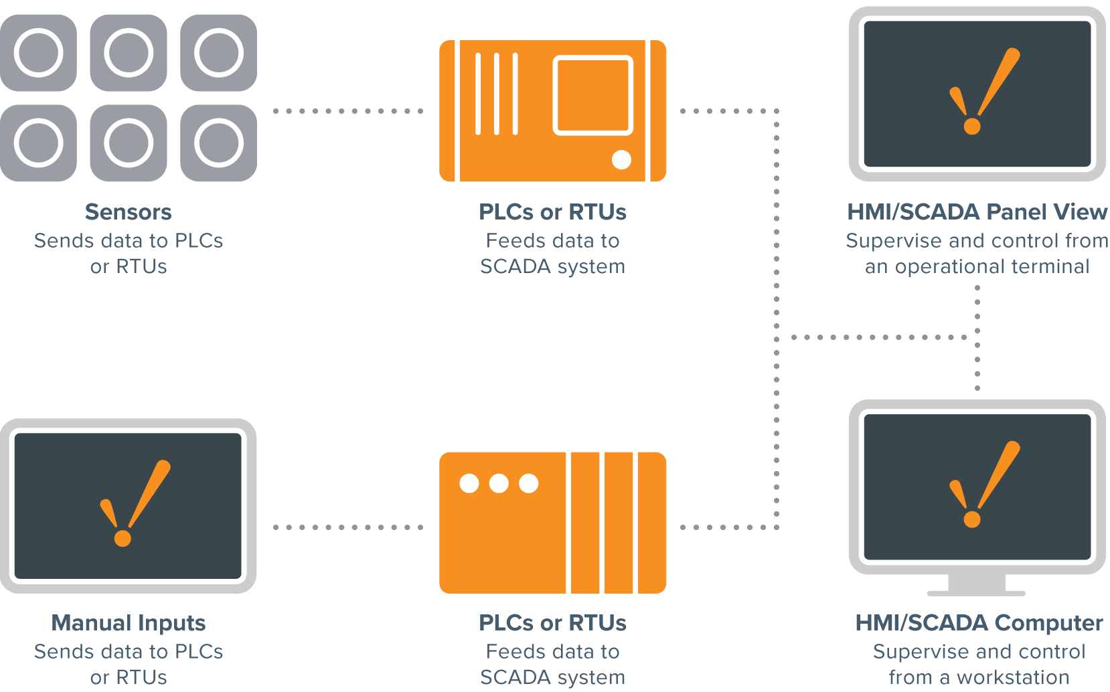

**Who Uses SCADA?**

SCADA systems are used by industrial organizations and companies in the public and private sectors to control and maintain efficiency, distribute data for smarter decisions, and communicate system issues to help mitigate downtime. SCADA systems work well in many different types of enterprises because they can range from simple configurations to large, complex installations.

SCADA systems are the backbone of many modern industries, including:

|  |  |  |
| --- | --- | --- |
| * Energy * Food and beverage * Manufacturing | * Oil and gas * Power * Recycling | * Transportation * Water and waste water * And many more |

Virtually anywhere you look in today's world, there is some type of SCADA system running behind the scenes: maintaining the refrigeration systems at the local supermarket, ensuring production and safety at a refinery, achieving quality standards at a waste water treatment plant, or even tracking your energy use at home, to give a few examples.

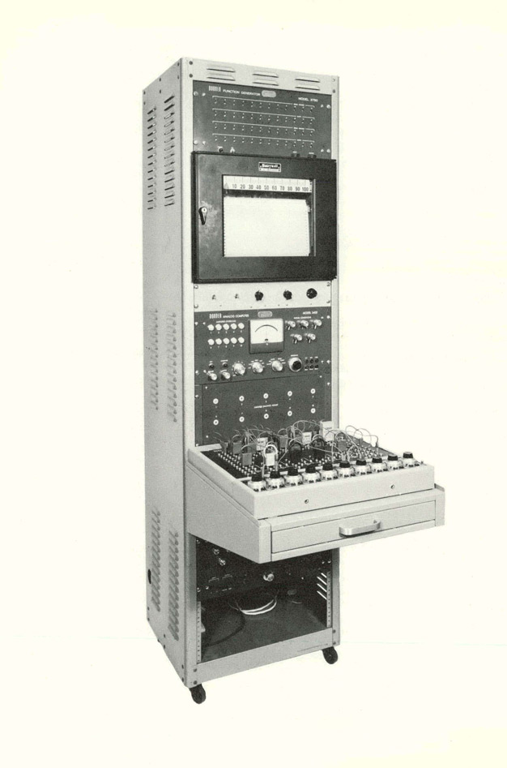Effective SCADA systems can result in significant savings of time and money. Numerous case studies have been published highlighting the benefits and savings of using a modern SCADA software solution such as Ignition.

**The Birth of SCADA**

To understand the origins of SCADA, we must understand the problems industrial organizations are trying to solve. Before the concept of SCADA was introduced in the mid-20th century, many manufacturing floors, industrial plants, and remote sites relied on personnel to manually control and monitor equipment via push buttons and analog dials.

As industrial floors and remotes site began to scale out in size, solutions were needed to control equipment over long distances. Industrial organizations started to utilize relays and timers to provide some level of supervisory control without having to send people to remote locations to interact with each device.

While relays and timers solved many problems by providing limited automation functionality, more issues began to arise as organizations continued to scale out. Relays and timers were difficult to reconfigure, fault-find and the control panels took up racks upon racks of space. A more efficient and fully automated system of control and monitoring was needed.

In the early 1950s, computers were first developed and used for industrial control purposes. Supervisory control began to become popular among the major utilities, oil and gas pipelines, and other industrial markets at that time. In the 1960s, telemetry was established for monitoring, which allowed for automated communications to transmit measurements and other data from remotes sites to monitoring equipment. The term “SCADA” was coined in the early 1970s, and the rise of microprocessors and PLCs during that decade increased enterprises’ ability to monitor and control automated processes more than ever before.

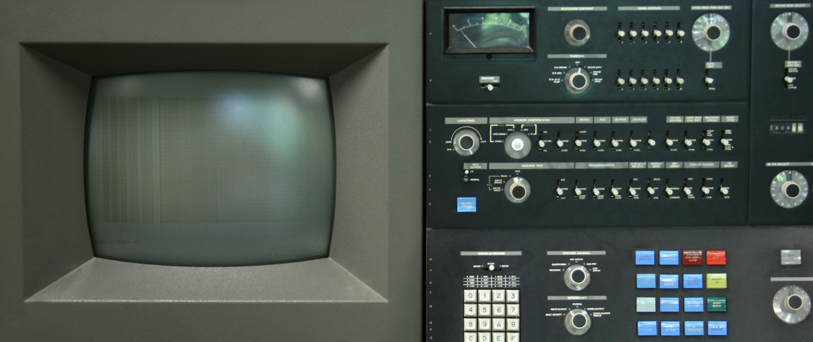

**The Evolution of SCADA**

The first iteration of SCADA started off with mainframe computers. Networks as we know them today were not available and each SCADA system stood on its own. These systems were what would now be referred to as monolithic SCADA systems.

In the 80s and 90s, SCADA continued to evolve thanks to smaller computer systems, Local Area Networking (LAN) technology, and PC-based HMI software. SCADA systems soon were able to be connected to other similar systems. Many of the LAN protocols used in these systems were proprietary, which gave vendors control of how to optimize data transfer. Unfortunately, these systems were incapable of communicating with systems from other vendors. These systems were called distributed SCADA systems.

In the 1990s and early 2000s, building upon the distributed system model, SCADA adopted an incremental change by embracing an open system architecture and communications protocols that were not vendor-specific. This iteration of SCADA, called a networked SCADA system, took advantage of communications technologies such as Ethernet. Networked SCADA systems allowed systems from other vendors to communicate with each other, alleviating the limitations imposed by older SCADA systems, and allowed organizations to connect more devices to the network.

While SCADA systems have undergone substantial evolutionary changes, many industrial organizations continued to struggle with industrial data access from the enterprise level. By the late 1990s to the early 2000s, a technological boom occurred and personal computing and IT technologies accelerated in development. Structured query language (SQL) databases became the standard for IT databases but were not adopted by SCADA developers. This resulted in a rift between the fields of controls and IT, and SCADA technology became antiquated over time.

Traditional SCADA systems still use proprietary technology to handle data. Whether it is a data historian, a data connector, or other means of data transfer, the solution is messy and incredibly expensive. Modern SCADA systems aim to solve this problem by leveraging the best of controls and IT technology.

**Modern SCADA Systems**

Modern SCADA systems allow real-time data from the plant floor to be accessed from anywhere in the world. This access to real-time information allows governments, businesses, and individuals to make data-driven decisions about how to improve their processes. Without SCADA software, it would be extremely difficult if not impossible to gather sufficient data for consistently well-informed decisions. Also, most modern SCADA designer applications have rapid application development (RAD) capabilities that allow users to design applications relatively easily, even if they don't have extensive knowledge of software development.

The introduction of modern IT standards and practices such as SQL and web-based applications into SCADA software has greatly improved the efficiency, security, productivity, and reliability of SCADA systems. SCADA software that utilizes the power of SQL databases provides huge advantages over antiquated SCADA software. One big advantage of using SQL databases with a SCADA system is that it makes it easier to integrate into existing MES and ERP systems, allowing data to flow seamlessly through an entire organization.

Historical data from a SCADA system can also be logged in a SQL database, which allows for easier data analysis through data trending.

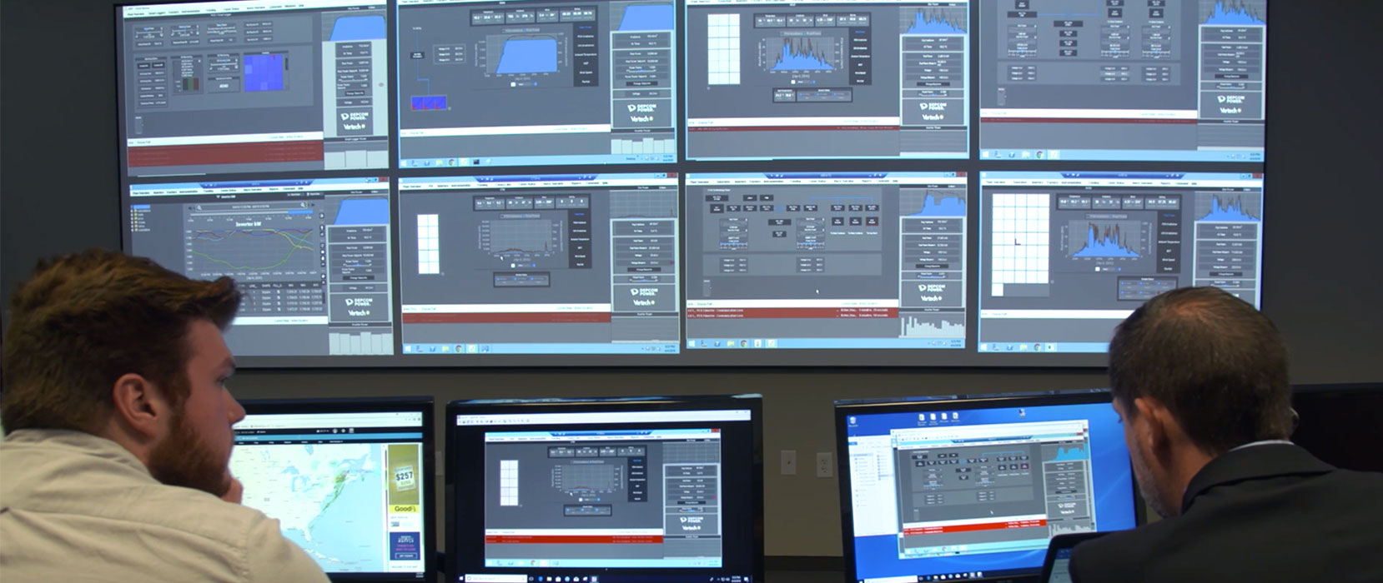

# **Modbus and Profibus**

Modbus, a [serial communication](https://instrumentationtools.com/serial-communication-interview-questions-answers/) protocol developed by Modicon in 1979. It is developed by  Modicon for PLC in industrial applications, now it an open protocol. It is used over serial and Ethernet cable.

It is easy to implement and also easy to use. The term Modbus typically refers to one of three variants.

1. Modbus ASCII.
2. Modbus RTU
3. Modbus TCP/IP.

### Modbus RTU:

This is used in serial communication. Makes use of compact, binary representation of data for protocol communication.

### Modbus ASCII:

This is used in serial communication, makes use of ASCII characters for protocol communication.

### Modbus TCP/IP:

This is used for communication over [TCP/IP](https://instrumentationtools.com/difference-tcpip-model-osi-model/) networks.

Modbus is often used to connect the supervisory computer with an RTU in the [SCADA](https://instrumentationtools.com/features-of-scada/) system.

## Modbus

Modbus RTU is the most popular protocol, use three physical media.

* RS 232,
* RS 485,
* RS422.

#### Point to Point Communication

RS 232 is a point to point communication. One device to one device can be connected and the distance between two devices is 50 feet (15 meters) then RS 232 does the job.

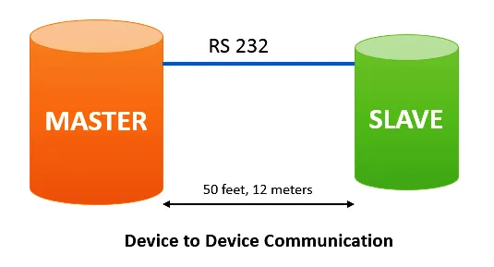

#### Multidrop Communication

To connect more devices on the same line, and have a distance greater than 50 feet, one can use RS 485, or RS422. This standard supports 32 nodes over 4000 feet( roughly 1200 meters).

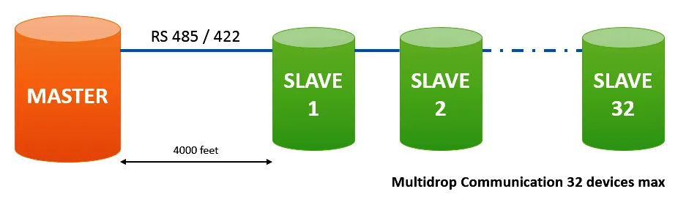

## Profibus

**PROFIBUS**is a young athlete, lean and fast. As with the Modbus, there are a number of variants associated with Profibus.

* PROFIBUS PA,
* PROFIBUS DP,
* PROFIBUS FM
* PROFINET,
* PROFISAFE.

[Profibus](https://instrumentationtools.com/what-is-hart-foundation-fieldbus-profibus/) ( Process Fieldbus) is one of the standards for field bus communication in automation technology.

PROFIBUS is also a Master/Slave protocol. But with additional token ring protocol to allow multiple masters as shown in the figure below.

PROFIBUS has certain protocol features that let certain versions of it operate in multi-master on RS 485 which Modbus could be the only a single master.

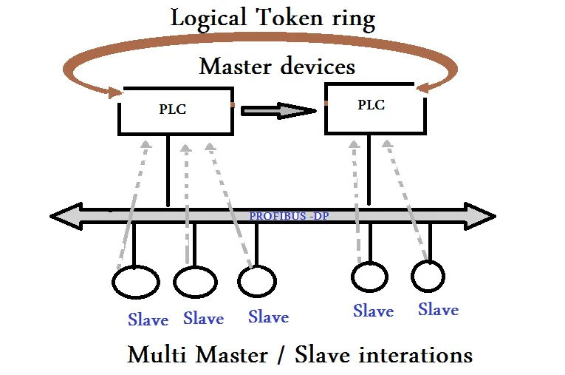

### Profibus DP

PROFIBUS DP (DP-Decentralized Peripherals) is used in machine automation and other discrete signal applications.

### Profibus PA

PROFIBUS PA (PA- Process automation) is used in process control applications. It connects to [PLC](https://instrumentationtools.com/step-by-step-guidelines-for-downloading-free-plc-software/) by Profibus-DP through a segment coupler as shown in the figure below.

**UNIT 2**

* **Relay Circuits:**

Construction & Principle of Operation, Types of Relays, Relay as a memory element, Contactor Circuits, Advantages of Contactors over Relay, DOL circuit implementation using contactor, Automation problems based on relays.

* **PLC Introduction:**

History and Current Trends, Basic Block Diagram of PLC, Classification of PLCs.

**Relay Definition**

Relays are a fundamental device for switching an electrical circuit on or off, much like a toggle switch or a [limit switch](https://library.automationdirect.com/what-is-a-limit-switch/). But a relay is operated based on an electrical control signal, as opposed to a toggle switch that is operated by a human hand, or a limit switch triggered by equipment contact. This blog post covers why relays are used, how they work, the terminology involved, some various relay features and where relays are used.

**Why are Relays Used?**

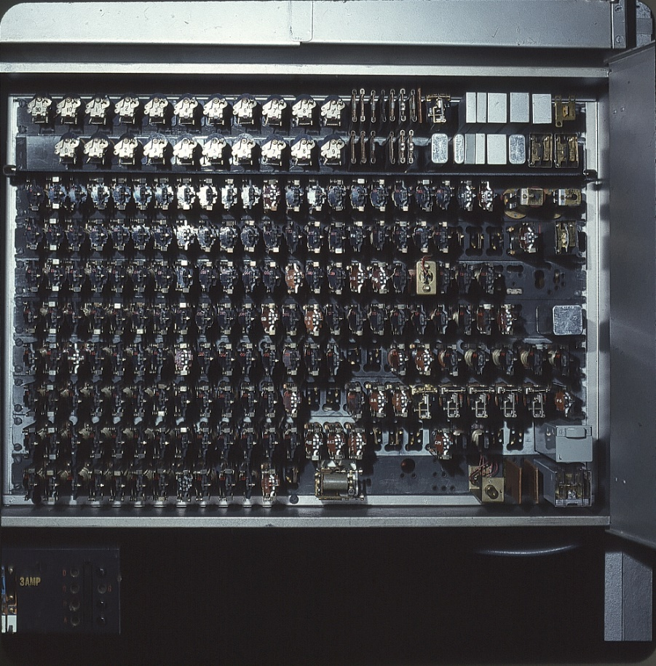

Large relay panels were used to control complex systems like elevators.

The main reason for using relays is so that separate circuits, often operating at higher voltages and currents, can be switched on and off by much lower power control circuits, such as the digital outputs (DOs) of a programmable logic controller (PLC). Small on/off control circuits are effectively *amplified* to operate large on/off power circuits (Figure 1). The control circuit and the power circuit can be completely different voltages and remain *isolated* from each other.

A more heavy-duty kind of relay, called a [contactor](https://library.automationdirect.com/what-is-a-contactor/), is used to switch larger loads, such as motors.

Another reason for using relays is to assemble logical circuits for performing other functions. For instance, three relay contacts wired in series produces the result of “Relay1 AND Relay2 AND Relay3”. This result can be used to activate a light or relay when all three relay contacts are closed, for instance. Old elevators and many other types of control panels were effectively programmed by hard-wiring hundreds of relays and timers (Figure 1).

Today, however, most systems like this are automated with PCs or PLCs performing the logic and driving relays interfacing with higher powered equipment. Hence many refer to relays as an *interface relay*s or *interposing relays*. It is very common to use relays in automation equipment to isolate and protect the digital control system.

**How Do Relays Work?**

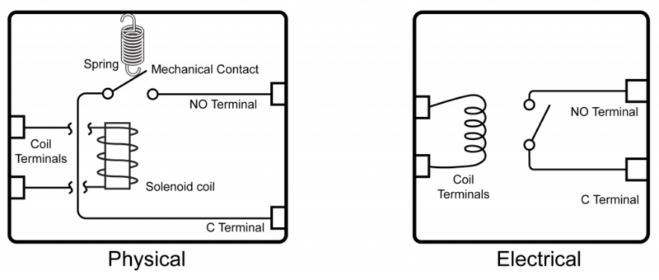

Electro-mechanical relays use a small electrical control signal to shift contacts operating a separate circuit.

Common relays are electro-mechanical devices. They have an electric solenoid coil which is on the “control” side of the circuit. When this is energized, it moves the mechanical contacts on the “load” side from off to on.

Another popular style is solid-state relays. These electronic devices use semiconductors to act as contacts. Since there are no physically moving parts, they can operate very quickly.

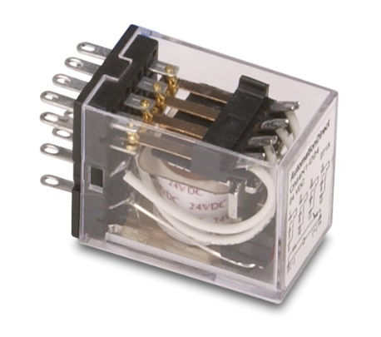

Small electro-mechanical control relays are often called ice-cube relays.

There are also other specialty types like latching, mercury-switched, reed, and thermal relays.

**Electrical Ratings**

Relay coils are rated to operate at a certain voltage and will draw a specified current when energized. The *pickup voltage* is the minimum voltage that will energize the relay, often about 80% of rated voltage. The *dropout voltage* is the voltage below which an energized relay will de-energize. An energized relay may be called *pulled-in*. Some relays may be rated with a higher *inrush* current to energize them, but a lower *holding* current once pulled-in.

Contacts are also rated for various voltages and currents, and this high-power side must be carefully matched to the load. When contacts are completely isolated from the coils, which is usually the case, they may be called *dry contacts*. Sometimes the external voltage connected to a dry contact is called a *wetting voltage*.

**AC vs DC Relays**

Coils can be AC or DC voltage and must be selected to match the available control circuit voltage. The AC versions are not polarity-sensitive, but the DC versions are, meaning positive and negative must be wired to the right connections. Some AC versions may experience *hum* or slight noise when energized.

Contacts are also rated for AC or DC voltage and must be selected to match the load. A special concern is that contacts must be able to quench the electrical arc that forms as the contacts are opened. Designers will find it much easier to select relays for switching AC loads than DC. This is because AC power cycles through zero volts and therefore the arc is more readily quenched. Since DC power is at a constant voltage, the arc is more likely to sustain.

Relay contacts have provisions for switching the rated current through millions of operations. Contacts for switching high current use special metals and designs to quench arcing. Contacts for switching very low voltages and currents may be gold-plated. A contact uses some kind of mechanical wiping action to clean itself and protect against corrosion and oxidation.

**Relay Contacts**

Relay contact connections are exposed on *pins* or *terminals*. These terminals may have other designations, but are usually called *normally open (N.O.)*, *normally closed (N.C.)*and *common (C)*. There are three main forms of relay contacts, which define how the continuity operates at the terminals:

* Form A, N.O., make contacts, when energized, passes power between C and N.O. terminals
* Form B, N.C., break contacts, when energized, interrupts power between C and N.C. terminals
* Form C, N.O./N.C., changeover or transfer contacts (three terminals), when energized, passes power between C and N.O. terminals and interrupts power between C and N.C. terminals

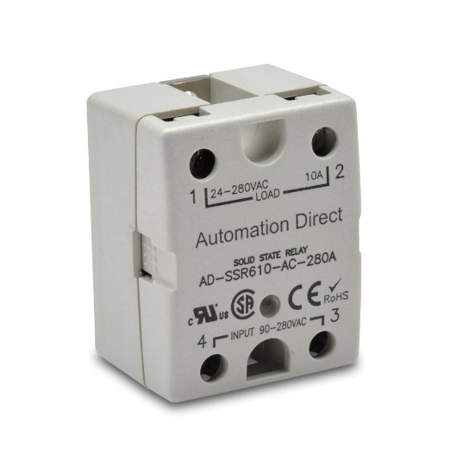

Solid-state relays have no moving parts and very fast switching times.

Relays can have many different contact arrangements and quantities. The term *pole* refers to how many isolated contacts a relay has, the most common being single-pole (SP) and double-pole (DP). The term throw indicates if a contact is Form A or B which would be single-throw (ST), or Form C which would be double-throw (DT). The most common configurations one would see on a specification sheet are:

* SPST
* SPDT
* DPST
* DPDT
* 3PDT
* 4PDT

When contacts are first energized closed, they sometimes *bounce* off and then back on briefly. This is imperceptible under most conditions, but on sensitive control and logic circuits this extra action can cause timing problems. Most contacts are simply on/off, but there are some special contacts called make-before-break and break-before-break that are mechanically arranged to perform those actions.

**Special Relays**

Basic relays are simply on/off devices, and they *fail off* to the off position when de-energize. However, a relay may be *bistable* or *latching*, which means it alternates when the coil is pulsed and then stays in that position until the next pulse shifts it the other way. These relays *fail last* in the last position. There are also relays with built-in functions like *timer, on-delay, off-delay* or *pulsing* functions. Sometimes these functions are mechanical, but more commonly they employ digital electronics. Some *smart relays* can perform functions similar to tiny programmable PLCs.

**Relay Installation**

Relays can have screw terminals, pigtail wires or be soldered into place. Older style relays and higher-current designs may be *open* with exposed energized parts. Newer and smaller designs are typically *touch-safe*, so users are less likely to come in contact with energized parts. For most industrial applications, a relay is used with a corresponding *socket*, which can be screwed into equipment or clipped on to a DIN rail. The socket is hardwired into place, and the relay can be easily removed and replaced. There are many socket sizes and formats, with two popular styles being *blade* and *octal pin*. Smaller control relays are often called *ice-cube* relays due to their size and shape resembling a cube of ice.

**Relay Options**

Depending on the need, relays are available with many options like:

* LED/neon indicator light
* Mechanical indicator flag
* Mechanical push-to-test button
* Diode or surge suppression protection
* Hold down clip for retaining relay in the socket

**Design Considerations**

Designers need to ensure the relay control circuits are compatible with selected relay coils, which usually means ensuring that a PLC DO has enough current to energize the relay. They also need to make sure that the contacts are suitable for all operating conditions. Relay coils consume power and generate heat in operation. Therefore, designers must calculate the heat load due to relays and allow for it.

Specifying surge suppression is key when interfacing a PLC to a relay. Without suppression, PLC discrete output points on the output card can be damaged by the spike created when the relay deenergizes.

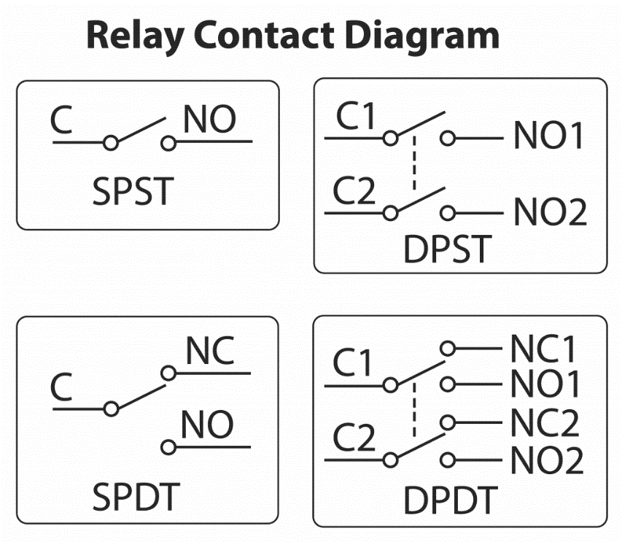

This diagram shows the connections for several types of relay contacts.

**Classification of Relays**

[Types of Relays](https://www.electronicshub.org/classification-of-relays/#Types_of_Relays)

* + [Latching Relays](https://www.electronicshub.org/classification-of-relays/#Latching_Relays)
  + [Reed Relay](https://www.electronicshub.org/classification-of-relays/#Reed_Relay)
  + [Polarized Relay](https://www.electronicshub.org/classification-of-relays/#Polarized_Relay)
  + [Buchholz Relays](https://www.electronicshub.org/classification-of-relays/#Buchholz_Relays)
  + [Overload Protection Relays](https://www.electronicshub.org/classification-of-relays/#Overload_Protection_Relays)
  + [Solid State Relays (SSRs)](https://www.electronicshub.org/classification-of-relays/#Solid_State_Relays_SSRs)
  + [Inverse Definite Minimum Time Relays (IDMT Relays)](https://www.electronicshub.org/classification-of-relays/#Inverse_Definite_Minimum_Time_Relays_IDMT_Relays)
  + [Differential Relays](https://www.electronicshub.org/classification-of-relays/#Differential_Relays)

**Introduction**

A Relay is a type of Switch which can switched ON or OFF with the help of a signal or a pulse of electricity. For example, if you want to turn ON or OFF and LED using a Microcontroller, you can probably connect the LED directly to the IO pin of the Microcontroller (with a current limiting resistor) and send a signal to, well, turn the LED ON or OFF.

But what if you want to turn ON or OFF a 10W mains powered LED Bulb using a Microcontroller? As the LED is a tiny device with small voltage and current requirements (which are reasonable for the Microcontroller), it is connected directly to the IO Pin of the Microcontroller.

**Types of Relays**

There are different types of relays like:

* Electromagnetic Relays
* Latching Relays
* Electronic Relays
* Non-Latching Relays
* Reed Relays
* High-Voltage Relays
* Small Signal Relays
* Time Delay Relays
* Multi-Dimensional Relays
* Thermal Relays
* Differential Relays
* Distance Relays
* Automotive Relays
* Frequency Relays
* Polarized Relays
* Rotary Relays
* Sequence Relays
* Moving Coil Relays
* Buchholz Relays
* Safety Relays
* Supervision relays
* Ground Fault Relays

All these and many other relays are classified based on their function, application type, configuration or structural features, etc. Now, let us take a look at various types of relays, which are more popularly used in many applications.

**Latching Relays**

A Latching Relay is a relay which maintains its state after being actuated. That is why these types of relays are also called as Impulse Relays or Keep Relays or Stay Relays. In applications, where there is a need to limit the power consumption and dissipation, a latching relay is best suitable. There is an internal magnet in a latching relay. When the current is supplied to the coil, it (internal magnet) holds the contact position and hence it requires no power to maintain its position. So, even after being actuated, removal of drive current to the coil cannot move the contact position but remains in its last position. Thus, considerable energy is saved by these relays.

[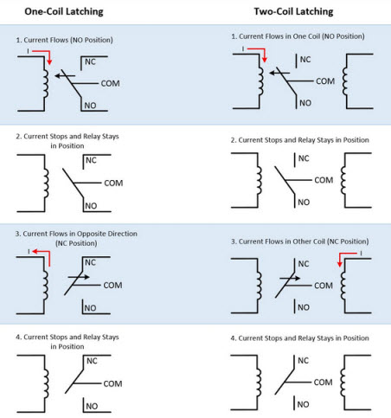](https://www.electronicshub.org/wp-content/uploads/2015/06/Latching-relays.jpg)

Latching relays can be made with one or two coils and these coils are responsible for the position of the armature of the relay. Hence, latching relays don’t have any default position as shown in above figure.

In one coil type relay, the armature position is determined by the direction of current flow in the coil, whereas in case of two coil type, the position of the armature is dependent on the coil in which current flows. These relays can maintain their position once they are actuated but their reset position depends on the control circuitry.

**Reed Relay**

Similar to the electromechanical relays, reed relays also produce the mechanical actuation of physical contacts to open or close a circuit path. However, compared with electromagnetic relays these relay contacts are much smaller and have low mass. These relays are designed by coils wounded around a reed switch. The reed switch of the relay acts as armature and it is a glass tube or capsule filled with an inert gas within which, two overlapping reeds (or ferromagnetic blades) are hermetically sealed.

The overlapping ends of a reed consist of contacts so that input and output terminals can be connected to them. When the power is supplied to the coils, a magnetic field is produced. These fields cause reeds to drawn together, thereby their contacts make a closed path through the relay. Also, during de-energizing process of the coil, reeds are separated apart by the pulling force of spring attached to it.

[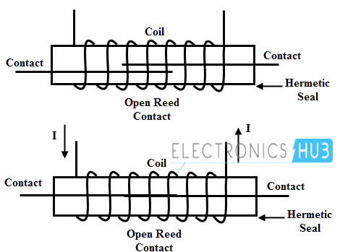](https://www.electronicshub.org/wp-content/uploads/2015/06/Reed-relay.jpg)

The switching speed of the reed relay is 10 times more than an electromechanical relay due to the less massive, different actuating medium and smaller contacts. However, these relays suffer from electrical arcing due to smaller contacts.

In the event of switching arc jumps across the contacts, the contact surface will melt over a small section. Further, this leads to the welding of the contacts if both contacts are still closed. Thus, even after the de-magnetization of the coil, spring force may not sufficient to separate them. It is an undesirable condition of the relay. This problem can be overcome by placing series impedance like a resistor or ferrite between the relay and system capacitance so that inrush currents are reduced thereby avoiding any arcing in the relay. Many switching applications use the reed relay due to the small size and high speed.

**Polarized Relay**

As the name indicates, these relays are very sensitive to the direction of current by which it is energized. It is a type of DC electromagnetic relay provided with an additional source of permanent magnetic field to move the armature of the relay. In these relays, magnetic circuit is built with permanent magnets, electromagnets and an armature.

Instead of spring force, these relays use magnetic forces to attract or repel the armature. In this, the armature is a permanent magnet, pivoted between the pole faces formed by an electromagnet. When the current flows through the electromagnet, it produces a magnetic flux.

[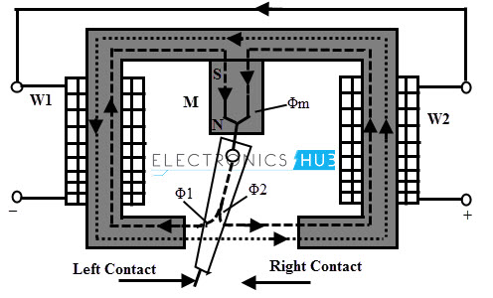](https://www.electronicshub.org/wp-content/uploads/2015/06/Polarized-Relay.jpg)Whenever the force exerted by the electromagnet exceeds the force exerted by permanent magnet, the armature changes its position. Similarly, when the current is interrupted, the electromagnetic force is reduced to less than that of permanent magnet and hence armature returns to its original position.

The magnetic flux Φm produced by the permanent magnet passes through the armature branches into two parts namely Φ1 and Φ2. The flux Φ1 passes through the left working gap of the magnet, while Φ2 passes through the right working gap of the magnet. If there is no current in the coil, the armature will stay either at left or right of the neutral position due to these two fluxes, since neutral is not stable in such magnetic systems.

Whenever a current is supplied to the coils of the relay, an additional working magnetic flux Φ passes through the working gap of the magnet. Due to these magnetic field interactions, a force exerts on the armature, which depends on the magnitude of the current, initial position of the armature, polarity of the current, power of the magnet and the value of the working gap. Depending on the combination of these parameters, the armature of the relay turns to a new stable state thereby closes the right contact and hence the relay picks up.

There are different types of polarized relays depending on the magnetic circuit configuration. The two most popular types of these relays include differential and bridge type relays. In differential magnetic system, the difference of two fluxes of permanent magnet acts on the armature. In bridge type magnetic system, the field created by the coils divided into two fluxes which have opposite signs in the working gap area but the magnetic flux of the permanent magnet is not divided into two fluxes. For normal size relays differential type of magnetic system is widely used.

**Buchholz Relays**

[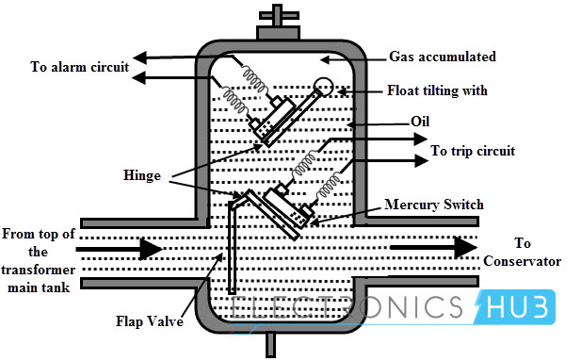](https://www.electronicshub.org/wp-content/uploads/2015/06/Buch.jpg)These relays are gas operated or actuated relays. These relays are used to detect incipient faults (or internal faults which are minor faults initially but in due course of time they turn into major faults). These are most widely used for transformer protection and are accommodated in the chamber in between the transformer tank and conservator. These are used only for oil immersed relays that are majorly employed for power transmission and distribution systems.

The figure above shows the operating principle of Buchholz relay. When incipient faults (or slow developing faults) occur inside the transformer, the oil level falls because of gas accumulation. This causes the hollow float to tilt and hence the mercury contacts are closed. These mercury contacts complete the path of the alarm circuit so that operator knows that there is some incipient fault occurred in the transformer.

Whenever a severe fault takes place in the transformer, such as a short circuit of phases or earth fault, etc., the pressure inside the tank is abruptly increased due to the fast reduce level of the oil. Thus, the oil is rushed towards the conductor and due to this, the lower side flap valve gets deflected. So, it closes mercury switch contacts thereby trip circuit is enabled. The transformer is then disconnected from the supply source.

**Overload Protection Relays**

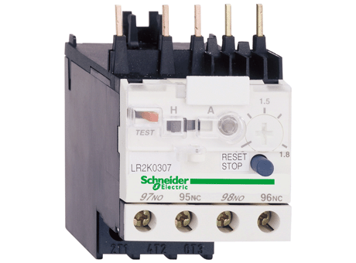Overload protection relays are specially designed to provide the overcurrent protection of electrical motors and circuits. These overload relays can be of different types such as fixed bimetallic strip type, electronic or interchangeable heater bimetallic, etc. If the electric motors are overloaded, then the motors are needed to be protected from overcurrent. For this purpose, overload sensing equipment, such as heat operated relay is used. Heat operated relay consists of a coil that heats up bimetallic strip or solder pot melts and thus, releases the spring for operating auxiliary contacts which are in series with the coil. The coil gets de-energized by sensing excess current in the load due to overload.

The temperature of the motor winding can be estimated using the motor armature thermal model, electronic overload protection relay by measuring motor current. Thus, motor can be accurately protected using overload protection relay.

**Solid State Relays (SSRs)**

Solid state relays use solid state components such as BJTs, thyristors, IGBTs, MOSFETs and TRIACs to perform the switching operation. The power gain of these relays is much higher than the electromechanical relays because the control energy required (to power the control circuit) is much lower compared with power to be controlled (switching output) by these relays. These relays can be designed to work for both AC and DC supply. Due to the absence of mechanical contacts, these relays have high switching speeds. A SSR consist of a sensor which is also an electronic device and this sensor responds to a control signal in order to switch on or off the power to the load.

SSRs are classified into different types, however major types of these relays include photo-coupled SSRs and transformer coupled SSRs. In transformer coupled SSR, a small DC current is supplied to the primary of the transformer through a [DC to AC converter](https://www.electronicshub.org/12v-dc-220v-ac-converter-circuit/). This current is then converted to AC and stepped-up to operate the solid-state device (TRIAC in this case) as well as triggering circuit. The degree of the isolation between the input and output depends on the design of the transformer.

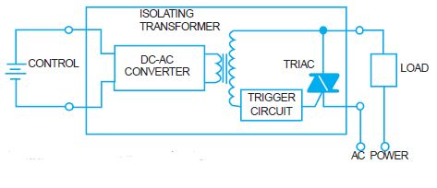

In case of photo coupled SSRs, photosensitive semiconductor device is used for performing the switching operation. The control signal is applied to the LED so that photosensitive device turns into conduction mode by detecting the light emitted from LED. The isolation provided by this type of SSR is relatively high compared with transformer coupled SSR due to the photo detection principle.

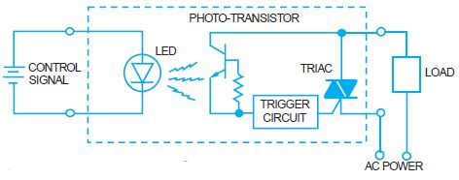

Solid state relays have faster switching speeds as compared with electromechanical relays. Also due to no moving parts, its life expectancy is higher and they tend to produce very less noise.

**Inverse Definite Minimum Time Relays (IDMT Relays)**

This type of relay gives a definite-time current characteristic at higher values of the fault current and an inverse time current characteristic at lower values of the fault current. These are widely used for protection of distribution lines and they offer to set the limits for current and time settings.

In this type of relay, the operating time of the relay is approximately inversely proportional to the fault current near the pickup value and becomes constant slightly above the pickup value of the relay. This can be achieved by using the core of the magnet which gets saturated for the current slightly greater than the pickup current.

[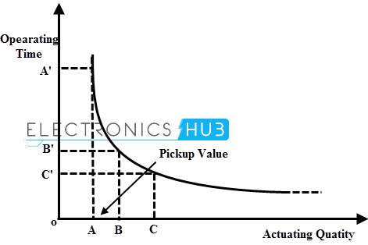](https://www.electronicshub.org/wp-content/uploads/2015/06/IDMT-Relays.jpg)

The pickup value the point where the actuating quantity or fault current initiates the relay to operate is called the pickup value. The relay is called IDMT because of its characteristic that when the actuating quantity reaches its infinity value the time doesn’t approach zero.

At lower values of the fault current, it gives inverse time characteristics while at higher values, it gives definite time characteristics as shown in figure. The operating time becomes constant from a particular value till the actuating quantity becomes infinity which is shown in the graph (a curve is obtained, which becomes constant).

**Differential Relays**

As the name suggests, Differential Relays are those relays which work on the ‘difference’ of the controlling (or actuating) signals. Differential Relays operate when the phasor difference of two or more similar electrical quantities exceeds a predetermined value. A current differential relay operates based on the result of comparison between the magnitude and phase difference of the currents entering in and leaving out of the system to be protected.

Under normal operating condition, the currents entering and leaving are equal in magnitude and phase so the relay is inoperative. But if a fault takes place in the system, these currents are no longer equal in magnitude and phase. This type of relay is connected in such that the difference between the current entering and current leaving flows through the operating coil of the relay. Hence the relay coil is energized under fault condition due to the difference quantity of the current. Thus, the relay operates and opens the circuit breaker so as to trip the circuit.

[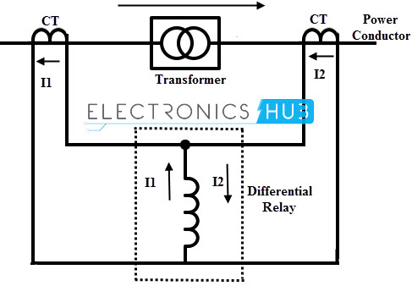](https://www.electronicshub.org/wp-content/uploads/2015/06/Diff-Relay.jpg)

The above figure shows the principle of differential relays in which there are two CTs connected either side of the power transformer i.e., one CT on the primary side and the other at the secondary side of the power transformer. The relay compares the currents on both sides and if there is any unbalance then relay tends to operate. The differential relays can be current differential relays, voltage balance differential relays and biased differential relays.

**Contactors**

**Introduction**

A contactor is an electrical device which is used for switching an electrical circuit on or off. It is considered to be a special type of relay. However, the basic difference between the relay and contactor is that the contactor is used in applications with higher current carrying capacity, whereas the [relay](https://www.c3controls.com/products/contactors-control-relays/) is used for lower current applications. Contactors can be field mounted easily and are compact in size. Generally, these electrical devices feature multiple contacts. These contacts are in most cases normally open and provide operating power to the load when the contactor coil is energized. Contactors are most commonly used for controlling electric motors.

There are various types of contactors, and each type has its own set of features, capabilities, and applications. Contactors can break current over a wide range of currents, from a few amperes to thousands of amperes, and voltages from 24 VDC to thousands of volts. In addition, these electrical devices come in varying sizes, from hand-held dimensions to sizes measuring a meter or yard on one side (approximately).

The most common application area of the contactor is high-current load. Contactors are known for their capability to handle currents of over 5000 amperes and high power over 100 kW. Heavy motor currents produce arcs when being interrupted. These arcs can be reduced and controlled using a contactor.

**Contactor Components**

The following three are crucial components of the contactor:

1. **Coil or Electromagnet:** This is the most crucial component of a contactor. The driving force that is required to close the contacts is provided by the coil or electromagnet of the contactor. The coil or electromagnet and contacts are protected by an enclosure.
2. **Enclosure:** Just like the enclosures used in any other application, contactors also feature an enclosure, which provides insulation and protection from personnel touching the contacts. The protective enclosure is made from different materials, such as polycarbonate, polyester, Nylon 6, Bakelite, thermosetting plastics, and others. Generally, the open-frame contactor features an additional enclosure, which protects the device from bad weather, hazards of explosion, dust, and oil.
3. **Contacts:** This is yet another important component of this electrical device. The current carrying task of the contactor is done by the contacts. There are different types of contacts in a contactor namely, contact springs, auxiliary contacts, and power contacts. Each type of contact has an individual role to play.

**How the Contactor Operates**

**Operating Principle of a Contactor:** The current passing through the contactor excites the electromagnet. The excited electromagnet produces a magnetic field, causing the contactor core to move the armature. A normally closed (NC) contact completes the circuit between the fixed contacts and the moving contacts. This permits the current to pass through these contacts to the load. When current is removed, the coil is de-energized and opens the circuit. The contacts of the contactors are known for their rapid open and close action.

**Different Types of Contactor Devices**

**Knife Blade Switch**

The knife blade switch was used earlier in the late 1800’s. It was probably the first ever contactor that was used to control (start or stop) electric motors. The switch consisted of a metal strip, which would drop onto a contact. This switch had a lever for pulling the switch down or pushing it up. Back then, one had to level the knife blade switch into the closed position by standing next to it.

However, there was a problem with this method of switching. This method caused the contacts to wear out quickly, since it was difficult to manually open and close the switch fast enough to avoid arcing. As a result of this, the soft copper switches underwent corrosion, which further made them vulnerable to moisture and dirt. Over the years, the size of the motors increased which further created the need for larger currents to operate them. This created potential physical danger to operate such high current carrying switches, thus leading to a serious safety concern. In spite of doing several mechanical improvements, the knife blade switch couldn’t be fully developed due to the pertaining problems and risks of dangerous operation and short life of the contacts.

**Manual Controller**

Since the knife blade switch became potentially dangerous to use, engineers came up with another contactor device, which offered a number of features that were missing in the knife blade switch. This device was referred to as a manual controller. These features included:

* Safe to operate
* Non-exposed unit, which is properly encased
* Physically smaller size
* Single break contacts replaced with double break contacts

As their name implies, double break contacts can open the circuit in two places at the same time. Thus, even in smaller space, it allows you to work with more current. Double break contacts divide the connection in such a way that it forms two sets of contacts.

The switch or button of the manual controller is not operated remotely and is attached to the controller physically.

The power circuit is engaged once the manual controller is activated by an operator. Once activated, it carries the electricity to the load. Soon, manual contactors replaced knife blade switches completely, and even today different variations of these types of contactors are being used.

**Magnetic Contactor**

The magnetic contactor does not require human intervention and operates electromechanically. This is one of the most advanced designs of a contactor, which can be operated remotely. Thus, it helps eliminate the risks involved in operating it manually and putting operating personnel in potential danger. Only a small amount of control current is required by the magnetic contactor to open or close the circuit. This is the most common type of contactor used in industrial control applications.

**The Life Expectancy of a Contactor or Contact Life**

The life expectancy of a contactor or its “contact life” is one of the biggest concerns of a user. It is natural that the contacts are being opened and closed more frequently, the life of the contactor will decrease. The opening and closing of the contacts create an electric arc, which generates additional heat. The continued production of these arcs can damage the contact surface.

Furthermore, the electrical arcs cause pitting and burn marks, which eventually blacken the contacts. However, the black deposit or oxide on the contacts make them even more capable of conducting electricity efficiently. Nevertheless, when the contacts get worn out and corroded to a large extent, then it is necessary to replace them.

Thus, the faster the contact closes, the quicker the arc extinguishes. This in turn helps to increase the life of the contact. The latest contactor versions are designed in such a way that they close very quickly and energetically. This causes them to slam against each other and produce a bouncing action as they rebound. This action is known as contact bounce. The contact bounce phenomenon creates a secondary arc. It is not only important to close the contacts quickly, but also to reduce the contact bouncing. This helps reduce wear and secondary arcing.

**What is Contactor?**

**Definition:** Contactors are electrically controlled switching devices which are used for switching electrically. The basic operation of this is similar to a relay, but the only difference is that contractors can carry large current compared to relay up to 12500A. They cannot provide short circuit or overload protection but can break the contact when coil excites.

**Construction of a Contactor**

The contactor consists of two iron cores, where one is fixed and the other one is the movable coil and it is an insulated copper coil. Where the copper coil is located on the fixed core. There are six main contacts for power connection, where three are fixed cores and the other three are movable cores. These contacts are made from pure copper, and the contact points are made from special alloy to withstand high starting current and temperature. A spring which is located between coil and the movable core, auxiliary contacts it could be normally open or closed. The main contacts cut on and off the light current loads such as contactors coil, [relays](https://www.elprocus.com/different-types-of-relays-used-in-protection-system-and-their-workings/), timers, and many other control circuit parts are linked to contact mechanism. A three-phase AC power supply provided to the circuit which is shown below,

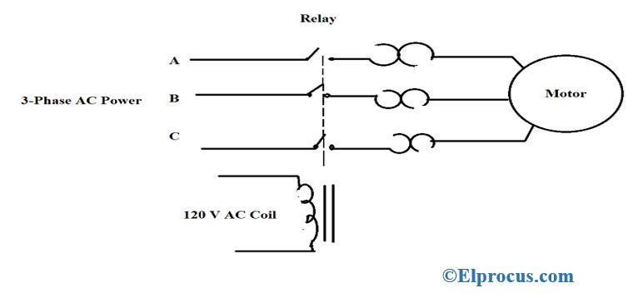

circuit-diagram-of-contactor

It consists of three main parts they are

***Coil***

It provides a force which is required to close the contact. The coil is also named as an [electromagnet](https://www.elprocus.com/electromagnetic-induction-and-laws/). An enclosure is used to safeguard the coil and contactor.

***Enclosure***

It acts like an insulator and protector, which protects the circuit form any electrical contact, dust, oil, etc. They are made up of different materials like Nylon 6, Bakelite, Thermosetting plastic, etc.

***Contacts***

The main function of this is that it carries the current to various parts of the circuit. There are classified into contact springs, axillary contacts, and power contacts. Where each of the contacts has its own functions, which is explained in principle of operation of the contactor.

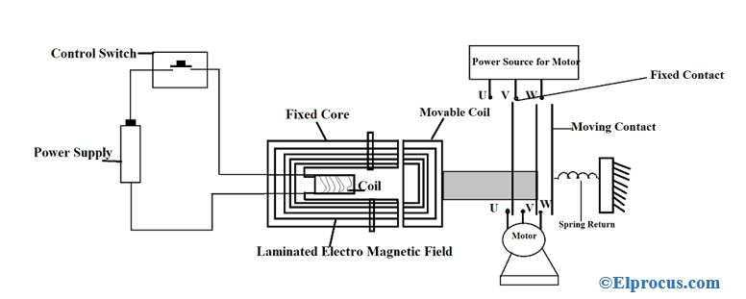

block-diagram-of-contactor

**Working Principle of Contactors**

An electromagnetic field is generated whenever current flows where the moving coils attract each other. A large amount of current is drawn initially by an electromagnetic coil. The moving contact is pushed forward by moving core, as a result, the force created by the electromagnet holds the moving and fixed contacts together.

* On de-energizing, the contactor coil gravity or spring moves back the electro-magnetic coil to its initial position and there is no flow of current in the circuit.
* If contactors are energized with AC current, a small portion of the coil is the shaded coil, where the magnetic flux in the core is slightly delayed. This effect is too average as it prevents the core from buzzing at twice line frequency. There are internal tipping point processes to ensure rapid action so that contactors can open and closed very rapidly.
* From the figure the supply is given using a switch, that is when the switch is closed current flows through the contactor coil and attaches the moving core. The contactor attached to the moving core closes and the motor starts running. When the switch is released the electromagnetic energizes spring arrangement pause the moving coil back to its initial position and power supply to the motor is cut off.

**How to Chooses a Correct Replacement for a Contactor?**

A correct replacement for this can be chosen as follows

* Firstly, one should check the coil voltage, which is a voltage used to energize the contactor.
* Checking for auxiliary contacts available, that is how many open and closed nodes are used in the contactor.
* Checking the rating which is mentioned in a table format on it.

ARC suppression concept arises whenever the contacts are open or closed. If there is a heavy load breakdown, an arc that is formed damages the contacts. Along with it if the temperature is high the arc causes harmful gases like carbon monoxide which leads to a reduction of the lifetime of motors.

**Types of Contactors**

These are classified based on three factors they are

* The load being used
* The current capacity and
* The power rating.

*Knife Blade Switch*

It is the first contactor used to control an electric motor in the late 1800s. It consists of a metal strip, which acts as a switch in connecting and disconnecting the connection. But the disadvantage of this method is that it switching process if very fast, due to which corrosion occurs in the copper material, depending on the capacity of current the size of the motor is increased which leads to high physical damage.

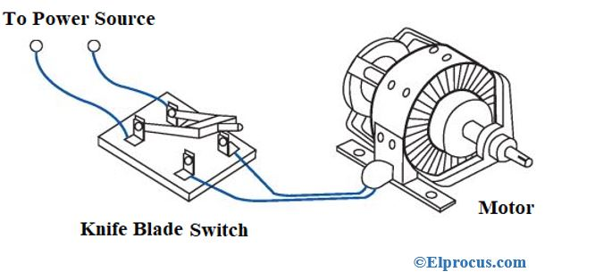

knife-blade-switch

***Manual Contactor***

The disadvantages of knife blade contractors are overcome using a manual contactor. Some of the features of these are,

* The operation performed is safe
* They are properly encased in order to protect from external environment problem
* The size of the manual connector is small
* Only a single break is used
* The[switches](https://www.elprocus.com/switches-types-working/) are controlled using a contactor.

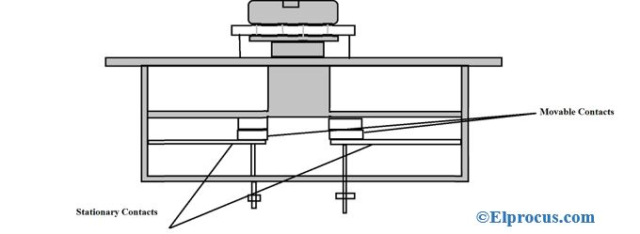manual-contactor

**Magnetic Contactor**

It operates electromagnetically that is it can be operated remotely, less amount of current is enough to make a connection and remove the connection. It is the most advanced contactor.

**Difference between AC Contactors and DC Contactors**

The difference between AC and DC contactor are as follows,

|  |  |
| --- | --- |
| **AC Contactors** | **DC Contactors** |
| They are designed for the contactors with self-extinguishing arc is drawn whenever the contact opens | They are specially designed to suppress electrical arching when there is switching in the [DC](https://www.elprocus.com/different-types-dc-to-dc-converters/) circuit. |
| They don’t use freewheel diode | They use freewheel diode |
| Separation time is less | Separation time is higher if the load is heavy a shunt load is attached to the main contact. |

**Advantages**

The following are the advantages of the contactor

* Fast switching operation
* Suitable for both AC and DC devices
* Simple in construction.

**Disadvantages**

The following are the disadvantages of the contactor

* In the absence of magnetic-filed, the coil may burn
* Aging of components causes corrosion of materials when exposed to moister.

**Applications of Contactors**

The following are the application of contactors

* It controls lighting
* [Magnetic starter](https://www.elprocus.com/motor-starter/)
* [Vacuum contactor](https://www.elprocus.com/vacuum-circuit-breaker-working-applications/)
* Mercury relay
* Mercury-wetted relay.

**Frequently Asked Questions:**

**Difference between a relay and a contactor?**

The main difference between a relay and a contractor is that,

|  |  |
| --- | --- |
| **Relay** | **Contactor** |
| A relay is used for low voltage switching purpose | It is used for high voltage switching purpose |
| The relay contactor is similar to the axillary contactor. | There are two types of contactors auxiliary and power |
| The size of the relay is small | The size of the contactor is large |
| Cannot be repaired | Can be repaired |

**What is a contactor used for?**

It is a switch used to switch high power load and protect the motor from external damage.

**What is a normally closed contactor?**

A normally closed contactor can be represented as NC, which means the connection is made and the circuit is normally on.

**How do you wire a 3 phase contactor?**

The connection of three-phase contactor is made as follows

* Disconnect the power supply
* The three colored phase wires are connected to three terminals T1, T2, T3 of machine
* Connect the power supply and allow the current to flow.

**How do you size a contactor?**

The size of this is a product of 100% and full load current.

**Applications**

**Lighting Control**

Contactors are often used to provide central control of large lighting installations, such as an office building or retail building. To reduce power consumption in the contactor coils, latching contactors are used, which have two operating coils. One coil, momentarily energized, closes the power circuit contacts, which are then mechanically held closed; the second coil opens the contacts.

**Electric Motor Starter**

Contactors can be used as a magnetic starter. A magnetic starter is a device designed to provide power to electric motors. It includes a contactor as an essential component, while also providing power-cutoff, under-voltage, and overload protection.

**Examples of Motor Control**

**Summary**

A contactor is a special type of relay used for switching an electrical circuit on or off. They are most commonly used with electric motors and lighting applications. The use of a contactor provides a level of isolation away from the high electric currents associated with those applications, protecting workers and equipment. IEC Contactors are smaller and are offered in a wide variety of sizes, whereas NEMA contactors are larger and designed with safety factors that go beyond design ratings by up to as much as 25%. IEC is a Global standard. NEMA contactors are primarily used in North America however, more companies are adopting IEC contactors, c3controls specializes in IEC.

**What is Contactor: Construction, Types and Applications**

A contactor is one of the main electrical circuit parts, which can stand on its own power control device or a part of a starter. They are used to connect and break power supply lines running through power lines or repeatedly establish and interrupt [electrical power](https://www.elprocus.com/classification-power-supply-different-types/) circuits. These are used in light loads, complex machine control. They are used with [motors](https://www.elprocus.com/dc-motor-basics-types-application/),[transformers](https://www.elprocus.com/various-types-of-transformers-applications/), heaters. It can be considered as an intersection point between the control circuit and power circuit because it is controlled by the control circuit, it also controls the circuit between power and loads. This article focuses on the importance of contactor in and electric field.

**DOL Starter using Contactor**

**Direct On-Line**is the simplest and cheapest method used for [starting](https://www.electricportal.info/2019/06/speed-control-of-three-phase-induction-motor.html) three-phase motor. **Dol**is used for up to 5 HP motor. dol starter is more popular due to the low price.

**DOL starter** connects the **motor** directly to supply without a reduction in supply voltage and apply full line voltage to 3 phase motors. This is the main **disadvantage** of dol starter.

Small HP motor can be started simply plugging into the power supply. But large HP motor required special unit called a **motor starter**.

**Direct online starter** for 3-phase **induction motor** contains parts like miniature circuit breaker (**MCB**) for motor protection purpose, overload relay, power contactor, fuse unit, start button, stop button.

Small size **dol starter** is operated manually but for larger HP motor, dol motor starter are operated using electromechanical **contactor** (relay) to switch motor ON and OFF.

**DOL Motor Starter**can be used, if high starting current cannot cause an excessive voltage drop in the motor circuit.

**DOL starter** use for starting the small motor, compressor, small water pumps, industrial conveyor belts. Fans, air curtains, exhaust fan, blower, etc.

A reversing starter can connect the motor for rotation in either direction. Such a starter contains two DOL **circuits**—one for clockwise operation and the other for counter-clockwise operation, with mechanical and electrical interlocks to prevent simultaneous closure. For three phase motors, this is achieved by changing the wires connecting any two phases. Single phase AC motors and direct-current motors require additional devices for reversing rotation

In the case of three phases asynchronous motor, draws very high starting current up till achieving full speed. This starting current up to 6 to 7 time of full load current. To reduce this starting current larger motor has starting methods like star delta starter or variable frequency drive.to reduced voltage dips on the power supply. The **demerits of dol starter**are that gives the highest possible current to [motor](https://www.electricportal.info/2019/04/types-of-single-phase-induction-motor-capacitor-start-run-permanent-split.html). Which is 6 to 7 time of rated current of the motor.

Besides then DOL starter draws the starting current there also exists a current peak that can rise up to 14 times the rated current since the motor is not energized from the first moment when starting. So, here the question arises what is dol motor starter and how dol starter work. Explanation of direct online motor starter with control and power circuit diagram is given below.

**Direct online starter (DOL starter) control diagram:**

|  |
| --- |
| [dol control circuit diagram](https://1.bp.blogspot.com/-RREJHIYhe64/XDCaXtfy7_I/AAAAAAAAArU/FABVp_TC1P4dlQNuoKWLyaYQKXkhM_sCQCLcBGAs/s1600/direct%2Bonline%2Bstarter%2Bdol%2Bcontrol%2Bcircuit%2Bdiagram.jpg) |
| Fig. direct online starter dol control circuit diagram |

**DOL starter control circuit diagram** consist components like Main [**power**](https://www.electricportal.info/2019/04/classification-of-buses-in-power-system.html) contactor, start button, stop push button and overload relay is connected in series this circuit is called control circuit of **dol motor starte**r. All controlling of starter are controlled by this circuit.

**DOL starter power circuit diagram:**

Direct Online starter power diagram has fuse unit (F1), Main power contactor (K1), overload relay (F2). Also, we can connect MCB for protection purpose in direct On-Line motor starter.

|  |
| --- |
| [Dol starter power circuit diagram](https://2.bp.blogspot.com/-HaZst95TA8g/XEc84NQPWbI/AAAAAAAAAws/iFn-xS81i_gobCNWnfAkxCZ0yyTe2ItKwCLcBGAs/s1600/Dol%2Bstarter%2Bpower%2Bdiagram.jpg) |
| DOL Starter power circuit diagram |

Direct online starter circuit Wiring diagram:

|  |
| --- |
| **[Direct online starter DOL diagram](https://1.bp.blogspot.com/-yAcxOdhpQiE/XPnmO2CDC-I/AAAAAAAAA9g/QI7o_eQZYLseLYJtVVAgST-IwcupCuVDgCLcBGAs/s1600/Direct-online-starter-dol-diagram.jpg)** |
| Direct online starter DOL diagram |

DOL starter of three phase induction motors control and power circuit consist MCB or fuse unit which connected in series with the supply. Power contactor, thermal Overload relay for protection and stop and start push button.

**Working Principle of Direct online starter (DOL Starter):**

1) To start the motor, start push button is pressed. After that, the main **power contactor** coil energized due to electromechanical action and this latch contactor pole.it applies full line voltage to the motor terminals. and the motor starts running. The motor will draw a very high inrush current for a short time.  
2) As the **motor** accelerates and head toward the full speed, current begins to drop but it will not drop significantly till motor achieved full speed, about 85% of synchronous speed.

3) The motor load will affect the time taken for the motor to accelerate to full speed and therefore the duration of high starting current, but it will not affect the magnitude of starting current.

4)the torque developed by motor exceeds the load torque at all speeds during the start cycle, the motor will reach full speed. If the torque developed by the motor is less than the torque of load at any speed during the start period. the motor stops accelerating.  
5) If motor torque developed by **DOL Motor starter** is less for load, then the motor must be replaced by the motor which can develop high starting torque.

**DOL starter working :**

1)When start push button on the direct online motor starter is pressed, contactor coil gets energized and it latches contactor pole due to electromagnetic action. 3 phase supply get applied to the **induction motor terminal** and motor start running

2) after that start push button get released and supply to contactor coil continued through latching contact provided to the main contractor of D O L starter.

3) At time of stopping the motor we need to pressed stop push button on **dol starter circuit**, this disconnect supply to the coil and contactor coil get de-energized, and it releases contactor latched pole and motor supply get disconnected.

**Component of direct online starter (DOL Starter):**

1. **Contactor:**

A **contactor**is a heavy-duty relay with the high current rating, used for power up **electrical motor**. Current rating for contactor varies from 10 amps to several hundred amps. High current contactor is made from an alloy containing silver. Arcing during the switching operation of contactor causes contact to oxidize. However, silver oxide still good conductor. **Overload protection** is provided along with the contactors to start the motor. Contactor is not used to interrupt a short circuit current, Unlike the circuit breaker used. Contactor size varies from small to large for high current appliances.

Contactor creates noise while switching operation. If when requires silent operation solid state relay used. A contactor is**an electromechanical** switch which operates on energization and de-energized of the coil. The contactor has 3 NO contact which connects a motor to the power supply and one additional contact refer as Auxiliary contact, which is act as hold on contact when start push-button release. To maintain energization of contactor coil. If some time power fails abruptly due to this contactor coil get de-energized, its open contactor terminal and motor get disconnected from the supply.

**2) Over load relay (overload protection):**

Most of motor winding failure occurs due to overload. Motor overload tends to the heating of motor winding that results in the weakening of winding insulation. A minor overload does not cause a motor failure immediately but it will eventually shorten the expected lifetime.  To prevent this situation thermal overload relay is provided into a direct online starter circuit.  Thermal overload [relay](https://www.electricportal.info/2018/12/how-test-electrical-relay-method.html) has a bimetallic strip that bends because of overheating caused by overcurrent.

This disconnects motor from supply and prevent further motor winding damage also insulation failure.

**3) Miniature circuit breaker (MCB):**

To**protect the motor** from short circuit condition and avoid damage to motor winding **MCB** is used in **DOL circuit**.

**4 ) Push buttons :**

There are two push buttons are used in dol motor starter, one is a green colour for the start button and other is red for the stop push button.  Switching of power supply carried out by using electromechanical contactor which has 3 to 4 pole

**Start push button:**

this is normally open type push button, to start motor, this push button need to press and supply get applied to motor through power contactor.

**Stop push button:**

This is NC type push button we need to press to stop motor from running condition. after pressing stop button contactor coil get de-energized with the opening of contacts. Due to this switching operation motor get disconnected from supply and motor stops rotating.

**Advantages of DOL Starter (direct online starter)**

* **Direct On-Line motor starter** is Cheapest motor Starter.
* **DOL** is the simplest motor starter to design and maintain.
* 100% starting torque.
* D O L starter used up to 5HP motor depending upon insulation class of motor.

**Disadvantages of DOL Starter**

* High starting current
* typically, 7 to 8 time rated current applied at starting
* due to high current stress applied on motor winding.
* not suitable for high rating motor.
* create a voltage dip on the power system
* High starting torque.

**UNIT – 3 Automation using PLC**

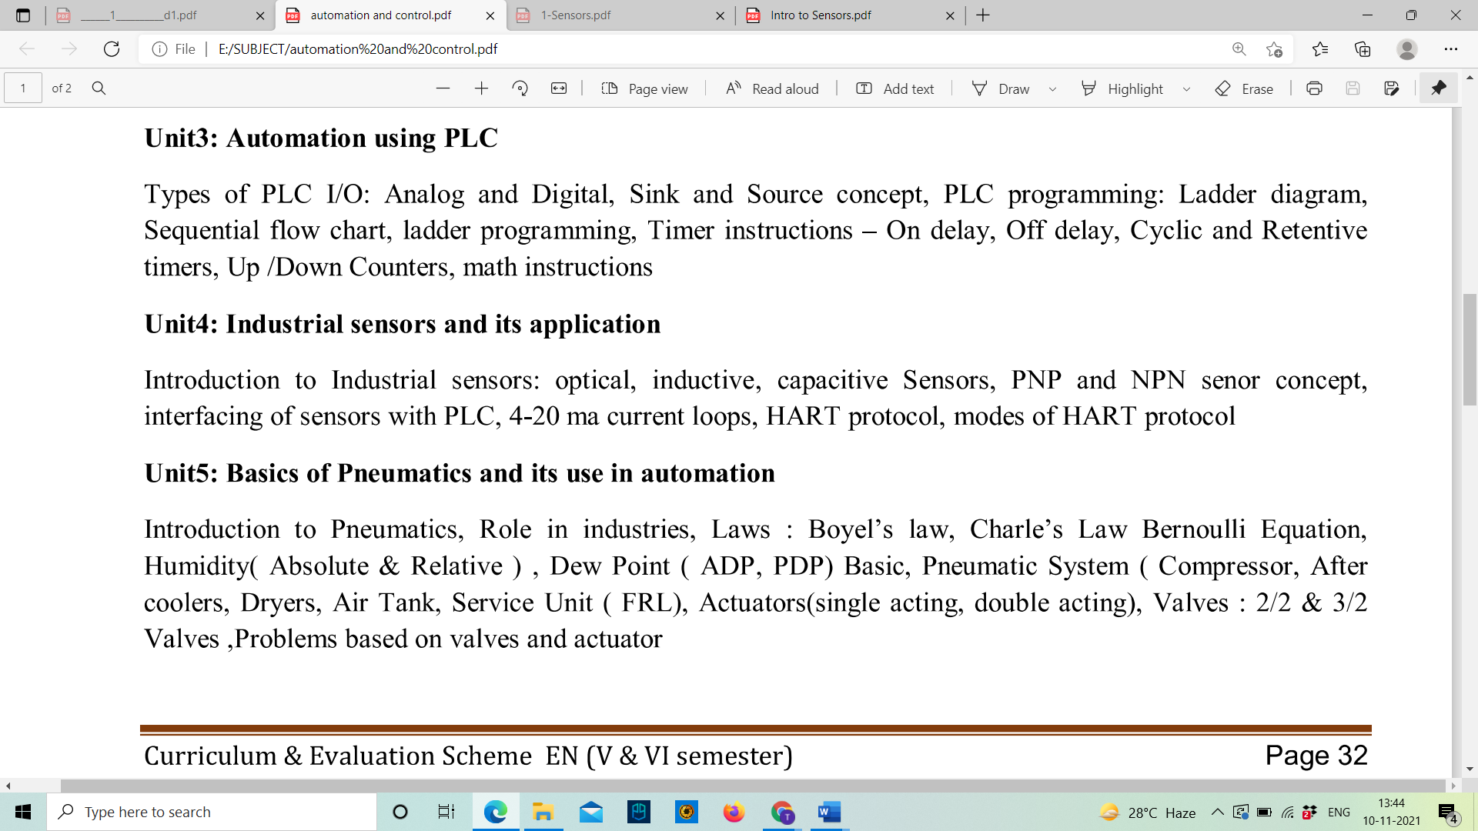

**Sink and Source concept in PLC**

The Sinking and Sourcing are the input/output module cards used in PLCs. Conventional Relay cards are simple and very easy to the interface but suffer from the mechanical limitation of low operation and limited lifespan. These problems can almost overcome by using sinking and sourcing digital cards.

A sinking digital I/O (input/output) provides a grounded connection to the load, whereas a sourcing digital I/O provides a voltage source to the load.

**Sinking input:**

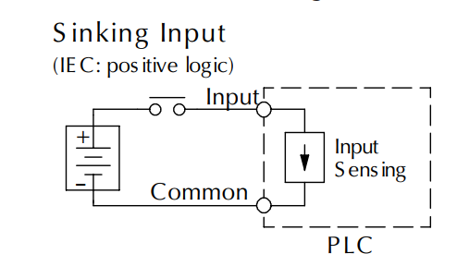

The switching element used in sinking card is NPN, so they are also known as NPN cards

**Sinking output:**

[[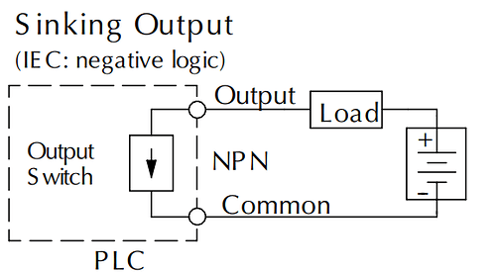](https://forumautomation.com/uploads/default/original/1X/72e324fc304c4e45e189000d1d2c9e0cf39af659.png)](https://forumautomation.com/uploads/default/original/1X/72e324fc304c4e45e189000d1d2c9e0cf39af659.png" \o "sinking op.png)

**Advantage of sinking:**

* Ability to switch voltage higher than the card supply voltage

But two power supplies are required for proper interfacing

**Sourcing input:**

[[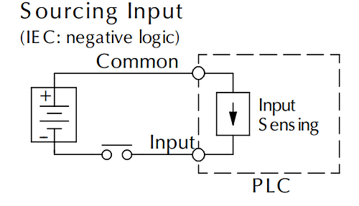](https://forumautomation.com/uploads/default/original/1X/0f7de662c2f0933bf512ac9b6ca6509083c8ff63.png)](https://forumautomation.com/uploads/default/original/1X/0f7de662c2f0933bf512ac9b6ca6509083c8ff63.png" \o "soursingop.png)

The switching element used here is PNP and so they are known as PNP cards.

**Sourcing output:**

[[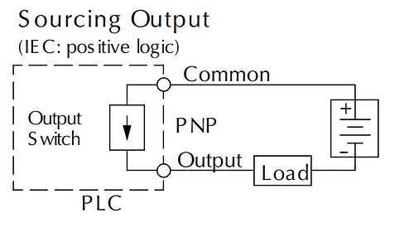](https://forumautomation.com/uploads/default/original/1X/f84bcc32da652c08632054d75f12ef79c6e19c33.png)](https://forumautomation.com/uploads/default/original/1X/f84bcc32da652c08632054d75f12ef79c6e19c33.png" \o "soursingoutput.png)

**Advantage of sourcing:**

* Easier interfacing since only one power supply needed.
* The voltage load is limited to card supply voltage

**Types of Languages in PLC**

The **five types of languages used in PLC** programming are as follows.

They are

* Ladder (LD),
* Structured text (ST),
* Functional Block Diagram (FBD),
* Sequential Flow Chart (SFC) and
* Instruction List (IL).

As an introduction to ladder diagrams, consider the simple wiring diagram for an electrical circuit in Figure 3.1a. The diagram shows the circuit for switching on or off an electric motor. We can redraw this diagram in a different way, using two vertical lines to represent the input power rails and stringing the rest of the circuit between them. Figure 11.1b shows the result. Both circuits have the switch in series with the motor and supplied with electrical power when the switch is closed. The circuit shown in Figure 3.1b is termed a ladder diagram.

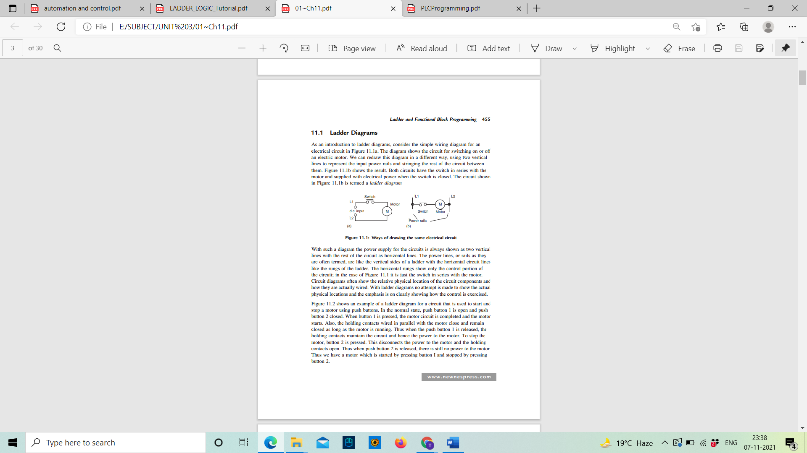

Figure 3.1: Ways of drawing the same electrical circuit

With such a diagram the power supply for the circuits is always shown as two vertical lines with the rest of the circuit as horizontal lines. The power lines, or rails as they are often termed, are like the vertical sides of a ladder with the horizontal circuit lines like the rungs of the ladder. The horizontal rungs show only the control portion of the circuit; in the case of Figure 3.1 it is just the switch in series with the motor. Circuit diagrams often show the relative physical location of the circuit components and how they are actually wired. With ladder diagrams no attempt is made to show the actual physical locations and the emphasis is on clearly showing how the control is exercised.

Figure 3.2 shows an example of a ladder diagram for a circuit that is used to start and stop a motor using push buttons. In the normal state, push button 1 is open and push button 2 closed. When button 1 is pressed, the motor circuit is completed and the motor starts. Also, the holding contacts wired in parallel with the motor close and remain closed as long as the motor is running. Thus when the push button 1 is released, the holding contacts maintain the circuit and hence the power to the motor. To stop the motor, button 2 is pressed. This disconnects the power to the motor and the holding contacts open. Thus when push button 2 is released, there is still no power to the motor. Thus we have a motor which is started by pressing button I and stopped by pressing button 2.

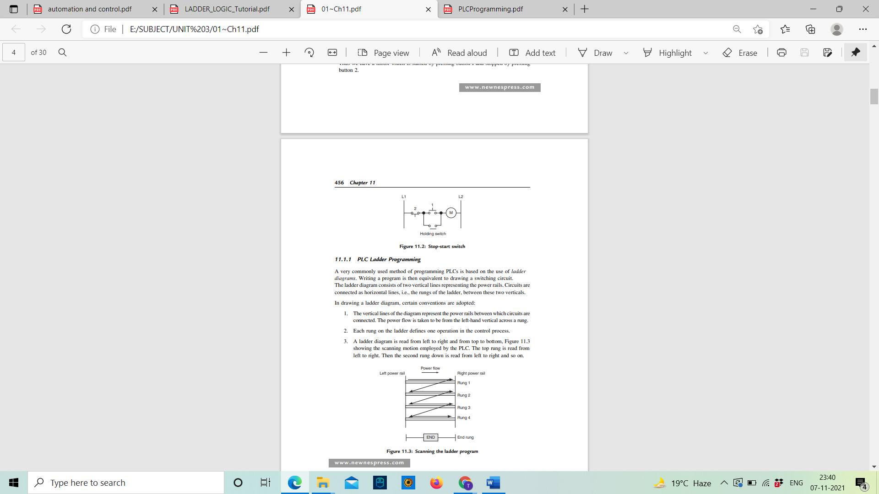

Figure 3.2: Stop-start switch

**PLC Ladder Programming**

A very commonly used method of programming PLCs is based on the use of ladder diagrams. Writing a program is then equivalent to drawing a switching circuit.

The ladder diagram consists of two vertical lines representing the power rails. Circuits are connected as horizontal lines, i.e., the rungs of the ladder, between these two verticals.

In drawing a ladder diagram, certain conventions are adopted:

1. The vertical lines of the diagram represent the power rails between which circuits are connected. The power flow is taken to be from the left-hand vertical across a rung.

2. Each rung on the ladder defines one operation in the control process.

3. A ladder diagram is read from left to right and from top to bottom, Figure 3.3 showing the scanning motion employed by the PLC. The top rung is read from left to right. Then the second rung down is read from left to right and so on.

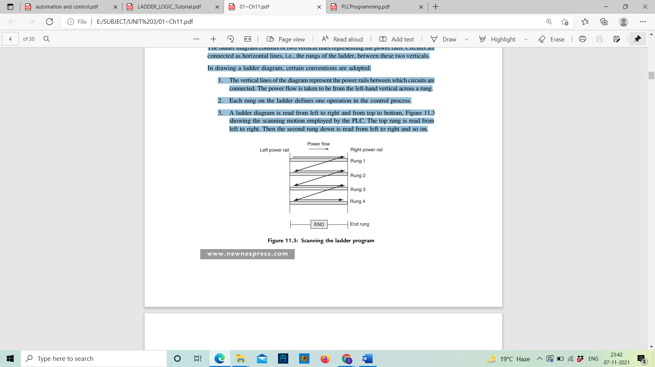

Figure 3.3: Scanning the ladder program

When the PLC is in its run mode, it goes through the entire ladder program to the end, the end rung of the program being clearly denoted, and then promptly resumes at the start. This procedure of going through all the rungs of the program is termed a cycle. The end rung might be indicated by a block with the word END or RET for return, since the program promptly returns to its beginning.

4. Each rung must start with an input or inputs and must end with at least one output. The term input is used for a control action, such as closing the contacts of a switch, used as an input to the PLC. The term output is used for a device connected to the output of a PLC, e.g., a motor.

5. Electrical devices are shown in their normal condition. Thus, a switch, which is normally open until some object closes it, is shown as open on the ladder diagram. A switch that is normally closed is shown closed.

6. A particular device can appear in more than one rung of a ladder. For example, we might have a relay that switches on one or more devices. The same letters and/or numbers are used to label the device in each situation.

7. The inputs and outputs are all identified by their addresses, the notation used depending on the PLC manufacturer. This is the address of the input or output in the memory of the PLC.

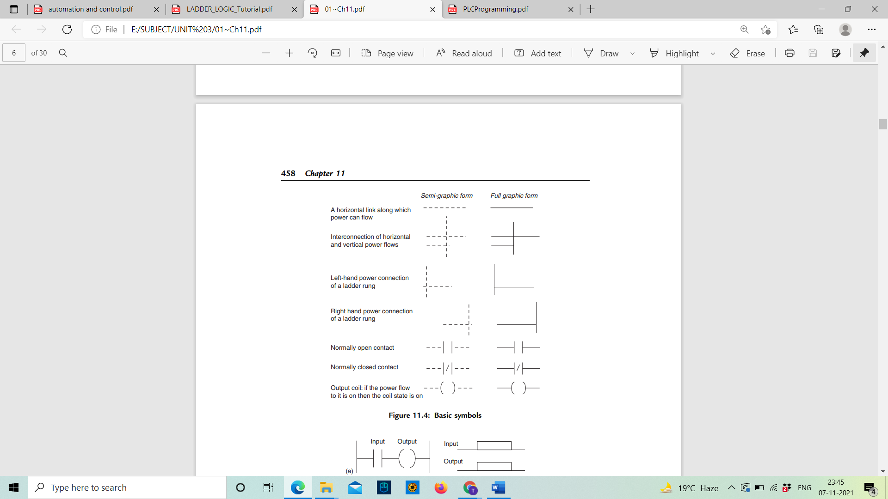

**Latching**

There are often situations where it is necessary to hold an output energized, even when the input ceases. A simple example of such a situation is a motor, which is started by pressing a push button switch. Though the switch contacts do not remain closed, the motor is required to continue running until a stop push button switch is pressed. The term latch circuit is used for the circuit used to carry out such an operation. It is a self-maintaining circuit in that, after being energized, it maintains that state until another input is received.

An example of a latch circuit is shown in Figure 3.4. When the input A contacts close, there is an output. However, when there is an output, another set of contacts associated with the output closes. These contacts form an OR logic gate system with the input contacts. Thus, even if the input A opens, the circuit will still maintain the output energized. The only way to release the output is by operating the normally closed contact B.

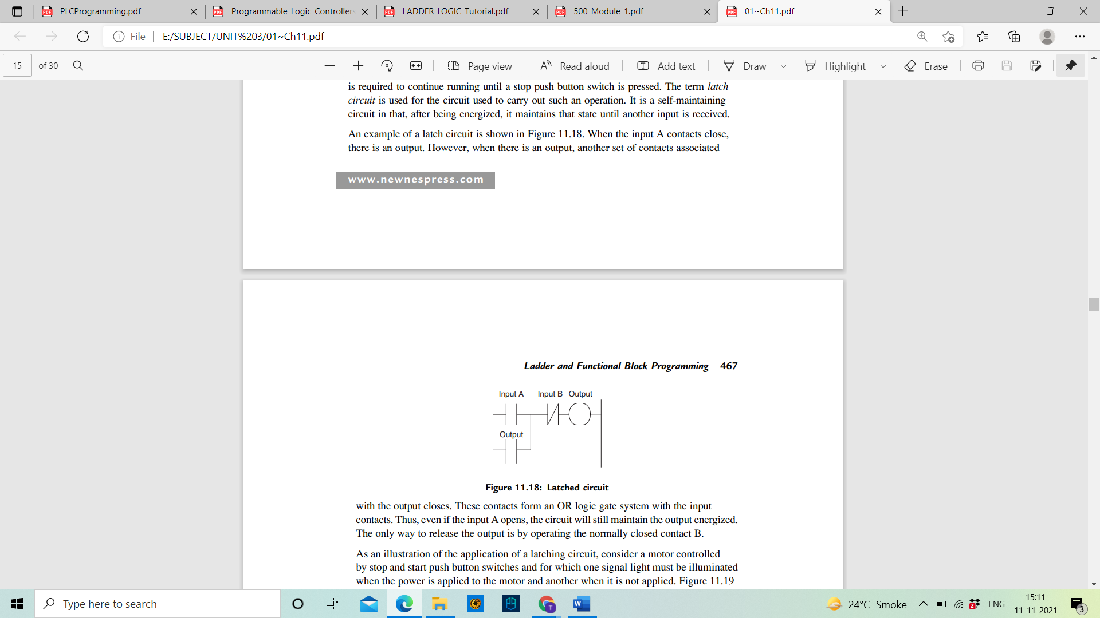

Figure 3.4: Latched circuit

**SFC Language in PLC**

A **Sequential Flow Chart** is a language used in **PLC programming** which is a **graphical representation** of the flowcharts or steps, which is similar to flowchart algorithms used in computer languages.

This language is a very useful tool in a condition where the process is very large and the functions are performed in steps.

Instead of writing the whole logic in a [ladder diagram](https://instrumentationtools.com/programmable-logic-controller-plc-questions-and-answers-19/) or even if you use functional block diagrams, the repetition rates and the overall viewing of the process can be made simpler by using SFC language.

**Sequential Flow Chart Programming**

Consider a simple example where you turn on or off a motor by pressing the start and stop buttons. Refer to the below image showing **SFC language**.

The black box represents action to be written inside the step. The brown line indicates the flow of the sequence.

The horizontal grey line in between indicates the transition condition.

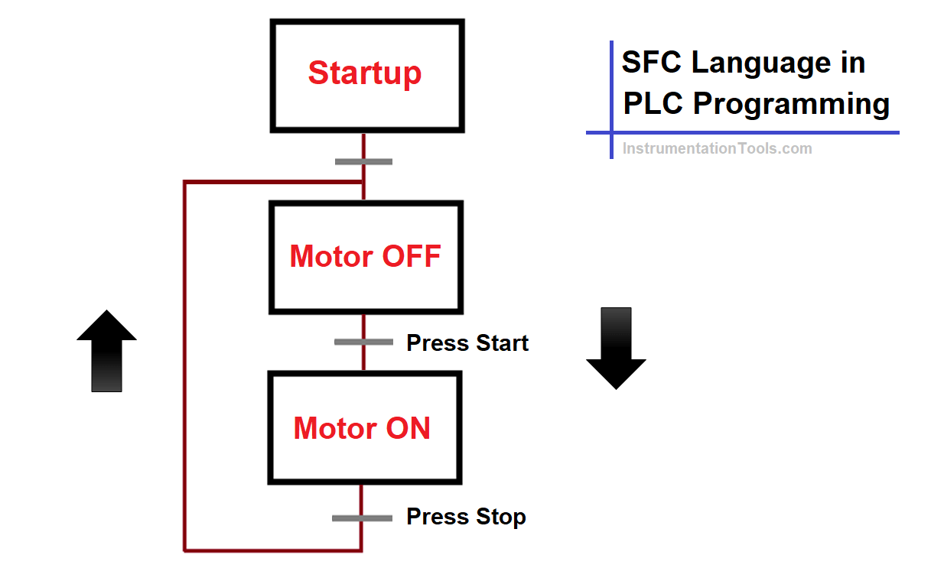

In the first box, a start-up condition of 2 seconds [timer](https://instrumentationtools.com/timers-using-statement-list-stl-plc-programming/) is written for starting this action. This step executes on PLC cold start or warm start.

This means that the start and stop action will be executed after an initial delay of 2 seconds of PLC start-up. The first transition condition is set to true. The second step is written to reset the **motor** variable.

The second transition condition is written for checking the start [pushbutton](https://instrumentationtools.com/hand-switches/) press. The third step is written to set the motor variable. The third transition condition is written for checking stop pushbutton press.

So, the [sequence](https://instrumentationtools.com/siemens-drum-block-for-sequencer-operation/) will work as follows. On PLC start-up, after a delay of 2 seconds, the motor will be turned off by default in the second step as written.

Now, if the start button is pressed, the motor will be turned on as per the second transition condition and third step. If the stop button is pressed, the [motor](https://instrumentationtools.com/how-to-run-multiple-motors-with-a-single-vfd/) will be turned off as per the third transition condition and the second step.

This means that the logic will be executed as per the flow sequence lines written. A transition condition can be defined as an [interlock](https://instrumentationtools.com/motor-stop-interlock/) for executing a step or action. You can write a variable or even call a section in a step.

**SFC Programming Example**

The below image is an actual example of the language written in [PLC software](https://instrumentationtools.com/download-rslogix-plc-software/).

In the box, you can define the action and in the black line, you can define the variable condition to be written.

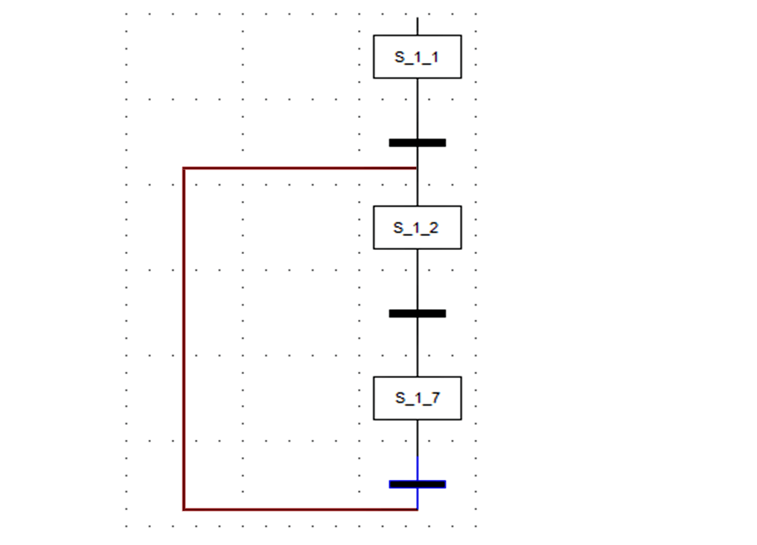

**SFC’s** are useful in breaking a very complex **flow chart sequence** in a simpler way to execute the logic. You have to properly define the conditions and arrange the blocks and flow sequence accordingly to perform the function.

Remember to not get trapped in a repetitive or infinite loop which will not break the logic and can instead confuse the [programmer](https://instrumentationtools.com/fb-and-fc-plc-programmer/) in writing the logic.

You must have written this simple logic in a ladder language. But, it must be noted that you can also use SFC language for such logic or other complex ones.

Due to the visual representation of flowchart-type logic in front of the programmer, he can easily troubleshoot logic and also reduce the downtime required for [developing a logic](https://instrumentationtools.com/plc-logic-functions/).

You can also use branching in the SFC language. That means, after a step, you can execute other parallel running steps like a branch.

In branching logic is a sub-category named selective branching. That means each branch will have its own individual transition condition to execute that branch/step.

Similar to branching, convergence is also possible. It is the opposite of branching. That means, all the branches combine together to execute a single step.

SFC’s are a strong tool in designing [logic](https://instrumentationtools.com/pause-the-timer-plc-ladder-logic/) and making the sequence more understanding and easier to use.

**Timers in PLC:**

PLC timers are instructions that provide the same functions as on-delay and off-delay mechanical and electronic timing relays. A PLC timer provides a preset delay to the control actions.

In general, there are three types of PLC timer delays, ON-delay timer, OFF-delay timer and retentive timer on.

The terms represented in the timer block in the PLC are a Preset value which means the delay period of the timer, an Accumulated value which is the current delay of the timer.

A timer begins the counting on time-based intervals and continues until the accumulated value equals the preset value. When the accumulated value equals the preset time the output will be energized. Then the timer sets the output.

**TON timer or ON delay timer**

An ON delay timer is used where we need a time delay before the time delay before an instruction becomes true.

[[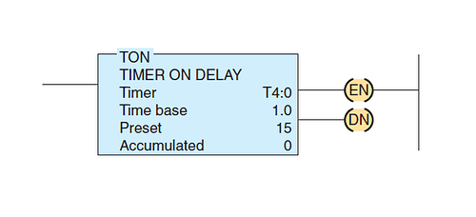](https://forumautomation.com/uploads/default/original/1X/faee9169d3e06ded1636060610353e3ecf79d71e.png)](https://forumautomation.com/uploads/default/original/1X/faee9169d3e06ded1636060610353e3ecf79d71e.png" \o "tiemr2.png)

A representation TON timer is shown above, which contains,

*Timer number:* The timer file name *Time base:* which is shown in seconds, *Preset value:* Numeric valve set as the delay required to the timer. *Accumalated value:* The values are counting is displayed from zero. Value becomes zero whenever the timer is reset

[[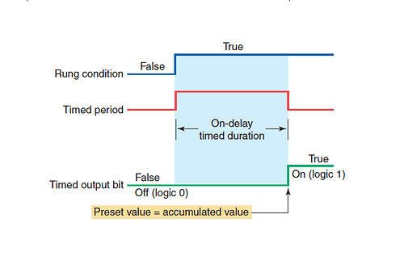](https://forumautomation.com/uploads/default/original/1X/032515fd2e04f312f3176ce49518b1ff49be3277.png)](https://forumautomation.com/uploads/default/original/1X/032515fd2e04f312f3176ce49518b1ff49be3277.png" \o "timergraph.png)

* The timer starts operating when the rung condition becomes true. The timer delay starts counting when the rung condition starts to accumulate.
* When the Preset value becomes equal to the accumulated value, the output is made true.
* The timed output becomes true sometime after the timer rung becomes true; hence, the timer is said to have an on-delay.
* The length of the delay can be adjusted by setting the preset value.

**TOFF timer or OFF delay timer:**

A TOFF timer will keep the output energized for a preset time after the rung signal has gone false.

[[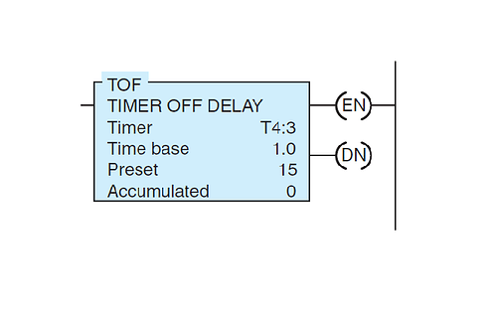](https://forumautomation.com/uploads/default/original/1X/d1b386f5fcad2b897adc33e85c6b9af05a0be875.png)](https://forumautomation.com/uploads/default/original/1X/d1b386f5fcad2b897adc33e85c6b9af05a0be875.png" \o "tofftimer.png)

The TOFF timer will have all the contents as in the TON timer, with the similar function.

[[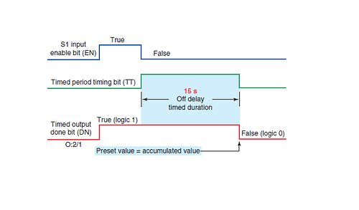](https://forumautomation.com/uploads/default/original/1X/de909b15037999b7bc821ebe23092e7af211620c.png)](https://forumautomation.com/uploads/default/original/1X/de909b15037999b7bc821ebe23092e7af211620c.png" \o "timergraph.png)

* When the rung timer is true, the output will be true without any delay. When the rung signal becomes false the timer starts operating.
* The timer starts accumulating times when the rung condition becomes true, until the accumulated value becomes equal to the Preset value.
* The output turns off when the output will turn false when the accumulated value equals the preset value.

**Retentive timer:**

A retentive timer is used when you want to retain accumulated time value through the power loss or the change in the rung state.

A retentive timer accumulates time whenever the device receives power, and it maintains the current time should power be removed from the device

Loss of power to the timer after reaching its preset value does not affect the state of the contacts. The retentive timer must be intentionally reset with a separate signal for the accumulated time to be reset

[[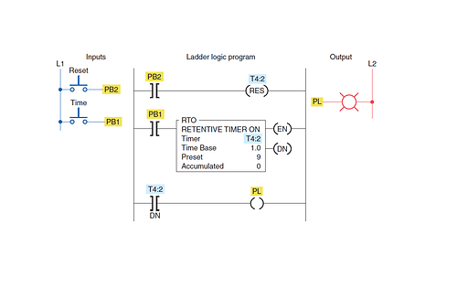](https://forumautomation.com/uploads/default/original/1X/1424a8f67a77bdc19a60a84c0cfc66aa4e6103f5.png)](https://forumautomation.com/uploads/default/original/1X/1424a8f67a77bdc19a60a84c0cfc66aa4e6103f5.png" \o "retimer.png)

An example logic is shown above.

* When the push bottom PB1 is pressed, the timer starts working and the reading starts accumulating.
* When we push the PB1 button then rung become false and the timer stops working. Consider we are switching ON the push after a time, the timer starts counting from the previous value before the timer is stopped.
* We have to add another switch PB2 to reset the values in the timer

**Counter in PLC**

Counters are [PLC instructions](https://forumautomation.com/t/learn-ladder-logic-programming-with-free-plc-programmable-logic-controllers-programming-software-for-beginners/221) that either increment or decrement or decrement the integer value when the input line make True from False. The counter which increments value is known as Up counters and Down counters decrement the integer values on a trigger. Both the Up and Down counter starts counting on one trigger.

And there is an Up-Down counter which does both the Up and Down counting. The Up-Down counter has two input triggers one for Up counting and other for Down counting.

**Up counter:**

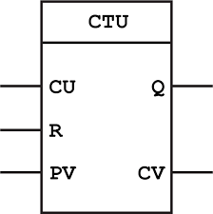

Up counter counts a value from the current value when a signal arrives at the input CU. R is the reset input and PV the preset value. The counter counts up until the count reaches the preset value.

Whenever the input CU value changes from 0 to 1 the counter increment 1 from the preset value. When the input value reaches the preset value the output turns ON. The counter preset value is user defined.

Each pulse on the count input (CU) will increase the current counter value (CV) by 1. When CV is greater than or equal to the counter limit (PV) the output (Q) is set. A pulse on the reset input (R) will reset the value of CV to 0.

**Down counter:**

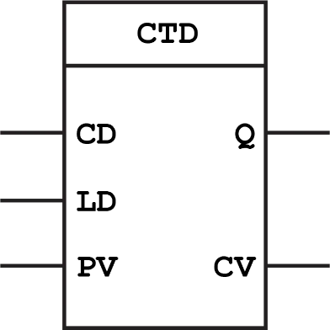

Each time the input CD turns ON the counter decrement one from the preset value. Whenever LD (load) input becomes high then the preset value is reloaded to the counter from the current value.

Whenever the input CD value changes from 0 to 1 the counter decrement 1 from the preset value.

**Up/Down counter:**

The Up/Down counter work as both the up counter and the down counter. The up/down counter has input for both the Up counter and Down counter operation CU and CD. And has both the inputs R and LD also.

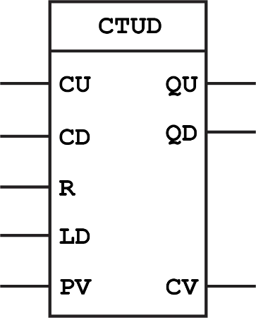

How it works

Each pulse on the count input (CU) will increase the current counter value (CV) by 1. And each pulse on the count input (CD) will decrement current counter value (CV) by 1.

When CV is greater than or equal to the counter limit (PV) the output (QU) is set. When CV is less than or equal to 0 the output (QD) is set.

A pulse on the reset input (R) will reset the value of CV to 0. A pulse on the load input (LD) will assign the value of counter limit (PV) to CV.

**Notes**

**Unit – 4**

Measurement is an important subsystem of a mechatronics system. Its main function is to collect the information on system status and to feed it to the micro-processor(s) for controlling the whole system.

Sensors in manufacturing are basically employed to automatically carry out the production operations as well as process monitoring activities. Sensor technology has the following important advantages in transforming a conventional manufacturing unit into a modern one.

1. Sensors alarm the system operators about the failure of any of the sub units of manufacturing system.
2. It helps operators to reduce the downtime of complete manufacturing system by carrying out the preventative measures.
3. Reduces requirement of skilled and experienced labors.
4. Ultra-precision in product quality can be achieved.

**Sensor**:

A sensor is a device that detects and responds to some type of input from the physical environment. The input can be light, heat, motion, moisture, pressure or any number of other environmental phenomena. The output is generally a signal that is converted to a human-readable display at the sensor location or [transmitted electronically](https://www.techtarget.com/iotagenda/definition/remote-sensing) over a network for reading or further processing.

Sensors play a pivotal role in the internet of things ([IoT](https://www.techtarget.com/iotagenda/definition/Internet-of-Things-IoT)). They make it possible to create an ecosystem for collecting and processing data about a specific environment so it can be monitored, managed and controlled more easily and efficiently. IoT sensors are used in homes, out in the field, in automobiles, on airplanes, in industrial settings and in other environments. Sensors bridge the gap between the physical world and logical world, acting as the eyes and ears for a computing [infrastructure](https://www.techtarget.com/searchdatacenter/definition/infrastructure) that analyzes and acts upon the data collected from the sensors.

**Transducer**:

It is defined as an element when subjected to some physical change experiences a related change or an element which converts a specified measurand into a usable output by using a transduction principle. It can also be defined as a device that converts a signal from one form of energy to another form. A wire of Constantan alloy (copper-nickel 55-45% alloy) can be called as a sensor because variation in mechanical displacement (tension or compression) can be sensed as change in electric resistance. This wire becomes a transducer with appropriate electrodes and input-output mechanism attached to it. Thus we can say that ‘sensors are transducers’.

**Classification of sensors**:

Sensors can be classified into various groups according to the factors such as measurand, application fields, conversion principle, energy domain of the measurand and thermodynamic considerations. Detail classification of sensors in view of their applications in manufacturing is as follows.

1. Displacement, position and proximity sensors:

• Potentiometer

• Strain-gauged element

• Capacitive element

• Differential transformers

• Eddy current proximity sensors

• Inductive proximity switch

• Optical encoders

• Pneumatic sensors

• Proximity switches (magnetic)

• Hall effect sensors

1. Velocity and motion:

• Incremental encoder

• Tachogenerator

• Pyroelectric sensors

1. Force:

• Strain gauge load cell

1. Fluid pressure:

• Diaphragm pressure gauge

• Capsules, bellows, pressure tubes

• Piezoelectric sensors

• Tactile sensor

1. Liquid flow:

• Orifice plate

• Turbine meter

1. Liquid level:

• Floats

• Differential pressure

1. Temperature:

• Bimetallic strips

• Resistance temperature detectors

• Thermistors

• Thermo-diodes and transistors

• Thermocouples

• Light sensors

• Photo diodes

• Photo resistors

• Photo transistor

**Advantages of Sensors:**

* No physical contact and therefore no stress
* No wear and tear, hence long life
* Contact less and therefore maintenance free
* Electronic high precision
* Protected and safe switching in harsh environments
* High switching rate
* Potential-free contact, thus not prone to false pulses

**Proximity Sensors:**

A proximity sensor is a [sensor](https://en.wikipedia.org/wiki/Sensor) able to detect the presence of nearby objects without any physical contact.

A proximity sensor often emits an [electromagnetic](https://en.wikipedia.org/wiki/Electromagnetic_field) field or a beam of [electromagnetic radiation](https://en.wikipedia.org/wiki/Electromagnetic_radiation) ([infrared](https://en.wikipedia.org/wiki/Infrared), for instance), and looks for changes in the [field](https://en.wikipedia.org/wiki/Electric_field) or return [signal](https://en.wikipedia.org/wiki/Signal). The object being sensed is often referred to as the proximity sensor's target. Different proximity sensor targets demand different sensors. For example, a [capacitive proximity sensor](https://en.wikipedia.org/wiki/Capacitive_proximity_sensor) or [photoelectric sensor](https://en.wikipedia.org/wiki/Photoelectric_sensor) might be suitable for a plastic target; an [inductive proximity sensor](https://en.wikipedia.org/wiki/Inductive_sensor) always requires a metal target.

Proximity sensors can have a high reliability and long functional life because of the absence of mechanical parts and lack of physical contact between the sensor and the sensed object.

Proximity sensors are also used in machine vibration monitoring to measure the variation in distance between a shaft and its support bearing. This is common in large steam [turbines](https://en.wikipedia.org/wiki/Turbine), [compressors](https://en.wikipedia.org/wiki/Gas_compressor), and motors that use sleeve-type [bearings](https://en.wikipedia.org/wiki/Bearing_(mechanical)).

**Inductive Proximity Sensor:**

The inductive proximity sensor as seen in Figure is used to detect both ferrous metals that contain iron and can be magnetized and nonferrous metals such as what we use to conduct electricity and copper. Inductive proximity sensors operate under the electrical principle of magnetism when a fluctuating current induces the voltage in a target object.

[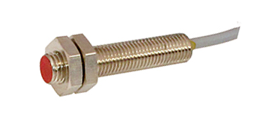](https://electricalacademia.com/wp-content/uploads/2017/08/Inductive-Proximity-Switch.png)

The inductive proximity sensor contains a certain type of solid-state control system. It contains an oscillator circuit that generates a high-frequency magnetic field. When the metal object enters the field, it disturbs the magnetic field, this disturbance results in a change of state in the high-frequency circuit.

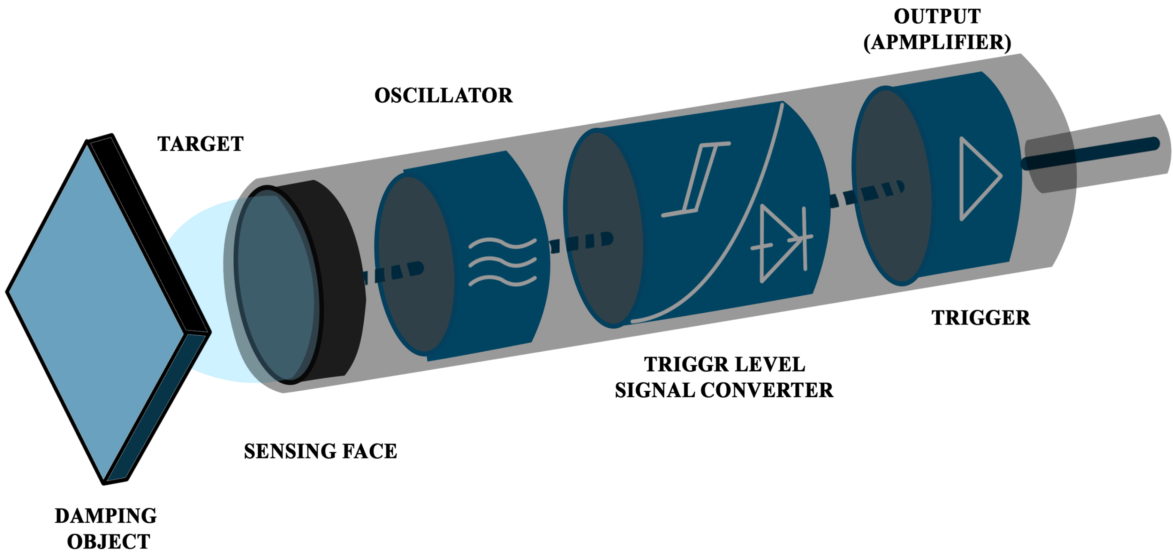

The oscillator creates a symmetrical, oscillating magnetic field that radiates from the ferrite core and coil array at the sensing face. When a ferrous target enters this magnetic field, small independent electrical currents (eddy currents) which are **induced**on the metal’s surface.

[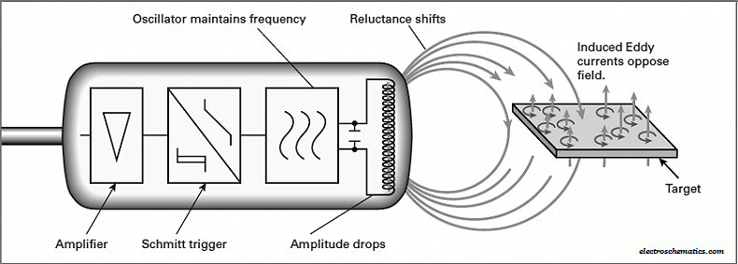](https://robu.in/wp-content/uploads/2020/02/inductive-sensor-working-principle.png)

An inductive proximity sensor has the frequency range from 10 to 20 Hz in ac, or 500 Hz to 5 kHz in dc. Because of magnetic field limitations, inductive sensors have a relatively narrow sensing range like from fractions of millimetres to 60 mm on an average.

[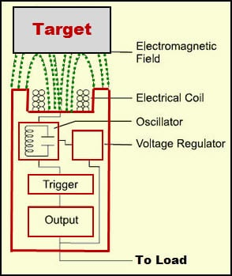](https://robu.in/wp-content/uploads/2020/02/Proximity-Sensor-Circuit-Diagram-when-Target-is-Detected.jpg)

Due to this, load will be caused on the sensor that decreases the electromagnetic field amplitude. If the metal object moves towards the [proximity sensor](https://www.elprocus.com/types-of-sensors-with-circuits/),  the eddy current will increase accordingly. Thus, the load on the oscillator will increase, which decreases the field amplitude.

The Schmitt trigger block monitors the amplitude of the oscillator and at particular level (predetermined level) the trigger circuit switches on or off the sensor. If the metal object or target is moved away from the proximity sensor, then the amplitude of the oscillator will increase.

[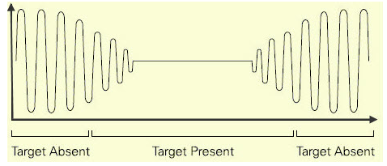](https://robu.in/wp-content/uploads/2020/02/Oscillator-waveform.png)

The above image shows the waveform of the inductive proximity sensor oscillator in the presence of the target and in the absence of the target.

Nowadays, inductive proximity sensors are available with different operating voltages. These inductive proximity sensors are available in AC, DC, and AC/DC modes (universal modes). The operating range of the proximity sensor circuits is from 10V to 320V DC and 20V to 265V AC.

**Advantages of Inductive Proximity Sensors**

* Contactless detection
* Environment adaptability- resistant to common conditions seen in industrial areas such as dust and dirt
* Capable and versatile in metal sensing
* High switching rate
* No moving parts, ensuring a longer service life

**Disadvantages of Inductive Proximity Sensors**

* Lack in detection range, averaging a max range of up to 60 mm
* Can only detect metal objects
* External conditions like extreme temperatures, cutting fluids or chemical effects on the performance of the sensor.

**Applications of Inductive Proximity Sensors**

* Machine tools, assembly line, automotive industry
* Detection of metal parts in harsh environments
* High-speed moving parts

**Capacitive Proximity Sensors**

[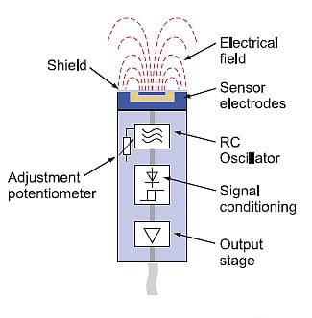](https://robu.in/wp-content/uploads/2020/03/Cap-Prox-Sensor.jpg)Capacitive Proximity Sensors detect changes in the capacitance between the sensing object and the Sensor. As per the name, capacitive proximity sensors operate by noting a change in the capacitance read by the sensor.

The amount of capacitance varies depending on the size and distance of the sensing object. An ordinary Capacitive Proximity Sensor is similar to a capacitor with two parallel plates, where the capacity of the two plates detected.

One of the plates is the object being measured (with an imaginary ground), and the other is the Sensor’s sensing surface. It detects the changes in the capacity generated between these two poles. The detection of the object depends on their dielectric constant, but they include resin and water in addition to metals.

The [**capacitive proximity sensor**](https://robu.in/product/autonics-cr18-8dp-dc1030-8mm-m18-capacitive-proximity-sensor-pnp-no-shielded/) consist a high-frequency oscillator along with a sensing surface formed by two metal electrodes. When an object comes near the sensing surface, it enters the electrostatic field of the electrodes and changes the capacitance of the oscillator.

[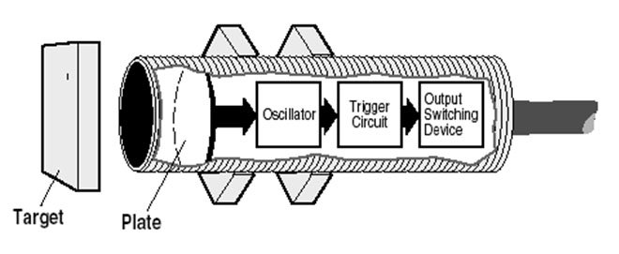](https://robu.in/wp-content/uploads/2020/03/operation_capacitive.jpg)

As a result, the oscillator circuit starts oscillating and changes the output state of the sensor when it reaches certain amplitude. As the object moves away from the sensor, the oscillator’s amplitude decreases, switching the sensor back to its initial state.

A typical sensing range for capacitive proximity sensors is from a few millimetres up to about 1 inch. (or 25 mm), and some sensors have an extended range up to 2 inch. Where capacitive sensors really excel, however, is in applications where they must detect objects through some kind of material such as a bag, bin, or box. They can tune out non-metallic containers and can be tuned or set to detect different levels of liquids or solid materials.

[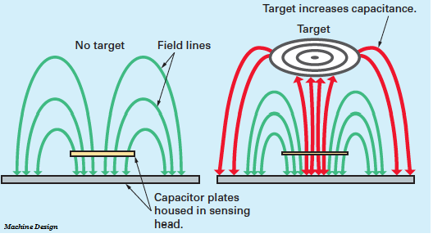](https://robu.in/wp-content/uploads/2020/03/Capacitive-sensor.png)  
 

The capacitive proximity sensor detects the larger dielectric constant of a target easily.  This makes possible the detection of materials inside non-metallic containers because the liquid has a much higher [dielectric constant](https://www.yourelectricalguide.com/2018/06/dielectric-strength-dielectric-constant-dielectric-loss.html) than the container, which gives the sensor ability to see through the container and detect the liquid.  
   
For best operation, they should use in an environment with relatively constant temperature and humidity.

**When dealing with non-conductive targets there are three factors that determine the sensing distance.**

* The size of the active surface of the sensor – the larger the sensing face the longer the sensing distance
* The capacitive material properties of the target object, also referred to as the dielectric constant – the higher the constant the longer the sensing distance
* The surface area of the target object to be sensed – the larger the surface area the longer the sensing distance

**Other factors that have minimal effect on the sensing distance**

* Temperature
* Speed of the target object

The point at which the proximity sensor recognizes an incoming target is the **operating point**. The point at which an outgoing target causes the device to switch back to its normal state is the **release point**. The area between operating and release points is the **hysteresis zone.**

Most proximity sensors are equip with an LED status indicator to verify the output switching action.

**The difference between Inductive and Capacitive Proximity Sensor:**

Inductive sensors use a magnetic field to detect objects. Capacitive sensors use an electric field. In order to be sense by an inductive sensor an object must be conductive. This limits suitable targets to metal objects (for the most part). In order to be sense by a capacitive sensor the target doesn’t need to be conductive.

A capacitive sensor will react to an object acting as a dielectric material as well as a conductive object. This makes metal and non-metal objects suitable targets.

**Advantages of Capacitive proximity sensors**

* Contactless detection
* A wide array of materials can detect
* Able to detect objects through non-metallic walls with its wide sensitivity band
* Well-suited to be used in an industrial environment
* Contains potentiometer that allows users to adjust sensor sensitivity, such that only wanted objects will be sensed
* No moving parts, ensuring a longer service life

**Disadvantages of Capacitive proximity sensors**

* Relative low range, though incremental increase from inductive sensors
* Higher price as compared to inductive sensors

**Capacitive sensing technology uses in other sensing technologies such as:**

* flow
* pressure
* liquid level
* spacing
* thickness
* ice detection
* shaft angle or linear position
* dimmer switches
* key switches
* x-y tablet
* accelerometers

**Optical / Photoelectric Proximity Sensor:**

A complete [optical proximity sensors](https://robu.in/product/e18-d80nk-adjustable-infrared-sensor-switch-3-80cm/) includes a light source, and a sensor that detects the light. These sensors detect objects directly in front of them by the detecting the sensor’s own transmitted light reflected back from an object’s surface.

Photoelectric sensors are able to detect both metallic and non-metallic targets. They uses in many applications like in mobile phones and for level sensing. In the iPhone, the sensor is used to deactivate the touch screen as the user brings the device closer to the face.

[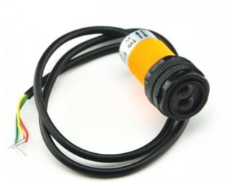](https://robu.in/wp-content/uploads/2020/04/art_42009850-314x252-1.jpg)

However, the main components of this sensor are emitter, detector and associated electronics. Emitter (Light Emitting Diode, laser diode) sends a beam of light. The detector (photo diode or[phototransistor](https://en.wikipedia.org/wiki/Photo%20transistor?redirect=no)) detects emitted light. Associated electronics required to amplify the detected signal.

The emitter sometimes called the sender transmits a beam of either visible or infrared light to the detecting receiver.

All[photoelectric sensors](https://robu.in/product-category/sensor/ir-and-pir-sensor/) operate under similar principles. Dark-on and light-on classifications refer to light reception and sensor output activity. With no reception of light, the output produces then the sensor is dark-on. If output from light received then it is light-on.

**Sensing Methods or Working Principle of Photoelectric Proximity Sensor:**

There are three main sensing methods of the photoelectric proximity sensor and they are,

* Through beam method
* Retro-reflective method
* Diffuse or Reflective method

**Through beam method**

In this type of method, an emitter sends out a beam of light directly in the line-of-sight of the emitter to a receiver. When an object breaks this beam of light, it detects as a presence. This type of setup requires two components they are an emitter and a separate detector, which makes it a bit more complex to install and wire. However, the advantage is that it’s the most accurate of the sensing methods with the longest sensing range.

[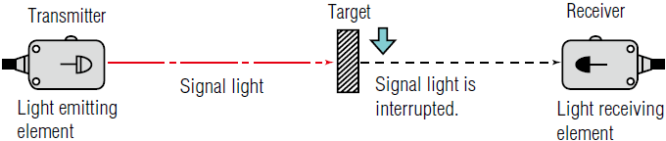](https://robu.in/wp-content/uploads/2020/04/Through-beam-method.png)

New [laser diode](https://robu.in/?category=&s=laser+diode&search_posttype=product) emitter models can transmit a well-collimated beam 60 m for increased accuracy and detection. At these distances, some through-beam laser sensors are capable of detecting an object the size of a fly, at close range, that becomes 0.01 mm. One ability unique to through beam photoelectric sensors is effective sensing in the presence of thick airborne contaminants.

**Retro-reflective method**

In this method, detection occurs when the light path breaks or disturbs. Both the light emitting and light receiving elements are in same housing. The light from the emitting element hits the reflector and returns to the light receiving element. When a target is present, the light gets interrupt.

[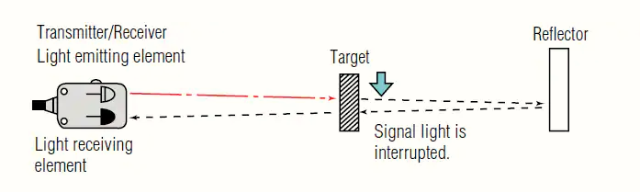](https://robu.in/wp-content/uploads/2020/04/retor-reflective.png)

One reason for using a retro-reflective sensor over a through-beam sensor is for the convenience of one wiring location, the opposing side only requires reflector mounting.

**Diffuse or Reflective method**

As in retro-reflective sensors, emitters and receivers located in the same housing. In this Diffuse method, Both the light emitting and light receiving elements contain in a single housing. The sensor receives the light reflected from the target.

[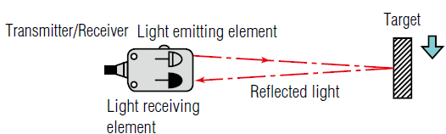](https://robu.in/wp-content/uploads/2020/04/reflective.png)

Diffuse photoelectric sensors are similar in some respects to reflective sensors. This is because like reflective sensors they emit a light beam in the direction of the object to be detected. However, instead of a reflector used to bounce the light back to a detector, the object to be sensed functions as the reflector, bouncing some of the light back to be detected and register an object’s presence.

Mostly, the diffuse sensors use in public washroom sinks, where they control automatic faucets. Hands placed under the spray head act as reflector, triggering (in this case) the opening of a water valve. diffuse sensors are somewhat color dependent, certain versions are suitable for distinguishing dark and light targets in applications that require sorting or quality control by contrast.

**Advantages of Photoelectric Proximity Sensor**

* The sensor senses all kinds of materials.
* It has longer life, long sensing range and very reliability.
* Very fast response time and less costly.
* Diffuse photoelectric sensor detects small objects including color mark and label detection.
* mostly retro-reflective type sensor can detect transparent objects.
* Through beam type can detect long range and it is tolerant of dirty environment.

**Disadvantages of Photoelectric Proximity Sensor**

* Over coarse of time lens get contaminated.
* Generally, the sensing range is affected due to color and reflectivity of the target.
* Through beam type requires transmitter (Tx) and receiver (Rx) at two separate locations
* Retro reflective type requires reflector in addition to Tx/Rx. This makes system installation complex

**Applications of Photoelectric Proximity Sensor**

The photoelectric proximity sensors use in different section. Few of them are as follow,

* **Checking objects on production lines or conveyors:**

photoelectric sensors can detect product size to spot any errors, or simply spot their absence. As well as picking up problems like misaligned caps on bottles. They are widely used in the food and pharmaceutical industries, and in packaging plants.

* **Counting of small objects:**

In some production environments, small items will fall from a vibrating conveyor belt into a packaging system or bag – and a photoelectric sensor can count them.

* **Detection of colours:**

Through scanning independently in red, green and blue light, with applications in multiple processes in the printing and packaging sectors.

* **Monitoring bigger areas for objects with light grids:**

Instead of using multiple sensors, a light grid uses parallel beams of light to cover a two-dimensional area.

* **Measuring distance:**

With multiple sensors, a triangulation process compares reflected laser beams and can use to accurately determine position and distance. for example, to check the location of manufacturing systems, or in automated transport applications.

* **Logistics and materials handling:**

In an automated warehouses with robotic pickers or trucks rely on position and object sensing to operate efficiently and safely.

* **Automatic doors:**

In buildings or public transport, photoelectric sensors detect when someone is standing by a door.

**Magnetic Proximity Sensor:**

Magnetic proximity sensors use for non-contact position detection beyond the normal limits of inductive sensors. In conjunction with a separate “damping” magnet, magnetic sensors offer very long sensing ranges from a small package size and can detect magnets through walls of non-ferrous metal, stainless steel, aluminium, plastic or wood.

[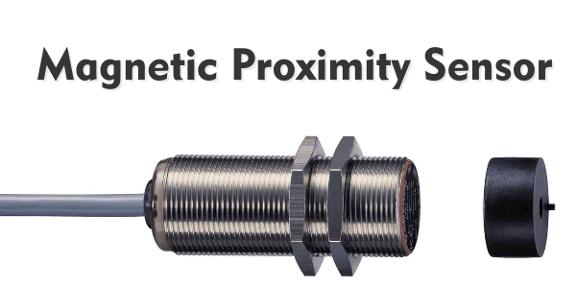](https://robu.in/wp-content/uploads/2020/04/magnetic-proximity-sensor.png)

Depending on the orientation of the magnetic field the sensor damped from the front or from the side. In the food industry, the magnetic sensor uses in connection with a cleaning device which pass through the inside of pipes.

**Output of Magnetic proximity sensor:**

The magnetic field sensor output can be linear in which its output voltage linearly relates to the magnetic field strength impinging on the detector, or binary in which the output is in one state when the measured magnetic field strength is greater than a particular threshold, and in the other state when the measured magnetic field strength is less than the threshold. Binary proximity sensors use to replace simple position-determining mechanical switches because they have no moving parts to wear or jam, and are therefore more reliable than their mechanical counterparts.

**Features of Magnetic proximity sensor:**

* Detection through plastic, wood, and any non-magnetisable metals
* Small housings with very long sensing ranges up to 70 mm
* Cylinder and rectangular designs satisfy space-dependent applications
* High mechanical stability in case of shock or vibration
* Flush or non-flush installation in non-magnetisable metals

**Working Principle of Magnetic Proximity Sensor**

There are several operating principles used including reed switches, GMR inductive, variable reluctance, magneto resistive or hall effect sensors.

1. **Variable reluctance**

Proximity sensors comprise of a permanent magnet and a pick-up coil. A VR sensor uses as a simple proximity sensor can determine the position of a mechanical link in a piece of industrial equipment.

A [Crankshaft position sensor](https://en.wikipedia.org/wiki/Crankshaft_position_sensor) (in an automobile engine) uses to provide the angular position of the crankshaft to the Engine control unit. The Engine control unit can then calculate engine speed (angular velocity).

A pickup uses in an electric guitar or in other musical instrument detect vibrations of the metallic "strings".

1. **Magneto-resistive**

Proximity sensors measure the magneto-resistive effect or the impact of the resistivity of a ferromagnetic material in the presence of a magnetic field.

[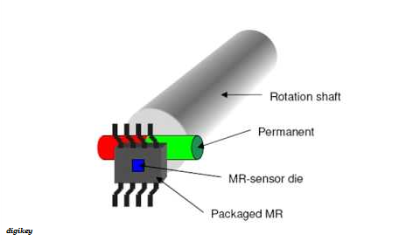](https://robu.in/wp-content/uploads/2020/04/Magneto-resistive.png)

Magneto-resistance is the tendency of a material to change the value of its electrical resistance in an externally applied magnetic field.

1. **Reed Switches**

Reed switches are magnetically actuated switches. They typically manufacture with two ferromagnetic reeds (contact blades), which seal powered in a glass capsule. In which consist of two low reluctance ferro-magnetic reeds enclosed in glass bulbs containing inert gas.

[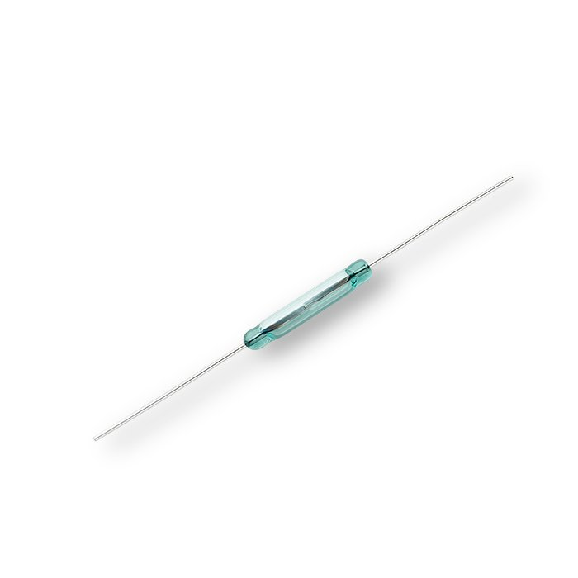](https://robu.in/wp-content/uploads/2020/04/Littelfuse_Reed_Switches_FLEX_14_Hi_Res.jpg.jpg)

A magnetic field from an electromagnet or a permanent magnet will cause the reeds to attract each other to establish an electrical circuit. An example of a reed switch application is to detect the opening of a door, when used as a proximity switch for a security alarm.

1. **Giant Magneto-Resistive Effect**

Magnetic sensors use GMR (Giant Magneto-Resistive Effect) technology. The measuring cell consists of resistors with several extremely fine, ferromagnetic and non-magnetic layers.

[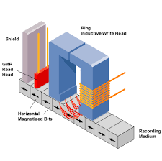](https://robu.in/wp-content/uploads/2020/04/GMR.png)

Two of these GMR resistors use to form a conventional Wheatstone bridge circuit which produces a large signal proportional to the magnetic field when a magnetic field is present. A threshold value defines and an output signal switches via a comparator.

The main application of GMR is magnetic field sensors, which use to read data in hard disk drives, [biosensors](https://en.wikipedia.org/wiki/Biosensor), [microelectromechanical systems](https://en.wikipedia.org/wiki/Microelectromechanical_systems) (MEMS) and other devices. GMR multi-layer structures also use in magneto-resistive random-access memory (MRAM) as cells that store one bit of information.

1. **Hall effect sensor**

Hall effect sensor is a device that uses to measure the magnitude of a magnetic field. Its output voltage is directly proportional to the magnetic field strength through it.

[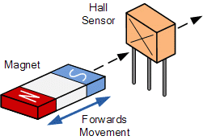](https://robu.in/wp-content/uploads/2020/04/HAll-effect-sesnor.png)

Hall effect sensors used for proximity sensing, positioning, speed detection, and current sensing applications. Frequently, a Hall sensor combines with threshold detection so that it acts as a switch.

**Advantages of Magnetic proximity sensor**

* Contacts are well protected against dust, oxidization and corrosion due to the hermetic glass bulb and inert gas; contacts are activated by means of a magnetic field rather than mechanical parts
* Special surface treatment of contacts assures long contact life
* Maintenance free
* Easy operation
* Reduced size

**Applications of Magnetic Proximity Sensor**

Magnetic sensors are used in many industrial applications for contactless current sensing, linear and angular position, and rotation sensing. Crocus’ magnetic sensors are designed to provide superior performance in all of these applications.

* **Magnetic Sensors for PDU**

The PDU (Power Distribution Unit) is a critical part of the data centre infrastructure. PDU equipment uses to supply AC or DC electrical power to servers. Typically, the PDU provides power filtering and intelligent load balancing together with remote monitoring.

* **Robotics and Factory Automation**

In factory automation, both linear and angular position sensing are imperative to carry out complex motor movements with high precision, repeatability and accuracy.  With the need for faster more efficient production lines, magnetic sensors are also used for linear and angular sensing, safety switches, and proximity detection.

* **White Goods**

New regulatory requirements for energy and water conservation in appliances can accomplish through additional intelligent sensing.  Crocus magnetic sensors provide the added intelligence for open/close door detection, fluid level, and contactless current sensing.

* **Used in Green Energy**

When it comes to alternative energy such as with wind and solar, magnetic sensors provide contactless current sensing, angular position sensing and switches.  For wind power, the angular position sensing allows for optimal wind power generation, while contactless current sensors provide solutions for power inverters and solar combiner boxes. Switches can also assist with safety applications in high voltage environments.

**PNP and NPN Sensor Concept and Interfacing to PLC:**

Proximity sensors are used to detect objects without making physical contact. There are 2-wire and 3-wire proximity sensors, and 3-wire proximity sensors are more popular. There are two main types of proximity sensors based on their output type: **NPN** and **PNP**.

Selecting the correct type of proximity sensor for a particular application can ensure the correct operation of a system. This article aims to provide an outline of the two main output types and a guide on how to connect a proximity sensor to a PLC.

**What Is an NPN Proximity Sensor?**

NPN proximity sensors provide an active LOW output. This means that when an object enters the detecting range of the sensor, the output of the sensor is connected with the ground. This type of sensor is also known as ‘[sinking](https://realpars.com/sinking-and-sourcing/)’ sensor.

**What Is A PNP Proximity Sensor?**

PNP proximity sensors provide an active HIGH output. When an object enters the detecting range of the sensor, the output of the sensor is connected with +24V. When connected to a PLC input, it detects this as a logic HIGH signal. PNP proximity sensors are also known as ‘[sourcing](https://realpars.com/sinking-and-sourcing/)’ sensors.

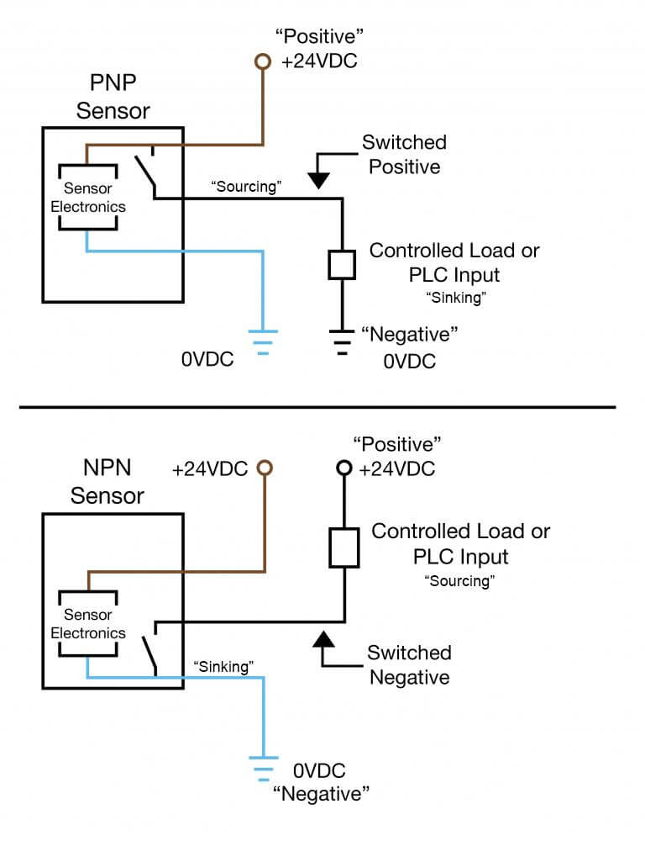**NPN And PNP Sensor Wiring:**

To easily remember the wiring of a 3-wire DC proximity sensor, use the following analogy:

**P**NP = Switched **P**ositive

**N**PN = Switched **N**egative

Proximity sensors are digital sensors. Therefore, they must always be connected to a 24V power source to function.

In the PNP sensor wiring, the load is **always connected to Negative.**The **P**ositive is switched when the proximity sensor detects an object. But, in the NPN sensor wiring, the load is **always connected to Positive**, and the **N**egative is switched when an object is detected.

**PNP vs NPN for 3 Wire Connection of A Sensor:**

Almost all the industrial proximity sensors are solid-state devices, meaning that they do not have moving parts inside. The most popular type of proximity sensor is the 3-wire type. They use PNP or NPN type transistors to switch the output when an object is detected.

Two of the wires are used to provide the sensor with power to operate, while the other wire is the output from the sensor.

At this point, t’s worth mentioning that being a PNP or NPN type sensor, **does not** imply if the sensor output is normally open (N/O) or normally closed (N/C). This is dependent only on the application. (I.e., a PNP sensor can be either N/O or N/C as can an NPN be either N/O or N/C)

Let’s have a look at a relay-type circuit, where a relay is operated directly by a proximity sensor.

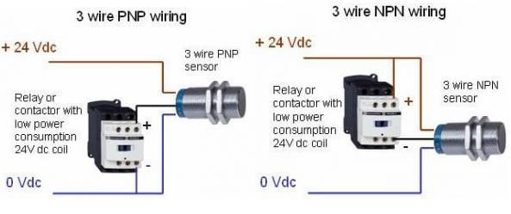

The difference between the two wirings is that in the PNP type wiring, the relay is always connected to 0V, and +24V is switched by the sensor. But in the NPN type wiring, the relay is always connected to +24V and the sensor switches the 0V connection. Regardless, the sensor is connected to +24 and 0V to supply power to it.

**How To Connect NPN/PNP Proximity Sensor To PLC**

Identifying The Color Code Of A 3-Wire Proximity Sensor

On a 3-wire sensor, the wiring color code is as follows: (Brown: +24V, Blue: 0V, Black: output)

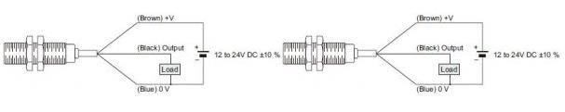

**Wiring An NPN Type 3-Wire Proximity Sensor to a PLC**

Before connecting the sensor to the PLC, make sure that the PLC is configured to the **‘sourcing’**type. For an example on a Siemens S7-200 PLC, this can be done by connecting input 1M to +24V. This means that the PLC will ‘source current’ out of the input, and the NPN sensor will ‘sink current’ when it detects an object.

If the input is fed to the PLC through an input card, it must be a **sourcing type** input card, or else a configurable one. The [SIMATIC S7-1200, Digital Input SB 1221](https://mall.industry.siemens.com/mall/en/WW/Catalog/Product/6ES7221-3AD30-0XB0) is such a sourcing-type input card.

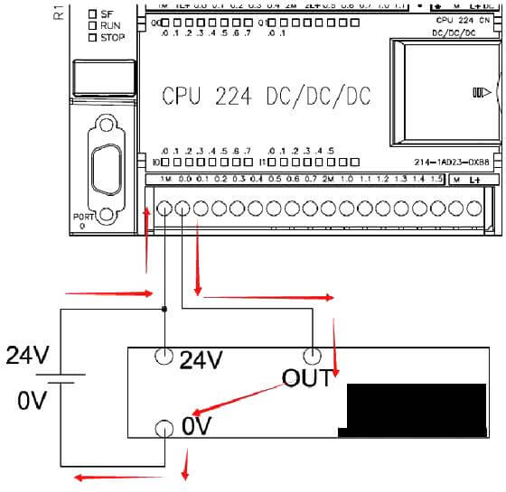

**Wiring A PNP Type 3-Wire Proximity Sensor to A PLC**

For a PNP type sensor, the PLC needs to be configured as a **‘sinking’** type. Connecting the input 1M to 0V will configure the PLC as input sinking. With this configuration, the sensor can ‘source current’ and the PLC will ‘sink current’ to detect sensor output.

For a PNP type proximity sensor, if an input card is used, it must be a ‘**sinking**’type card. The [S7-1200, Digital Input SM 1221](https://mall.industry.siemens.com/mall/en/WW/Catalog/Product/6ES7221-1BF32-0XB0) input card for S7-1200 PLCs is a sink/source configurable input card and it can interface with either type of sensor.

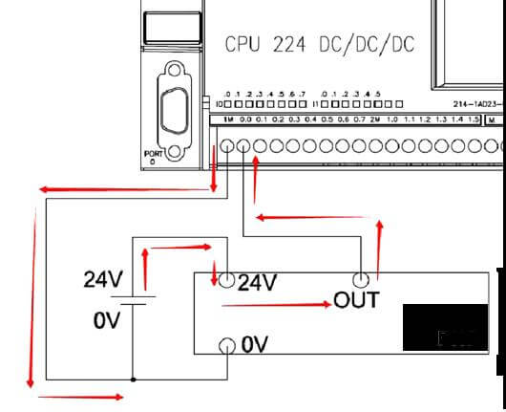

**How to Choose A PNP or NPN Sensor?**

Selecting PNP vs NPN depends mostly on the application and the availability. As [Arrow Electronics](https://www.arrow.com/en/research-and-events/articles/npn-vs-pnp-in-circuit-design-and-industrial-controls) mentions, NPN sensors are more common in the automation industry in the Asia region. PNP sensors are more popular in Europe and America.

NPN sensors are used in high-speed applications because they are faster than PNP sensors. They also find more applications in relay circuits than PLC circuits. PNP sensors are more popular in PLC circuits as they can prevent false-positive signals if damaged and shorted with the ground.

**How to Know If Proximity Sensor Is NPN or PNP?**

The easiest way to identify the sensor type is by observing the sticker on the body of the sensor. This sticker can sometimes have a wiring diagram printed on it as well. If the sensor is not marked and is installed, a multimeter can help identify the sensor type. Power on the system and carefully measure the voltage between 0V and the black wire. If there is a voltage of +24V when the sensor is active, it is a PNP-type sensor. If there is a 0V reading on the multimeter when the sensor is active, it is most likely an NPN sensor.

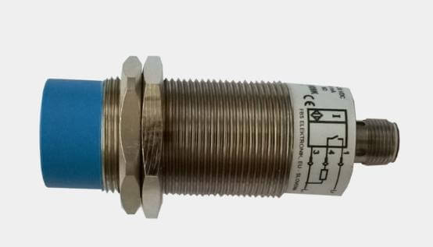

**4 – 20mA Current Loop:**

The DC current loop is used extensively in the instrumentation field to transmit process variable to indicators and controllers (PLC, DCS, Standalone controllers etc). It is also used to send control signals to field device to manipulate process variables such as temperature, level and flow. This can be done by sending signals from a controller (PLC, DCS, or other control equipment) to final control element such as control valve, pumps etc.

The standard current range used in these loops is 4 to 20 mA (milli ampere) and this value is normally converted to 1 to 5 VDC by a 250-ohm resistor at the input to controllers and indicator. These instruments are normally high input impedance electronic devices that draw virtually no current from the instrument loop.

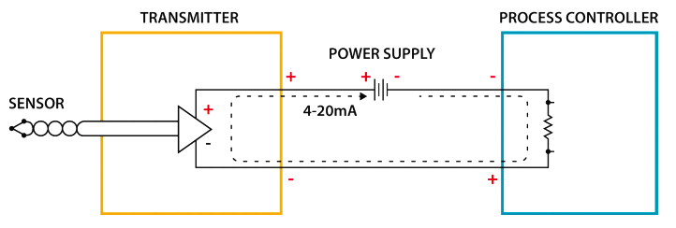

**Why to use 4-20 ma or What are the advantages of using current loop?**

1.Only two wires are required for each remotely mounted field transmitter. So cost saving is one of the advantage.

2.Current loop is not affected by electrical noise.

3.Current loop is not affected by changes in lead wire resistance caused by temperature changes.

**HART Protocol:**

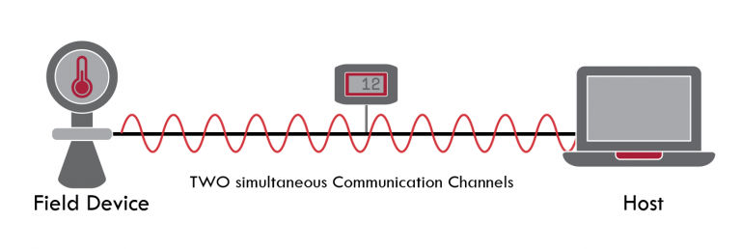HART is a bi-directional communication protocol that provides data access between intelligent field instruments and host systems. A host can be any software application from technician's hand-held device or laptop to a plant's process control, asset management, safety or other system using any control platform. Communication occurs between two HART-enabled devices, typically a smart field device and a control or monitoring system. Instrumentation grade wiring and standard termination practices assure reliable communication.

HART provides two simultaneous communication channels, one analog, the other digital:  A 4-20mA signal communicates the primary measured value (PV) as an analog  value of current using the wiring that provides power to the instrument.  The host system then converts the current value to a physical value according to parameters defined by HART Software.  For example, 7 mA = 80 degrees F.

Digital device information is communicated by encoding a digital signal, generally using a technique known as Frequency Shift Keying on the same 4-20mA wiring used for analog communications. The digital signal contains information from the device including PV, device status, diagnostics, and additional measured or calculated values, etc.

Together, the two communication channels provide a complete field communications solution that is easy to design, simple to use, low cost and extremely reliable.

**How HART Works**

“HART” is an acronym for Highway Addressable Remote Transducer. The HART Protocol makes uses Frequency Shift Keying (FSK) standard to superimpose digital communication signals at a low level on top of the 4-20mA. This enables two-way field communication to take place and makes it possible for additional information beyond just the normal process variable to be communicated to/from a smart field instrument.

The HART Protocol communicates at 1200 bps without interrupting the 4-20mA signal and allows a host application (master) to get two or more digital updates per second from a smart field device. As the digital FSK signal is phase continuous, there is no interference with the 4-20mA signal. The HART Protocol provides two simultaneous communication channels: the 4-20mA analog signal and a digital signal. The 4-20mA signal communicates the primary measured value (in the case of a field instrument) using the 4-20mA current loop - the fastest and most reliable industry standard. Additional device information is communicated using a digital signal that is superimposed on the analog signal.

The digital signal contains information from the device including device status, diagnostics, additional measured or calculated values, etc. Together, the two communication channels provide a low-cost and very robust complete field communication solution that is easy to use and configure.

**Modes of HART Protocol:**

HART devices can operate in one of two network configurations—point to point or multidrop.

**POINT-TO-POINT**

In point-to-point mode, the traditional 4–20 mA signal is used to communicate one process variable, while additional process variables, configuration parameters, and other device data are transferred digitally using the HART protocol (Figure 2). The 4–20 mA analog signal is not affected by the HART signal and can be used for control in the normal way. The HART communication digital signal gives access to secondary variables and other data that can be used for operations, commissioning, maintenance, and diagnostic purposes.

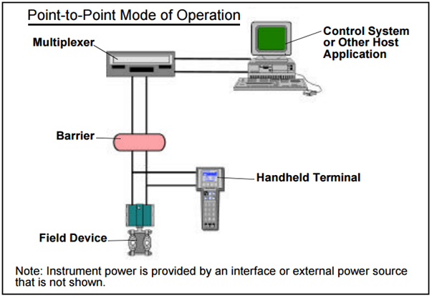

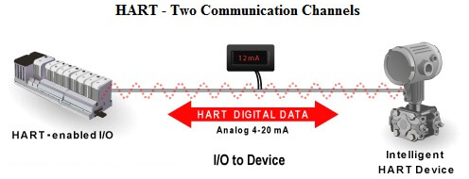

The HART Protocol provides for up to two masters (primary and secondary). This allows secondary masters such as handheld communicators to be used without interfering with communications to/from the primary master, i.e. control/monitoring system.

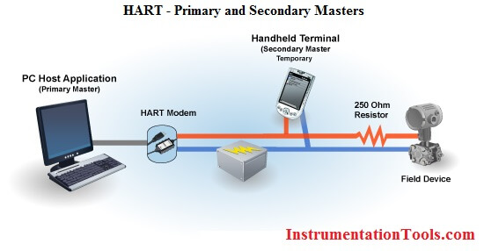

The HART Protocol permits all digital communication with field devices in either point-to-point or multidrop network configurations:

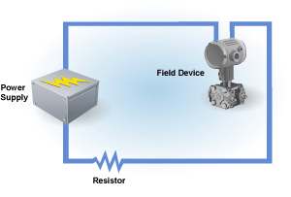

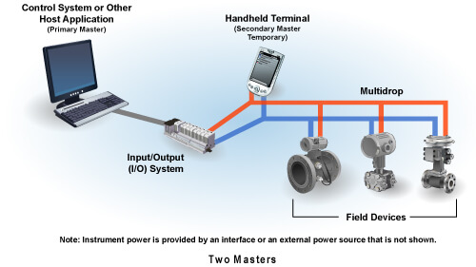

**Multidrop Configuration**

There is also an optional “burst” communication mode where a single slave device can continuously broadcast a standard HART reply message. Higher update rates are possible with this optional burst communication mode and use is normally restricted to point-to-point configuration.

The multidrop mode of operation requires only a single pair of wires and, if applicable, safety barriers and an auxiliary power supply for up to 15 field devices. All process values are transmitted digitally. In multidrop mode, all field device polling addresses are >0, and the current through each device is fixed to a minimum value (typically 4 mA).

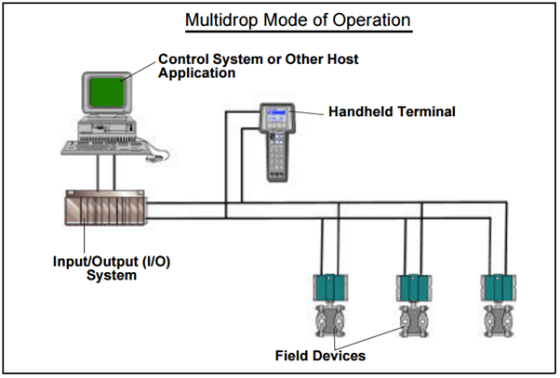

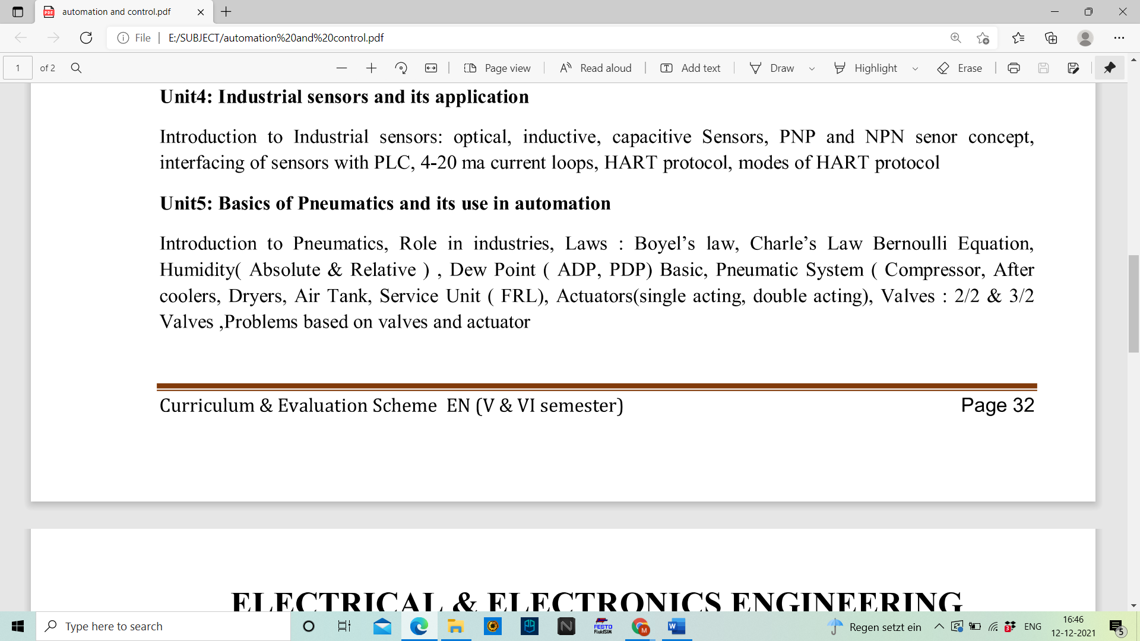



Humidity can be measured in several ways: either by relative humidity, absolute humidity or dew point.  Below we try to explain the different ways of measuring humidity.

**ABSOLUTE HUMIDITY:**

Relative humidity is the most common measurement, However, in order to understand relative humidity, it is helpful to first understand absolute humidity. Absolute humidity is the water content of air. In other words, the mass of water vapor divided by the mass of dry air in a volume of air.  It does not take temperature into consideration. Absolute humidity in the atmosphere ranges from near zero to roughly 30 grams per cubic meter when the air is saturated at 30 °C.  **The hotter the air is, the more water it can contain**. Absolute humidity is measured in g/kg. If you take an average summer day 22°C and 55% RH you would have an absolute humidity of 9 g/kg.

**RELATIVE HUMIDITY:**

Relative humidity, expressed as a percent, measures the current absolute humidity relative to the maximum for that temperature (which depends on the current air temperature). A reading of 100 percent relative humidity means that the air is totally saturated with water vapor and cannot hold any more, creating the possibility of rain in the atmosphere and condensation in the factory. Further, when the moisture content remains constant and temperature increases, relative humidity decreases. For example, if we have air at 22°C and 55% we would have an absolute humidity level of 9 g/kg. Warmer air can hold more humidity. So, if we increase the temperature to 30°C but keep the absolute humidity the same (9 g/kg) the relative humidity would now be 34% RH. Similarly, if we decrease the temperature from 22°C to 12 °C and kept the absolute humidity the same we would now have a relative humidity of 100% RH.

**DEW POINT:**

The dew point is the saturation temperature for water in air. The dew point is associated with relative humidity. A high relative humidity implies that the dew point is closer to the current air temperature. Relative humidity of 100% indicates the dew point is equal to the current temperature and that the air is maximally saturated with water. For example, at 22°C and 100% RH the air will have a dew point of 22°C also. Likewise, to take our previous example, air at 22 and 55% RH has a dew point of 12°C. So if cooled this air down, 12°C is the temperature at which moisture will be released from the air and condense on surrounding surfaces.

**Pneumatic system**

Pneumatic technology deals with the study of behavior and applications of compressed air in our daily life in general and manufacturing automation in particular. Pneumatic systems use air as the medium which is abundantly available and can be exhausted into the atmosphere after completion of the assigned task.

1. 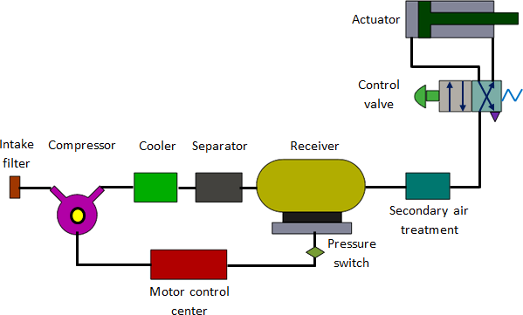***Basic Components of Pneumatic System:***

**Fig. 5.1 Components of a pneumatic system**

Important components of a pneumatic system are shown in fig. 5.1.

* 1. **Air filters:** These are used to filter out the contaminants from the air.
  2. **Compressor:** Compressed air is generated by using air compressors. Air compressors are either diesel or electrically operated. Based on the requirement of compressed air, suitable capacity compressors may be used.
  3. **Air cooler:** During compression operation, air temperature increases. Therefore, coolers are used to reduce the temperature of the compressed air.
  4. **Dryer:** The water vapor or moisture in the air is separated from the air by using a dryer.
  5. **Control Valves:** Control valves are used to regulate, control and monitor for control of direction flow, pressure etc.
  6. **Air Actuator:** Air cylinders and motors are used to obtain the required movements of mechanical elements of pneumatic system.
  7. **Electric Motor:** Transforms electrical energy into mechanical energy. It is used to drive the compressor.
  8. **Receiver tank*:*** The compressed air coming from the compressor is stored in the air receiver.

1. ***Receiver tank***

The air is compressed slowly in the compressor. But since the pneumatic system needs continuous supply of air, this compressed air has to be stored. The compressed air is stored in an air receiver as shown in Figure 5.2. The air receiver smoothens the pulsating flow from the compressor. It also helps the air to cool and condense the moisture present. The air receiver should be large enough to hold all the air delivered by the compressor. The pressure in the receiver is held higher than the system operating pressure to compensate pressure loss in the pipes. Also, the large surface area of the receiver helps in dissipating the heat from the compressed air. Generally, the size of receiver depends on,

* Delivery volume of compressor.
* Air consumption.
* Pipeline network
* Type and nature of on-off regulation
* 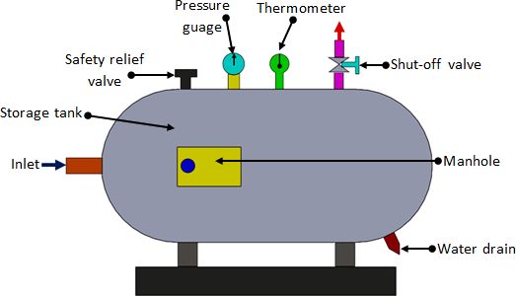Permissible pressure difference in the pipelines

**Fig.5.2 Air receiver**

1. ***Compressor:***

It is a mechanical device which converts mechanical energy into fluid energy. The compressor increases the air pressure by reducing its volume which also increases the temperature of the compressed air. The compressor is selected based on the pressure it needs to operate and the delivery volume.

The compressor can be classified into two main types

1. Positive displacement compressors and
2. Dynamic displacement compressor

Positive displacement compressors include piston type, vane type, diaphragm type and screw type.

* 1. 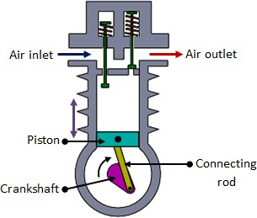**Piston compressors**

**Fig. 5.3 Single acting piston compressor**

Piston compressors are commonly used in pneumatic systems. The simplest form is single cylinder compressor (Fig. 5.3). It produces one pulse of air per piston stroke. As the piston moves down during the inlet stroke the inlet valve opens and air is drawn into the cylinder. As the piston moves up the inlet valve closes and the exhaust valve opens which allows the air to be expelled. The valves are spring loaded. The single cylinder compressor gives significant amount of pressure pulses at the outlet port. The pressure developed is about 3-40 bar.

* 1. 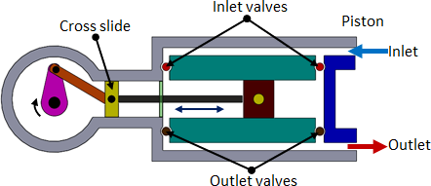**Double acting compressor**

**Fig. 5.4 Double acting piston compressor**

The pulsation of air can be reduced by using double acting compressor as shown in Figure 5.4. It has two sets of valves and a crosshead. As the piston moves, the air is compressed on one side whilst on the other side of the piston, the air is sucked in. Due to the reciprocating action of the piston, the air is compressed and delivered twice in one piston stroke. Pressure higher than 30bar can be produced.

* 1. 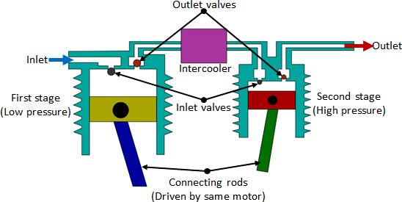**Multistage compressor**

**Fig. 5.5 Multi-stage compressor**

As the pressure of the air increases, its temperature rises. It is essential to reduce the air temperature to avoid damage of compressor and other mechanical elements. The multistage compressor with intercooler in-between is shown in Figure 5.5. It is used to reduce the temperature of compressed air during the compression stages. The inter- cooling reduces the volume of air which used to increase due to heat. The compressed air from the first stage enters the intercooler where it is cooled. This air is given as input to the second stage where it is compressed again. The multistage compressor can develop a pressure of around 50bar.

* 1. **Combined two stage compressors**

In this type, two-stage compression is carried out by using the same piston (Fig. 5.6). Initially when the piston moves down, air is sucked in through the inlet valve. During the compression process, the air moves out of the exhaust valve into the intercooler. As the piston moves further the stepped head provided on the piston moves into the cavity thus causing the compression of air. Then, this is let out by the exhaust port.

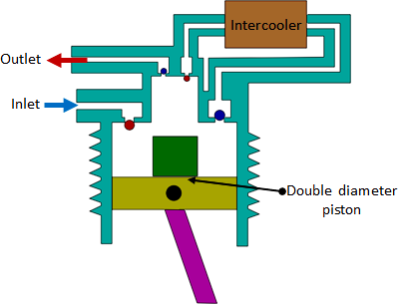**Fig. 5.6 Combined to stage compressor**

**Compressors**

1. 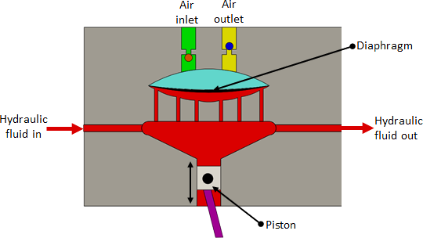***Diaphragm compressor***

**Fig. 5.7 Diaphragm compressor**

These are small capacity compressors. In piston compressors the lubricating oil from the piston’s walls may contaminate the compressed air. The contamination is undesirable in food, pharmaceutical and chemical industries. For such applications diaphragm type compressor can be used. Figure 5.7 shows the construction of Diaphragm compressor. The piston reciprocates by a motor driven crankshaft. As the piston moves down it pulls the hydraulic fluid down causing the diaphragm to move along and the air is sucked in. When the piston moves up the fluid pushes the diaphragm up causing the ejection of air from the outlet port. Since the flexible diaphragm is placed in between the piston and the air no contamination takes place.

1. ***Screw compressor***

Piston compressors are used when high pressures and relatively low volume of air is needed. The system is complex as it has many moving parts. For medium flow and pressure applications, screw compressor can be used. It is simple in construction with less number of moving parts. The air delivered is steady with no pressure pulsation. It has two meshing screws. The air from the inlet is trapped between the meshing screws and is compressed. The contact between the two meshing surface is minimum, hence no cooling is required. These systems are quite in operation compared to piston type. The screws are synchronized by using external timing gears.

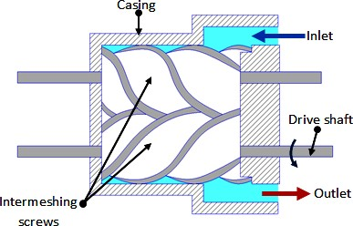

**Fig. 5.8 Screw compressor**

1. 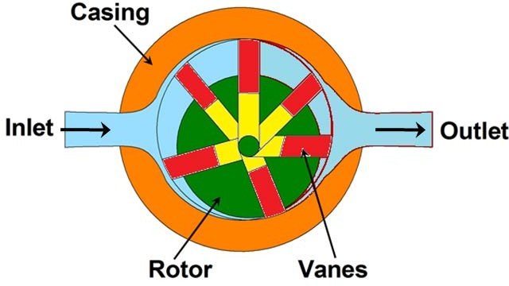***Rotary vane compressors***

**Fig. 5.9 Rotary vane compressor**

The principle of operation of vane compressor is similar to the hydraulic vane pump. Figure 5.9 shows the working principle of Rotary vane compressor. The unbalanced vane compressor consists of spring-loaded vanes seating in the slots of the rotor. The pumping action occurs due to movement of the vanes along a cam ring. The rotor is eccentric to the cam ring. As the rotor rotates, the vanes follow the inner surface of the cam ring. The space between the vanes decreases near the outlet due to the eccentricity. This causes compression of the air. These compressors are free from pulsation. If the eccentricity is zero no flow takes place.

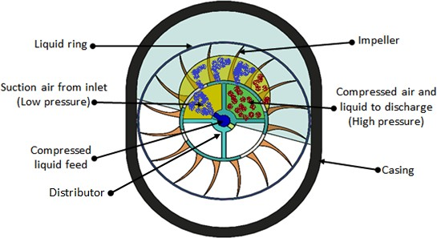

**Fig. 5.10 Liquid ring compressor**

Liquid ring vane compressor is a variation of vane compressors. Figure 5.10 shows the construction of Liquid ring compressor. The casing is filled with liquid up to rotor center. The air enters the compressor through the distributor fixed to the compressor. During the impeller rotation, the liquid will be centrifuged along the inner ring of the casing to form the liquid ring. There are two suction and discharge ports provided in the distributor. During the first quarter of cycle, the air is sucked in both suction chambers of the casing and during the second quarter of the cycle, the air is compressed and pushed out through the two discharge ports. During the third and fourth quarters of the cycle, the process is repeated. This type of compressor has no leakage and has minimal friction. For smooth operation, the rotation speed should be about 3000 rpm. The delivery pressure is low (about 5 bar).

1. 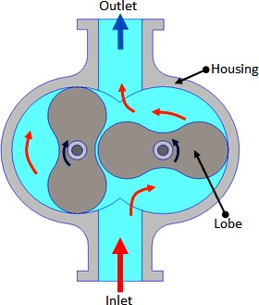***Lobe compressor***

**Fig. 5.11 Lobe compressor**

The lobe compressor is used when high delivery volume but low pressure is needed. It consists of two lobes with one being driven and the other driving. Figure 5.11 shows the construction and working of Lobe compressor. It is similar to the Lobe pump used in hydraulic systems. The operating pressure is limited by leakage between rotors and housing. As the wear increases during the operation, the efficiency falls rapidly.

1. ***Dynamic compressors***

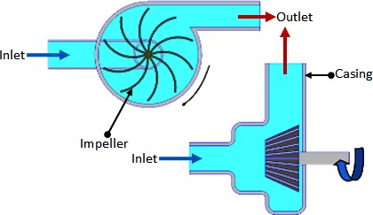

**Fig. 5.12 Blower (Centrifugal type)**

When very large volume of compressed air is required in applications such as ventilators, combustion system and pneumatic powder blower conveyors, the dynamic compressor can be used. The pressure needed is very low in such applications. Figure 5.12 shows a typical Centrifugal type blower. The impeller rotates at a high speed. Large volume of low pressure air can be provided by blowers. The blowers draw the air in and the impeller flings it out due to centrifugal force. Positive displacement

compressors need oil to lubricate the moving parts, whereas the dynamic compressors have no such need. The efficiency of these compressors is better than that of reciprocating types.

**Air Treatment and Pressure Regulation**

1. ***Air treatment stages***

For satisfactory operation of the pneumatic system the compressed air needs to be cleaned and dried. Atmospheric air is contaminated with dust, smoke and is humid. These particles can cause wear of the system components and presence of moisture may cause corrosion. Hence it is essential to treat the air to get rid of these impurities. The air treatment can be divided into three stages as shown in Figure 5.13.

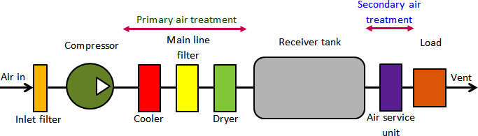

Fig. 5.13 Stages of air treatment

In the first stage, the large sized particles are prevented from entering the compressor by an intake filter. The air leaving the compressor may be humid and may be at high temperature. The air from the compressor is treated in the second stage. In this stage temperature of the compressed air is lowered using a cooler and the air is dried using a dryer. Also an inline filter is provided to remove any contaminant particles present. This treatment is called primary air treatment. In the third stage which is the secondary air treatment process, further filtering is carried out. A lubricator introduces a fine mist of oil into the compressed air. This will help in lubrication of the moving components of the system to which the compressed air will be applied.

* 1. **Filters**

To prevent any damage to the compressor, the contaminants present in the air need to be filtered out. This is done by using inlet filters. These can be dry or wet filters. Dry filters use disposable cartridges. In the wet filter, the incoming air is passed through an oil bath and then through a fine wire mesh filter. Dirt particles cling to the oil drops during bubbling and are removed by wire mesh as they pass through it. In the dry filter the cartridges are replaced during servicing. The wet filters are cleaned using detergent solution.

* 1. **Cooler**

As the air is compressed, the temperature of the air increases. Therefore the air needs to be cooled. This is done by using a cooler. It is a type of heat exchanger. There are two types of coolers commonly employed viz. air cooled and water cooled. In the air cooled type, ambient air is used to cool the high temperature compressed air, whereas in the water cooled type, water is used as cooling medium. These are counter flow type coolers where the cooling medium flows in the direction opposite to the compressed air. During cooling, the water vapor present will condense which can be drained away later.

1. ***Main line filter***

These filters are used to remove the water vapors or solid contaminants present in the pneumatic systems main lines. These filters are discussed in detail as follows.

* 1. **Air filter and water trap**

Air filter and water trap is used to

* + - prevent any solid contaminants from entering in the system.
    - 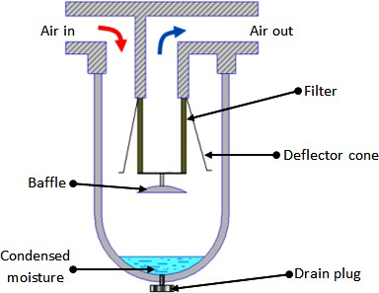condense and remove water vapor that is present in the compressed air.

Fig. 5.14 Air filter and water trap

The filter cartridge is made of sintered brass. The schematic of the filter is shown in Fig. 5.14. The thickness of sintered cartridge provides random zigzag passage for the air to flow-in which helps in arresting the solid particles. The air entering the filter swirls around due to the deflector cone. The centrifugal action causes the large contaminants and water vapor to be flung out, which hit the glass bowl and get collected at the bottom. A baffle plate is provided to prevent the turbulent air from splashing the water into the filter cartridge. At the bottom of the filter bowl there is a drain plug which can be opened manually to drain off the settled water and solid particles.

* 1. **Refrigerated dryers**

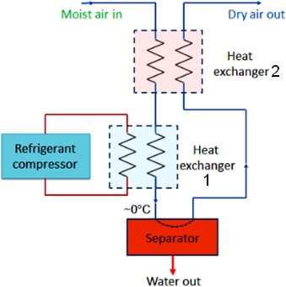

**Fig. 5.15 Refrigerated dryers**

It consists of two heat exchangers, refrigerant compressor and a separator. The system circuitry is shown in Figure 5.15. The dryer chills the air just above 0 °C which condenses the water vapor. The condensate is collected by the separator. However, such low temperature air may not be needed at the application. Therefore, this chilled air is used to cool the high temperature air coming out from the compressor at heat exchanger 2. The moderate temperature dry air coming out from the heat exchanger 2 is then used for actual application; whilst the reduced temperature air from compressor will further be cooled at heat exchanger 1. Thus, the efficiency of the system is increased by employing a second heat exchanger.

* 1. **Chemical dryers**

When absolute dry air is needed chemical dryers are used. These dryers are of two types viz. adsorption dryer and absorption dryer.

* + 1. Adsorption dryers

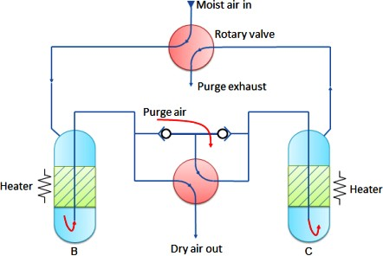

**Fig. 5.16 Adsorption dryer**

In Adsorption dryers, the moisture collects on the sharp edges of the granular material. The adsorbing materials can be silicon dioxide (silica gel) or other materials which exist in hydrated and dehydrated state (copper sulphate, activated alumina). Moisture from the adsorbing material can be released by heating in the column as shown in Fig. 5.16. At a given time, one column will dry the air while the other column will regenerate the adsorption material by heating and passing low purge air. The column B dries the air and column C regenerates. The rotary valves are opened using time clock at regular interval to reverse the process. These dryers are also called regenerative dryers.

* + 1. Absorption dryers

These are also called as deliquescent dryers. Figure 5.17 shows a schematic of the same. It uses chemical agents like phosphoric pentoxide or calcium chloride as drying agents. The moisture in the compressed air chemically reacts with the drying agent. The agent dissolves to form a liquid compound which collects at the bottom of the dryer where it can be drained out. The deliquescent agent has to be replenished regularly as it gets consumed during the drying process.

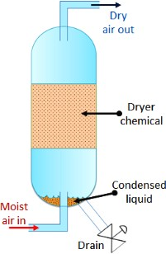

Fig. 5.17 Absorption dryer

1. ***Lubricators***

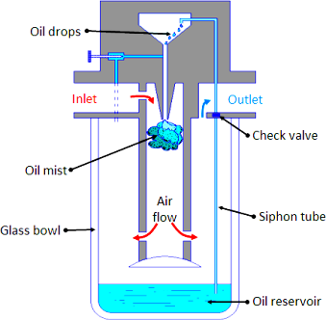

**Fig. 5.18 Air lubricator**

The compressed air is first filtered and then passed through a lubricator in order to form a mist of oil and air to provide lubrication to the mating components. Figure 5.18 shows the schematic of a typical lubricator. The principle of working of venturimeter is followed in the operation of lubricator. The compressed air from the dryer enters in the lubricator. Its velocity increases due to a pressure differential between the upper and lower changer (oil reservoir). Due to the low pressure in the upper chamber the oil is pushed into the upper chamber from the oil reservoir through a siphon tube with check valve. The main function of the valve is to control the amount of oil passing through it. The oil drops inside the throttled zone where the velocity of air is much higher and this high velocity air breaks the oil drops into tiny particles. Thus a mist of air and oil is generated. The pressure differential across chambers is adjusted by a needle valve. It is difficult to hold an oil mixed air in the air receiver as oil may settle down. Thus air is lubricated during secondary air treatment process. Low viscosity oil forms better mist than high viscosity oil and hence ensures that oil is always present in the air.

1. ***Pressure regulation***

* 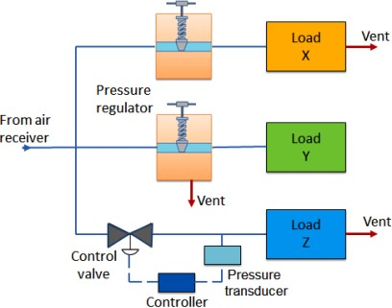In pneumatic systems, during high velocity compressed air flow, there is flow- dependent pressure drop between the receiver and load (application). Therefore the pressure in the receiver is always kept higher than the system pressure. At the application site, the pressure is regulated to keep it constant. There are three ways to control the local pressure, these are shown in Figure 5.19.

**Fig. 5.19 Types of pressure regulation**

* In the first method, load X vents the air into atmosphere continuously. The pressure regulator restricts the air flow to the load, thus controlling the air pressure. In this type of pressure regulation, some minimum flow is required to operate the regulator. If the load is a dead-end type which draws no air, the pressure in the receiver will rise to the manifold pressure. These types of regulators are called as ‘non-relieving regulators’, since the air must pass through the load.
* In the second type, load Y is a dead-end load. However, the regulator vents the air into atmosphere to reduce the pressure. This type of regulator is called as ‘relieving regulator’.
* The third type of regulator has a very large load Z. Therefore, its requirement of air volume is very high and can’t be fulfilled by using a simple regulator. In such cases, a control loop comprising of pressure transducer, controller and vent valve is used. Due to large load the system pressure may rise above its critical value. It is detected by a transducer. Then the signal will be processed by the controller which will direct the valve to be opened to vent out the air. This technique can be also be used when it is difficult to mount the pressure regulating valve close to the point where pressure regulation is needed.

1. 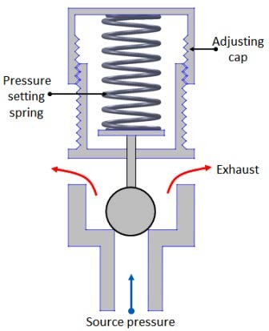***Relief valve***

**Fig. 5.20 Relief valve**

Relief valve is the simplest type of pressure regulating device. The schematic of its construction and working is shown in the Figure 5.20. It is used as a backup device if the main pressure control fails. It consists of ball type valve held on to the valve seat by a spring in tension. The spring tension can be adjusted by using the adjusting cap. When the air pressure exceeds the spring tension pressure the ball is displaced from its seat, thus releasing the air and reducing the pressure. A relief is specified by its span of pressure between the cracking and full flow, pressure range and flow rate. Once the valve opens (cracking pressure), flow rate depends on the excess pressure. Once the pressure falls below the cracking pressure, the valve seals itself.

1. ***Non-relieving pressure regulator***

In a non-relieving pressure regulator (Fig. 5.21) the outlet pressure is sensed by a diaphragm which is preloaded by a pressure setting spring. If outlet pressure is too low, the spring forces the diaphragm and poppet to move down thus opening the valve to admit more air and raise outlet pressure. If the outlet pressure is too high the air pressure forces the diaphragm up hence reduces the air flow and causing a reduction in air pressure. The air vents away through the load. At steady state condition the valve will balance the force on the diaphragm from the outlet pressure with the preset force on the spring.

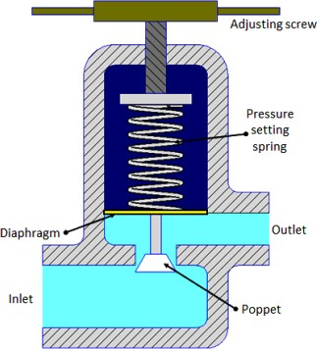

**Fig. 5.21 Non-relieving type pressure regulator**

1. ***Service units***

During the preparation of compressed air, various processes such as filtration, regulation and lubrication are carried out by individual components. The individual components are: separator/filter, pressure regulator and lubricator.

Preparatory functions can be combined into one unit which is called as ‘service unit’. Figure 5.22 shows symbolic representation of various processes involved in air preparation and the service unit.

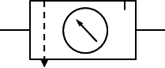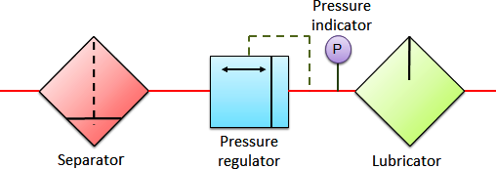

(a) (b)

**Fig. 5.22 (a) Service unit components (b) Service unit symbol**

**Actuators**

Actuators are output devices which convert energy from pressurized hydraulic oil or compressed air into the required type of action or motion. In general, hydraulic or pneumatic systems are used for gripping and/or moving operations in industry. These operations are carried out by using actuators.

Actuators can be classified into three types.

1. Linear actuators: These devices convert hydraulic/pneumatic energy into linear motion.
2. Rotary actuators: These devices convert hydraulic/pneumatic energy into rotary motion.
3. Actuators to operate flow control valves: these are used to control the flow and pressure of fluids such as gases, steam or liquid.

The construction of hydraulic and pneumatic linear actuators is similar. However they differ at their operating pressure ranges. Typical pressure of hydraulic cylinders is about 100 bar and of pneumatic system is around 10 bar.

1. ***Single acting cylinder***

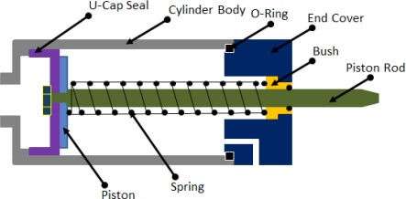

**Fig. 5.23 Single acting cylinder**

These cylinders produce work in one direction of motion hence they are named as single acting cylinders. Figure 5.23 shows the construction of a single acting cylinder. The compressed air pushes the piston located in the cylindrical barrel causing the desired motion. The return stroke takes place by the action of a spring. Generally, the spring is provided on the rod side of the cylinder.

1. ***Double acting cylinder***

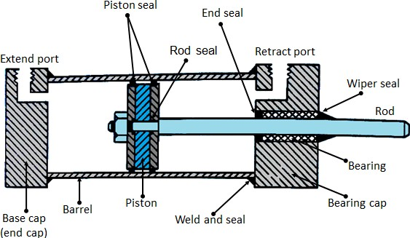

**Fig. 5.24 Double acting cylinder**

The main parts of a hydraulic double acting cylinder are: piston, piston rod, cylinder tube, and end caps. These are shown in Figure 5.24. The piston rod is connected to piston head and the other end extends out of the cylinder. The piston divides the cylinder into two chambers namely the rod end side and piston end side. The seals prevent the leakage of oil between these two chambers. The cylindrical tube is fitted with end caps. The pressurized oil, air enters the cylinder chamber through the ports provided. In the rod end cover plate, a wiper seal is provided to prevent the leakage of oil and entry of the contaminants into the cylinder. The combination of wiper seal, bearing and sealing ring is called as cartridge assembly. The end caps may be attached to the tube by threaded connection, welded connection or tie rod connection. The piston seal prevents metal to metal contact and wear of piston head and the tube. These seals are replaceable. End cushioning is also provided to prevent the impact with end caps.

1. ***Gear motor: a rotary actuator***

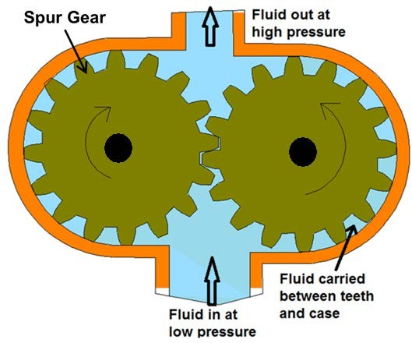Rotary actuators convert energy of pressurized fluid into rotary motion. Rotary actuators are similar to electric motors but are run on hydraulic or pneumatic power.

**Fig. 5.26 Gear motor**

It consists of two inter meshing gears inside a housing with one gear attached to the drive shaft. Figure 6.4.4 shows a schematic diagram of Gear motor. The air enters from the inlet, causes the rotation of the meshing gear due to difference in the pressure and produces the torque. The air exists from the exhaust port. Gear motors tend to leak at low speed, hence are generally used for medium speed applications.

1. ***Vane motor: a rotary actuator***

A rotary vane motor consists of a rotor with sliding vanes in the slots provided on the rotor (Fig. 5.27). The rotor is placed eccentrically with the housing. Air enters from the inlet port, rotates the rotor and thus torque is produced. Air is then released from the exhaust port (outlet).

**Fig. 5.27 Vane motor**

1. ***Speed control***

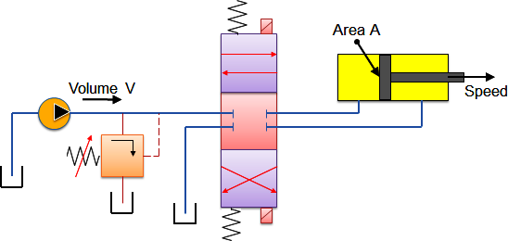For an actuator, the operational speed is determined by the fluid flow rate and the cylinder actuator area or the motor displacement. The speed can only be controlled by adjusting the fluid flow to the actuator, because the physical dimension of the actuator is fixed. Since the air is compressible, flow control is difficult as compared to the hydraulic system. There are various ways of controlling the fluid flow. One of the methods is discussed as below-

**Fig. 5.28 Speed control by pump volume**

Figure 5.28 shows the circuit diagram of hydraulic system developed to control the speed of motion of a piston. Consider a pump which delivers a fluid volume of ‘*V*’ per minute. The pump has a fixed displacement. The volume of fluid goes either to the pump or to the actuator. When the direction control valve moves from its center position the actuator of area ‘*A*’, the piston moves with a velocity,

**Applications of pneumatic systems**

1. ***Case study A***

Consider a simple operation where a double-acting cylinder is used to transfer parts from a magazine. The cylinder is to be advanced either by operating a push button or by a foot pedal. Once the cylinder is fully advanced, it is to be retracted to its initial position. A 3/2-way roller lever valve is to be used to detect the full extension of the cylinder. Design a pneumatic circuit for the above-mentioned application.

* 1. **Components used**

The pneumatic components which can be used to implement the mentioned task are as follows:

* + - double acting cylinder
    - 3/2 push button valve
    - 3/2 roller valve
    - shuttle valve
    - 3/2 foot pedal actuated valve
    - 5/3 pneumatic actuated direction control valve
    - compressed air source and connecting piping
  1. 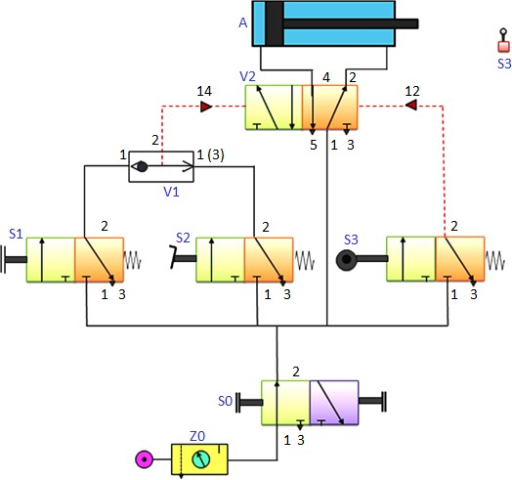**Working**

**Fig. 5.29 Pneumatic circuit for shuttle valve operation**

Figure 5.29 shows the proposed circuit diagram. As the problem stated, upon actuation of either the push button of valve (S1) or the foot pedal valve (S2), a signal is generated at 1 or 1(3) side of the shuttle valve. The OR condition is met and the signal is passed to the control port 14 of the direction control valve (V2). Due to this signal, the left position of V2 is actuated and the flow of air starts. Pressure is applied on the piston side of the cylinder (A) and the cylinder extends. If the push button or pedal valve is released, the signal at the direction control valve (V2) port is reset. Since DCV (V2) is a double pilot valve, it has a memory function which doesn’t allow switching of positions. As the piston reaches the rod end position, the roller valve (S3) is actuated and a signal is applied to port 12 of the DCV (V2). This causes actuation of right side of DCV (V2). Due to this actuation, the flow enters at the rod- end side of the cylinder, which pushes the piston towards left and thus the cylinder retracts.

1. ***Case study B***

A plastic component is to be embossed by using a die which is powered by a double acting cylinder. The return of the die is to be affected when the cylinder rod has fully extended to the embossing position and the preset pressure is reached. A roller lever valve is to be used to confirm full extension. The signal for retracting must only be generated when the piston rod has reached the embossing position. The pressure in the piston chamber is indicated by a pressure gauge.

* 1. **Components used**

The pneumatic components to be used to implement this task are:

* + - double acting cylinder
    - 3/2 push button valve
    - 3/2 roller valve
    - shuttle valve
    - 5/3 pneumatic actuated direction control valve
    - pressure sequence valve
    - compressed air source
    - pressure gauge and connecting piping
  1. **Working**

**Fig. 5.30 Pneumatic circuit for embossing application**

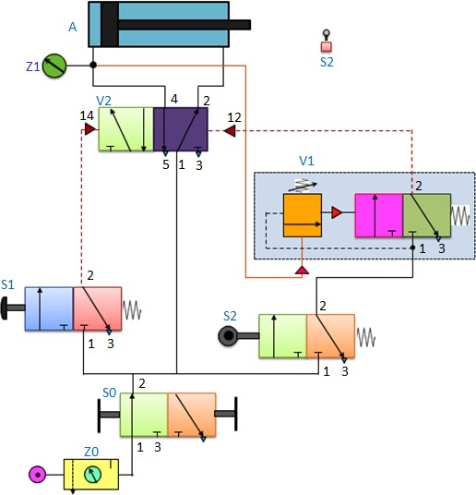

The proposed pneumatic circuit diagram for embossing application is shown in fig.5.30. When the push button valve (S1) is pressed, the flow takes place through the valve and a signal is sent to the control port 14 of the direction control valve (V2). The left position of the direction control valve (V2) is switched-on and the flow enters at the piston-end of the cylinder (A). It causes the extension of the cylinder. Even if the push button is released the position of the DCV (V2) will not change due to its memory function. As the piston nears the end position, the roller valve (S2) is actuated and pressure line is connected to the pressure sequence valve (V1). During the embossing process the pressure at the piston-side of the cylinder (A) increases. This increase in pressure is indicated by the pressure regulator (Z1). When the pressure reaches to its pre-set value in the pressure sequence valve (V1), the 3/2 valve of pressure sequence valve switches and the signal is applied to port 12 of the DCV (V2). The right position of the DCV is actuated and the piston retracts. During the retracting movement, the roller valve (S2) is released and the signal at the control port 12 of the DCV (V2) is reset and the pressure sequence valve is also reset.

1. ***Case study C***

**Sequencing application**

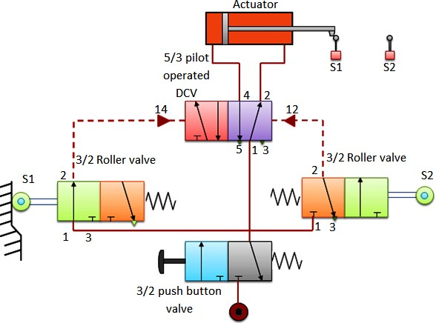In process control applications such as sequencing, the Pneumatics systems are generally employed. Electrical components such as relays, programmable logic controllers are used to control the operations of Pneumatic systems. A simple example of a pneumatic sequencing is shown in Figure 5.31.

**Fig. 5.31 Cylinder sequencing- Oscillating cylinder**

* 1. **Components used**

The components used in the circuit are: double acting cylinder, 3/2 roller lever valve, 5/3 pilot operated direction control valve and a 3/2 push button valve. By using this circuit, a continuous to and fro motion of the actuator is obtained.

* 1. **Working**

When the 3/2 push button is actuated, the air flows from the source through the push button valve to the 3/2 roller valve (S1). The roller valve is already actuated by the cylinder when the piston rod hits the lever of S1. Therefore, there is continuous flow to the 5/3 pilot operated direction control valve (DCV). The flow given to the pilot line 14 actuates the first position of DCV. The air flows from port 1-4 pushes the piston head which causes the extension of the cylinder. As the cylinder fully extends it actuates the 3/2 roller lever valve (S2). The roller valve is actuated and air flows through the valve to the 5/3 DCV. The air enters the DCV through pilot port 12 actuating the second position. Hence the air flows from port 1-2 to the actuator rod end, causing its retraction. The cylinder reciprocates till the supply is stopped. In this way, we can achieve the sequencing operation by controlled actuation of various valves in a pneumatic system.